Easy Read

Safeguarding Reviews
Learning from the past to make the future safer
We want to know what you think
Response form

This document was written by the Welsh Government. It is an easy read version of ‘Single Unified Safeguarding Review – Illuminating the Past to make the Future Safer - Response form’.

November 2022

Introduction

This is an easy read response form.
We need to change the way we deal with safeguarding problems in Wales.

Safeguarding means protecting a person’s health, wellbeing, and human rights. Especially children and adults most at risk, to make sure they can live free from abuse and harm.
We must work together to see what could have been done differently to stop the harm from happening.
This is called a safeguarding review.
We want to know what you think about the Single Unified Safeguarding Review (SUSR) we have developed. A way of dealing with safeguarding problems.

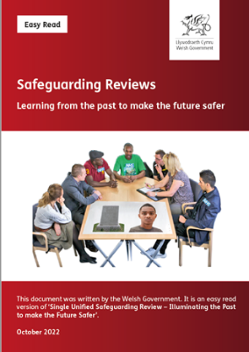

Please read the main document and then answer the questions in this response form.

Send us your answers by 31 March 2023.

You can:
Fill out this form and e-mail it to: SUSRWales@gov.wales

Or print it and post it to:
Division
Welsh Government
Cathays Park
Cardiff
CF10 3NQ
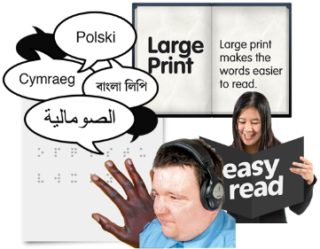
Please let us know if you want this document in a different format like large print, Braille or other languages.
This document was made into easy read by Easy Read Wales using Photosymbols. To tell us what you think about this easy read version, click here

How we use your information

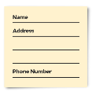
We use your information by following a law called UK General Data Protection Regulation (UK GDPR)

Welsh Government staff will be able to see your answers. Sometimes we ask other organisations to help us understand people’s answers. So, they may see your information too.

We normally publish a report showing the kinds of things people said.

Sometimes this means people’s personal details are included. Please tell us if you do not want your personal information included.

If you are in our report the information could be available for a long time.

But information that is not published is only kept for 3 years.

The data protection laws give you the right to:
- Know what information we have about you and how you can see it.
- Make us change any mistakes in the information about you.
- Ask us not to use the information in some cases.
- Ask us to delete the information we have about you in some cases.
- Move the information about you somewhere else in some cases.
- Complain to the Information Commissioner’s Office.

If you would like to know more about how your information is kept and used please contact us at:
Post: Data Protection Officer
Welsh Government
Cathays Park
Cardiff
CF10 3NQ

Email: Data.ProtectionOfficer@gov.wales

You can also contact the Information Commissioner’s Office:
Post: Wycliffe House
Water Lane
Wilmslow
Cheshire
SK9 5AF

Phone: 01625 545745 or 0303 123 1113

Website: https://ico.org.uk

About you

Name:

If you are answering as part of your job, what is the name of your organisation?

Email:

Phone:

Address:

We may share your feedback with others. If you do not want us to share your personal information tick the box here ☐

Questions

Please read pages 4 to 9 of the main document.
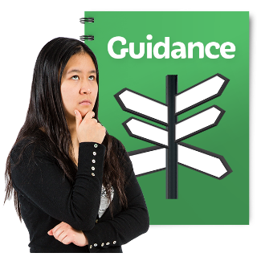

Question 1: Do you think the reasons for writing the guidance are clear and easy to understand?

Yes ☐
No ☐
Not sure ☐

Comments:

Please read page 10 of the main document.

Question 2. Are the principles which tell you why we created Single Unified Safeguarding Reviews (SUSR) useful to you?

Please read pages 10 to 16 of the main document.

Question 3. Is it clear in the document as to when a SUSR will be done?

Please read pages 17 to 18 of the main document.

Question 4. Is the process of SUSRs explained clearly? Do you think you need more information to explain each stage of the SUSR process?

Yes ☐
No ☐
Not sure ☐

Comments:

Please read pages 19 to 25 of the main document.

Question 5. It is important that the right people do the SUSR. Are the roles and responsibilities of people involved clear and useful?

Yes ☐
No ☐
Not sure ☐

Comments:

Please read pages 25 to 28 of the main document.

Question 6. For every review that we do, different people will need to be involved. Are the guidelines for families and key individuals clear and useful?

Yes ☐
No ☐
Not sure ☐

Comments:

Please read pages 34 to 35 of the main document.

Question 7. There are many stages to go through to complete a SUSR. Are the stages clear to you?

Yes ☐
No ☐
Not sure ☐

Comments:

Please read pages 36 to 37 of the main document.

Question 8. Is the section on what we can learn from a SUSR clear and easy to understand?

Yes ☐
No ☐
Not sure ☐

Comments:

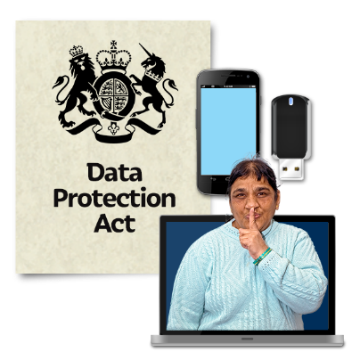
Please read page 38 of the main document.

Question 9. Do you think information on how we will use your personal information is clear and useful?

Yes ☐
No ☐
Not sure ☐

Comments:

Please read page 39 of the main document.
Question 10. Sometimes Regional Safeguarding Boards decide that it would be useful to do a SUSR on an old case. Is the section on doing SUSRs on old cases clear and useful?
Yes ☐
No ☐
Not sure ☐

Comments:

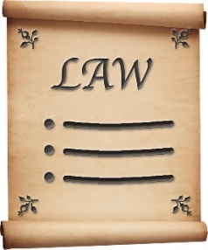
Please read page 40 of the main document.

Question 11. Do you think the process for dealing with complaints or when the law is broken is right?

Yes ☐
No ☐
Not sure ☐

Comments:

Welsh language

Do you think any of the changes we want to make through the Single Unified Safeguarding Review process will have any effects on the Welsh language?

This could be good or bad. And do you think the Welsh language will be treated fairly?

Tell us how we can make sure people who use Welsh are not affected badly by the changes in this document. How can we promote the Welsh language?

Any other comments

Is there anything else you would like to say?

Thank you

