Easy Read

Race Equality Action Plan
A plan to make Wales Anti-Racist by 2030
Tell us what you think

This document was written by Welsh Government. It is an easy read version of ‘Race Equality Action Plan Consultation. An Anti-Racist Wales’.
March 2021
 | How to use this document
 |  | This is an easy read document. But you may still need support to read it. Ask someone you know to help you.
 |  | Words in bold blue writing may be hard to understand. You can check what the words in blue mean on pages 24 and 25.
Where the document says we, this means Welsh Government. For more information contact:

The Equality Team
Welsh Government
Cathays Park
Cardiff

 |  | This document was made into easy read by Easy Read Wales using Photosymbols. To tell us what you think about this document, click here.

Introduction
 |  |  | There have been lots of news reports about racism against Black, Asian and Ethnic Minority people in Wales and around the world.
 |  |  | Racism means nasty or unfair treatment of someone because of where they come from, their language, history, skin colour, religion or culture.
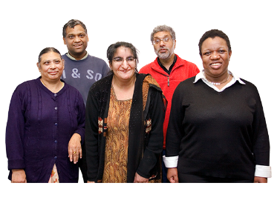 |  |  | Ethnic Minority people are people who live in places where most of the other people are a different race and usually in smaller numbers.
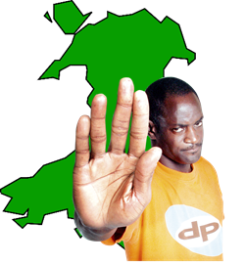 |  |  | We think it is time to take serious action to end racism in Wales.
 |  |  | We are working on a Race Equality Action Plan to change the lives of Black, Asian and Ethnic Minority people in Wales. We will call this group Ethnic Minority for short.
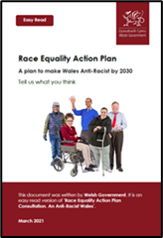 |  |  | This document is about the Race Equality Action Plan. What it is and what you think about it.

Our vision for Wales
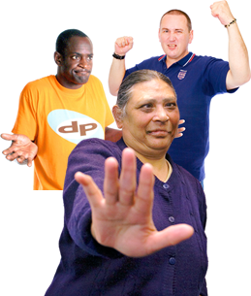 | Our vision is for Wales to be anti-racist by 2025.  Anti-racist means we are against racism, we do not let it happen, and take steps to make sure that people from ethnic minority groups are treated fairly and with respect.
 | We believe everyone in Wales should be respected, treated fairly and have equal life chances.
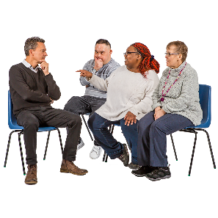 | We have held workshops and discussions to help us understand what we need to do make this happen.
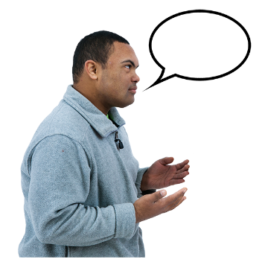 | We have also listened to people from ethnic minority groups who told us about their experiences of racism.

We have used the information people have given us to plan:
- our goals
- actions we think we need to take
- the outcomes of our actions that we want to see.

Outcomes are the differences our actions will make.
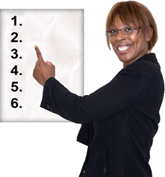 | We have made a list of priority areas to work on.  A priority is something that is most important and needs to be worked on first.
 | Our Priority areas
 | We will focus on:
 | - Education
 | - Employment and wages
- Leadership and representation.

Representation is when someone speaks up on behalf of others and makes decisions about them.

 | - Health
 | - Social Care
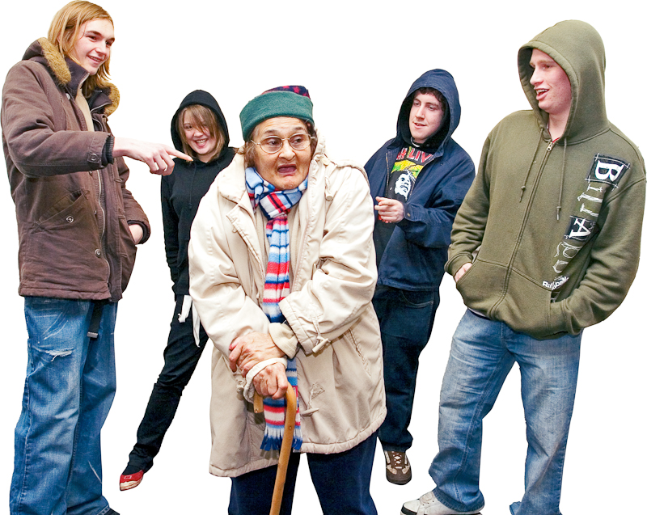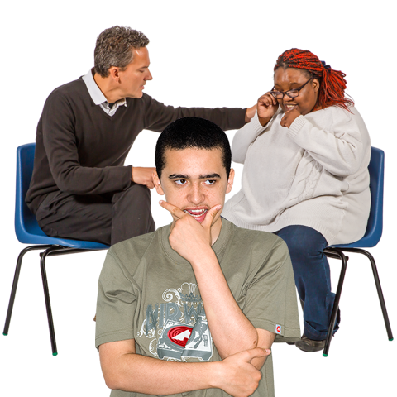 | - Hate crime and justice  Hate crime is being harassed or attacked because people think you are different. For example, because you are disabled, have different religion, or different skin colour.  Justice is fair treatment for people.
 | - Housing and accommodation
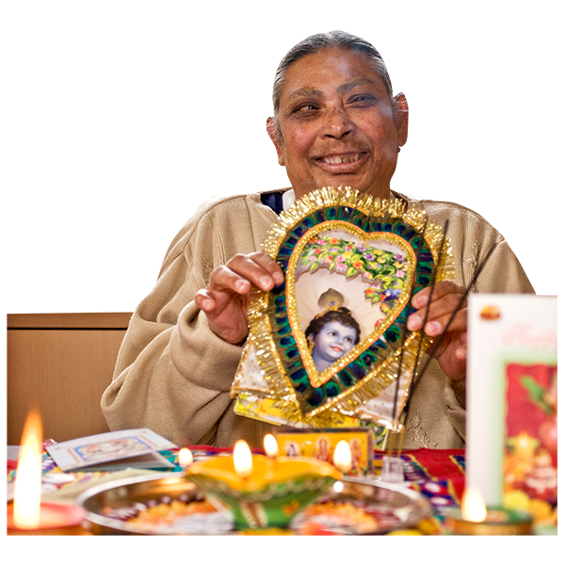 | - Arts, culture, Sports and Heritage  Heritage – Parts of a culture that are important to a particular group. For example: festivals, language and customs.
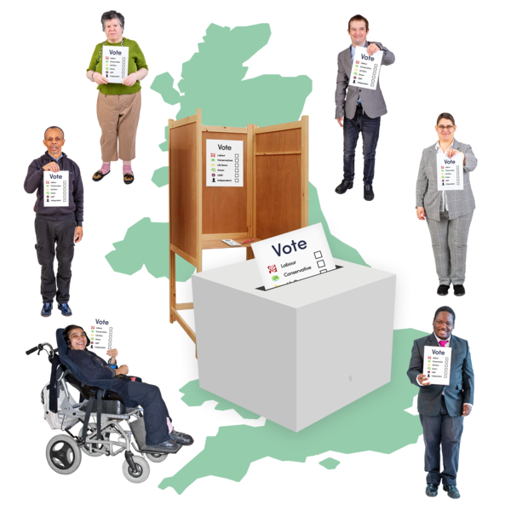 | - Local Democracy  Local Democracy – Groups and organisations that make decisions in your local area.
 | - Environment
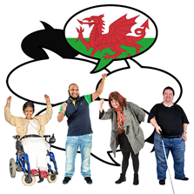 | - Welsh Language
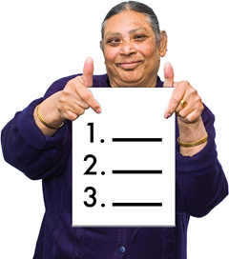 | We will also focus on issues that are found in all the above priorities, like:  - the need to have good communication  - the need to make sure we collect data to say why we want to change things  - the need to fund and look after people who may have experiences of racism.  These are sometimes called cross-cutting issues.

What you think about the Race Equality Action Plan
 | We are asking people what they think about the plan so far.
 | We might use your suggestions to change the plan.
 | We want to share the final plan in Autumn 2021.
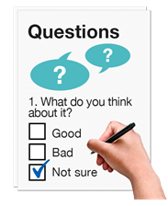 | We have some questions for you to think about on pages 14 to 23.
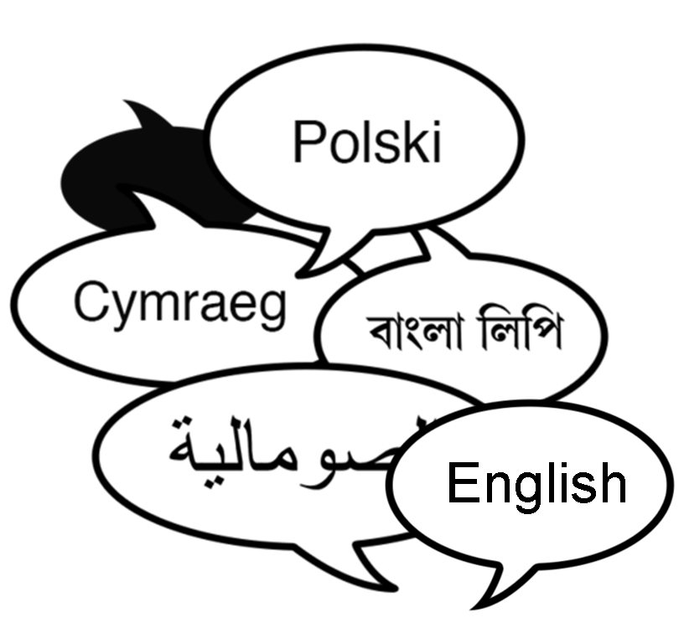 | You can tell us what you think in the best way for you. For example you can:  - Write to us  - Send us a video  - Use the language you prefer.
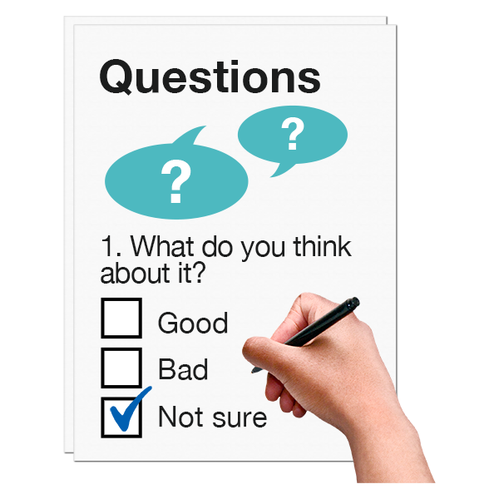 | You can answer the questions you want to. You don’t have to answer them all. You can just answer questions on the priority area you are interested in if you want.
 | How to send the form
You can tell us what you think by filling out the form and posting it to:

Address:

The Equality Team
Welsh Government
Cathays Park
Cardiff

 | Or email: RaceEqualityActionPlanconsultation@gov.wales

How we will use the information you

give us
 |  | We will be looking at your answers to think about any changes to our plan to make Wales anti-racist.
 |  | Sometimes we ask other organisations to help us make decisions. They may also see the answers that people give.
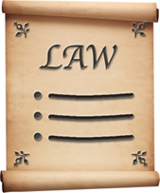 |  | We will make sure we follow the law when we use your information.
 |  | We will write a report about what people said.
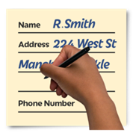 |  | We might write some people’s answers in full, with their names and addresses in the report or on the internet.
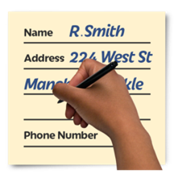 |  | When you send us your answers, please tell us if you do not want us to write your name and address in the report or on the internet.
The data protection laws give you the right to:

- know what information we have about you and how you can see it

- make us change any mistakes in the information about you

- ask us not to use the information in some cases

- ask us to delete the information we have about you in some cases

- move the information about you somewhere else in some cases

- complain to the Information Commissioner’s Office.
 |  | If you would like to know more about how your information is kept and used please contact us at:
Data Protection Officer
Welsh Government
Cathays Park
Cardiff
CF10 3NQ
 |  | E-mail: Data.ProtectionOfficer@gov.wales
You can also contact the Information Commissioner’s Office:

Address:

Wycliffe House
Water Lane
Wilmslow
Cheshire
SK9 5AF

 |  | Tel: 01625 545745 or 0303 123 1113
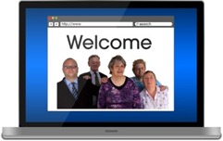 |  | Website: https://ico.org.uk

Questions

- Do you agree with our vision for Wales to be anti-racist by 2030?

Yes | ☐ | No | ☐ | Not sure | ☐

Is there anything else you would like to say about this?

- What problems do you think we might have making Wales anti-racist? Tell us in the box below.

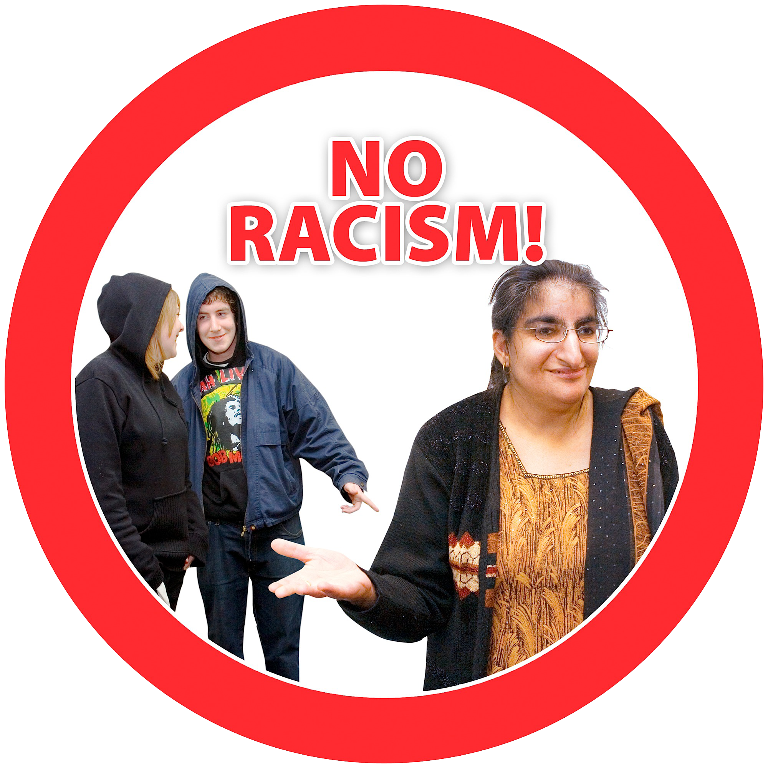 | - What else would help to make Wales anti-racist? Tell us in the box below.

- Have we clearly explained the goals and actions for our plan?

Yes | ☐ | No | ☐ | Not sure | ☐

Is there anything else you would like to say about this?

- Do you agree with our goals?

Yes | ☐ | No | ☐ | Not sure | ☐

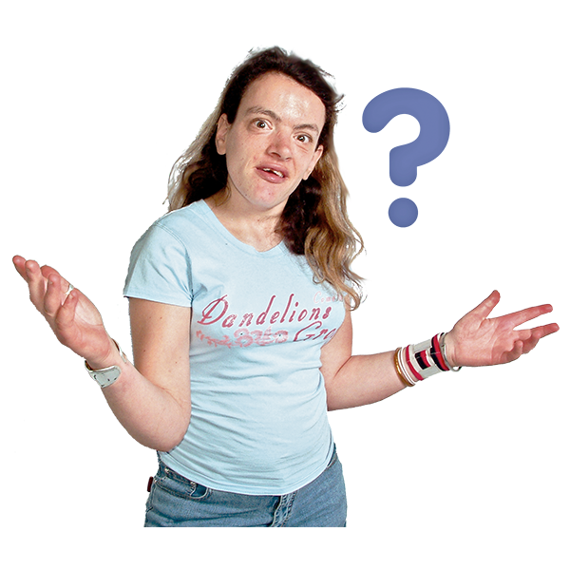 | - Can you think of any other goals? Tell us in the box below.

- Do you think our goals and actions will help to make Wales anti-racist?

Yes | ☐ | No | ☐ | Not sure | ☐

Is there anything else you would like to say about this?

- Do you agree with the priority areas?

Yes | ☐ | No | ☐ | Not sure | ☐

Is there anything else you would like to say about this?

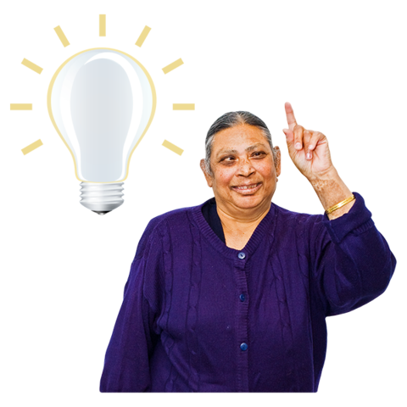 | - Have you thought of any other priority areas?

Yes | ☐ | No | ☐ | Not sure | ☐

Is there anything else you would like to say about this?

- What resources do you think we might need to make Wales anti-racist? For example: Money, training, staff?

- Do you think our plan respects other differences Black, Asian and Minority Ethnic people might have? For example: Age, sexuality, disability?

Yes | ☐ | No | ☐ | Not sure | ☐

Is there anything else you would like to say about this?

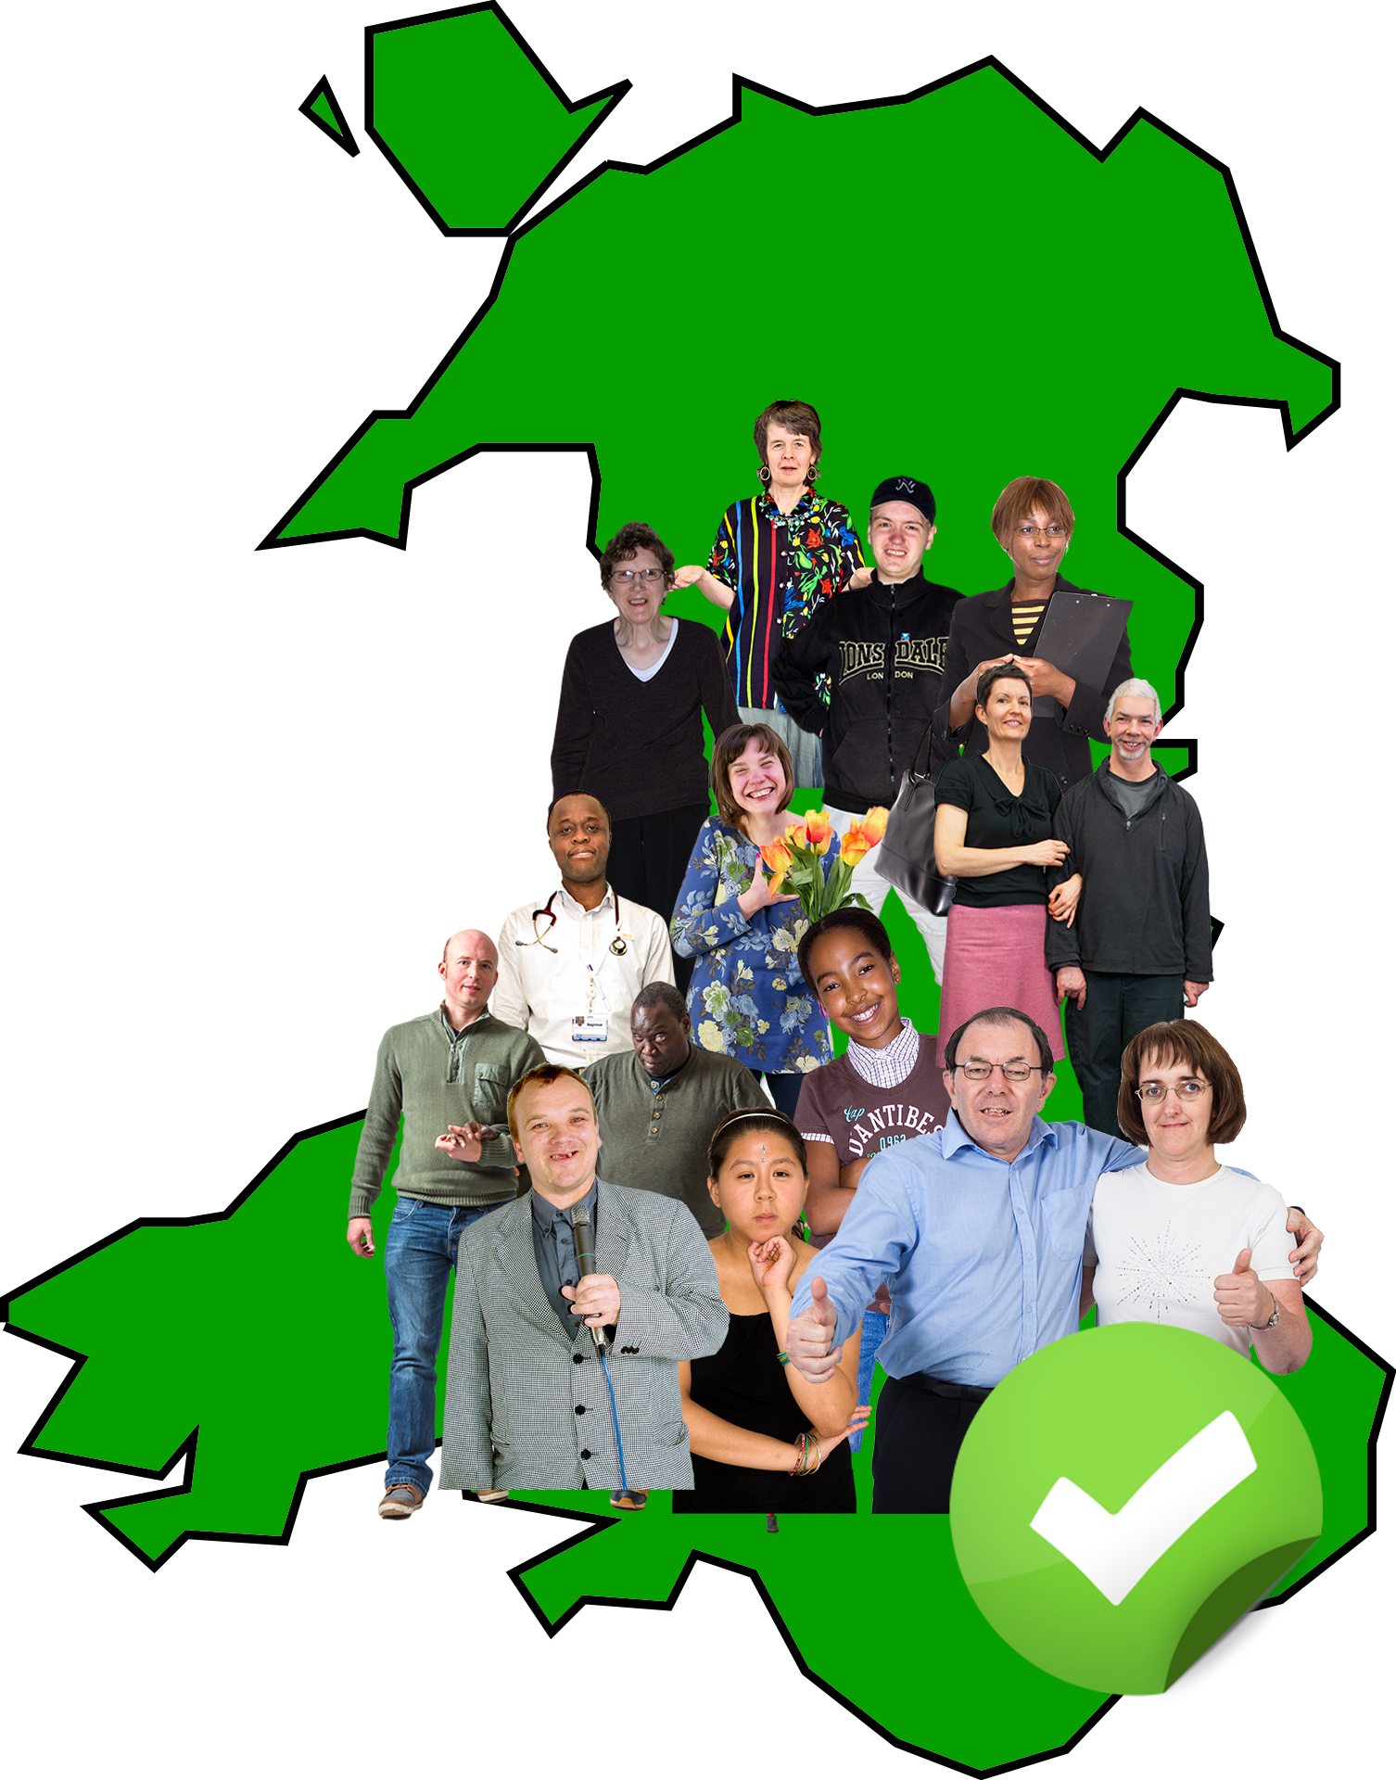 | - How will we know if Wales is anti-racist in 2025?

- What changes do you think we will be able to see?

- Do you think the Race Equality Action Plan will support people who speak Welsh?

Yes | ☐ | No | ☐ | Not sure | ☐

Is there anything else you would like to say about this?

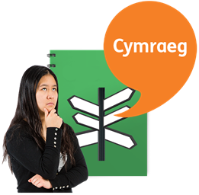 | - What else could we do to make sure the Welsh language is valued as much as English? We have this as one of the priority areas.

In this document we use the term Black, Asian and Minority Ethnic to describe people who are most likely to experience racism. Some people do not like this term.

- Do you think there is another way to describe the groups of people who are most likely to experience racism?

Yes | ☐ | No | ☐ | Not sure | ☐

Is there anything else you would like to say about this?

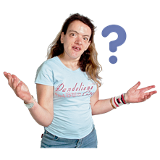 | - Is there anything else you would like to say about making Wales anti-racist?

Thank you.

Hard words

Anti-racist
Anti-racist mean we are against racism, we do not let it happen, and take steps to make sure that people from ethnic minority groups are treated fairly and with respect.
Ethnic Minority
Ethnic Minority people are people who live in places where most of the other people are a different race and usually in smaller numbers.
Hate crime
Hate crime is being harassed or attacked because people think you are different. For example, because you are disabled, have different religion, or different skin colour.
Heritage
Parts of a culture that are important to a particular group. For example: festivals, language and customs.
Justice
Justice is fair treatment for people.
Local Democracy
Groups and organisations that make decisions in your local area.
Outcomes
Outcomes are the differences our actions will make.
Priority
A priority is something that is most important and needs to be worked on first.

Racism
Racism means nasty or unfair treatment of someone because of where they come from, their language, history, skin colour, religion or culture.
Representation
Representation is when someone speaks up on behalf of others and makes decisions about them.

