Easy Read

LGBTQ+ action plan
Response Form
Please send this form back to us by 22 October 2021
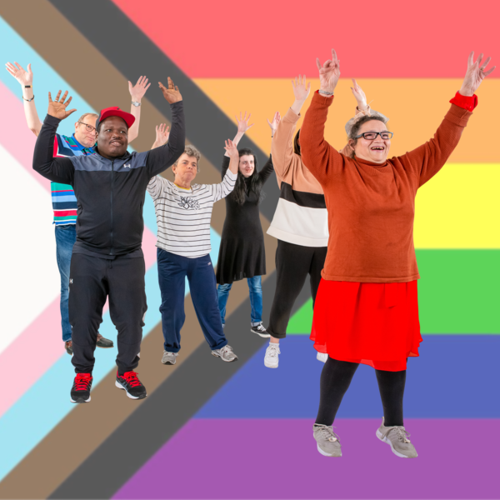

This document was written by Welsh Government. It is an easy read version of ‘LGBTQ+ Action Plan Consultation’.

July 2021

Introduction
These questions are about our ideas in our LGBTQ+ Action Plan

LGBTQ+ stands for Lesbian, Gay, Bisexual, Transgender, Queer or Questioning and others.
This is a community of people who share experiences because of who they are and who they love:
- Lesbians are women who are attracted to other women.
- Gay men are men attracted to other men.
- Bisexual people are people who are attracted to both men and women.
- Transgender people are people who are born as one sex but are the other sex. For example a person who looks like a man may be a woman on the inside.
- Even though Queer has been used as a bad word against LGBTQ+ people, some people have started to use it in a positive way for when they feel that words like straight, gay and lesbian do not really describe them.
- Questioning is for people who are still figuring out who they are and how they identify.

How to fill in this response form
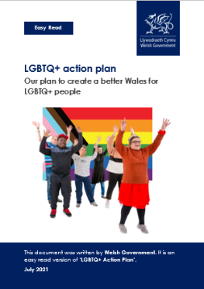
Before you answer the questions, please read the main easy read document:
LGBTQ+ Action Plan

We want to know what you think. You can tell us by filling out this response form. Or you can tell us in a way that suits you better.
For example, you could send us your thoughts:
- in a video
- by recording yourself talking
- or by writing an e-mail.
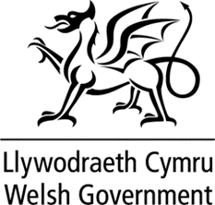
Where the document says we, this means the Welsh Government.

This document was made into easy read by Easy Read Wales using Photosymbols.

Please send this form back to us by:

Post: The Equality Team
Welsh Government
Cathays Park
Cardiff
CF10 3NQ

E-mail: LGBTQ+ActionPlan@gov.wales

Online:
gov.wales/node/38053/respond-online

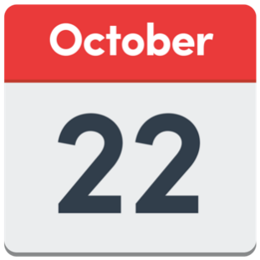
Please send your responses back by 22 October 2021.

How we will use the information you give us

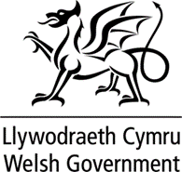
We will be looking at your answers to make decisions about the LGBTQ+ Action Plan.
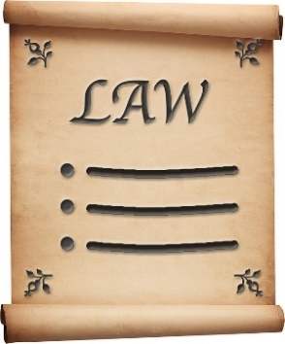
We will make sure we follow the law when we use your information.

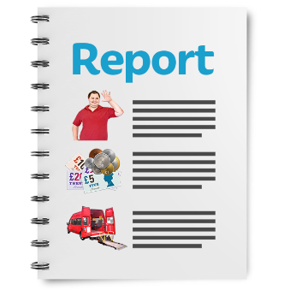
We will write a report about what people said.

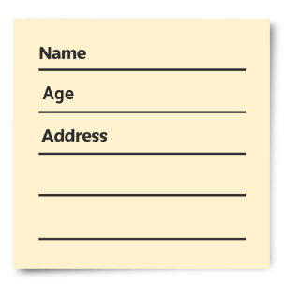
We might write some people’s answers in full with their names in the report or on the internet.

When you send us your answers, please tell us if you do not want us to write your name in the report or on the internet.

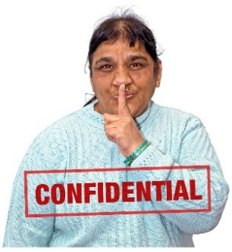
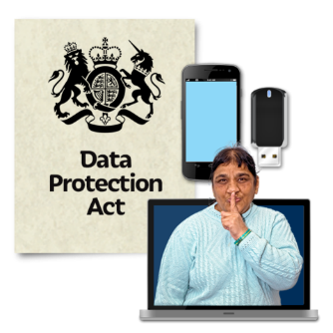
The data protection laws give you the right to:

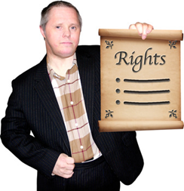
- know what information we have about you and how you can see it

- make us change any mistakes in the information about you

- ask us not to use the information in some cases

- ask us to delete the information we have about you in some cases

- move the information about you somewhere else in some cases

- complain to the Information Commissioner’s Office.

If you would like to know more about how your information is kept and used, please contact us at:

Data Protection Officer
Welsh Government
Cathays Park
Cardiff
CF10 3NQ
E-mail: Data.ProtectionOfficer@gov.wales

Questions

Question 1

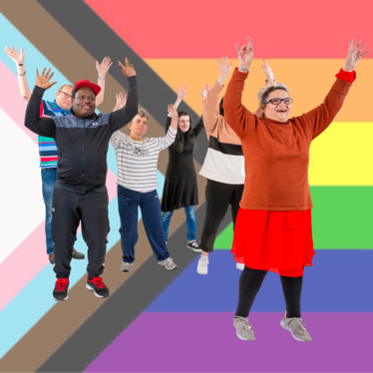
Do you think the action plan will make Wales better for LGBTQ+ people?

What do you think are the most important things for us to focus on to make life better for LGBTQ+ people in Wales?

Question 2

Do you agree with the ideas that the action plan is trying to achieve?

Is there anything you think we should add or take away?

Question 3

Do you agree with the actions that we are thinking about?

Are there any actions you think we should add or take away?

Question 4

What are the main challenges that could stop us achieving the aims and actions in the plan?

Question 5

What resources do you think will be important to meet the aims and actions in the plan?
Resources are the things we need. For example, money, staff, training.

Question 6

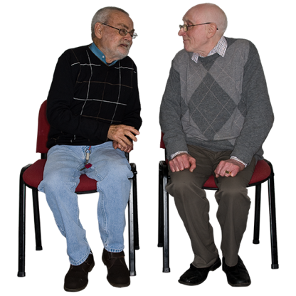
Do you feel the action plan covers LGBTQ+ people with other protected characteristics?

Protected characteristics includes race, age, gender, religion, disability and sex.

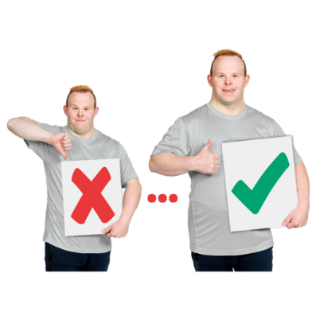
If not, how can we make this better?

Question 7

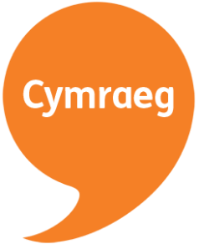
Do you think that this action plan will be good or bad for the Welsh language?

If so, what effects might it have?

Question 8
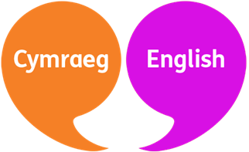
How do you think this action plan can make the Welsh language equal to the English language?

Question 9

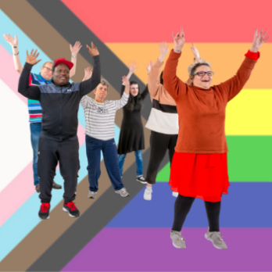
What do you think of the use of the term LGBTQ+? Is there another term you think would be better?

If you speak Welsh, what could be a good Welsh term to use?

Question 10

Are there any issues you think we have missed out?

Thank you.

