Easy Read

Period Dignity
We want to know what you think of our plan
Response Form
Please send this form back to us by 12 January 2022
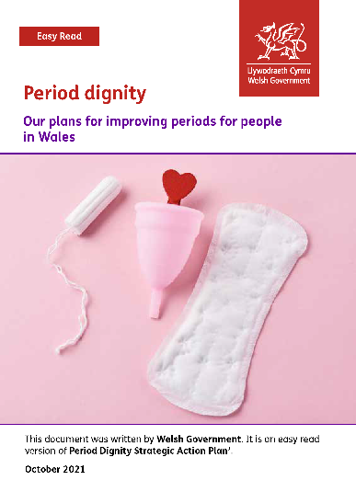

This document was written by Welsh Government. It is an easy read version of ‘Period Dignity Strategic Action Plan’.

October 2021

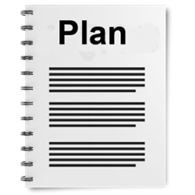
We want to know what you think
We have made a plan about improving periods for people in Wales.
We call this Period Dignity and mean things like:
- People should be able to get the period products they need
- People should not feel shame about having their period
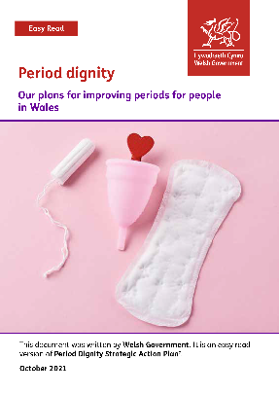
- For all people to be treated equally and fairly.
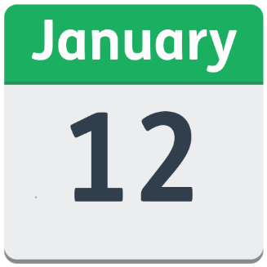
Please see the main document called Period dignity - Our plans for improving periods for people in Wales to help you answer these questions.
Please send us your views by 12 January 2022

You can email it to: PeriodDignity@gov.wales
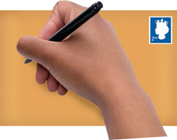
Or post it to: The Equality Team
Welsh Government
Cathays Park
Cardiff
CF10 3NQ

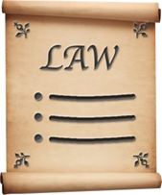
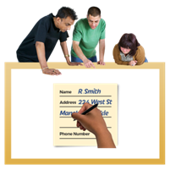
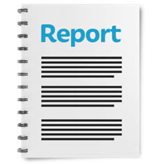
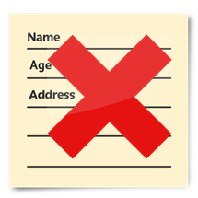
How we use your information
We use your information by following a law called UK General Data Protection Regulation (UK GDPR)
Our staff will be able to see your answers.
Sometimes we ask other organisations to help us understand people’s answers. So they may see your information too.
We normally publish a report showing the kinds of things people said.
Sometimes this means people’s personal details are included. Please tell us if you do not want your personal information included.
If you are in our report the information could be available for a long time.

But information that is not published is only kept for 3 years.
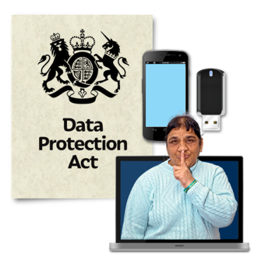
The data protection laws give you the right to:
- Know what information we have about you and how you can see it.
- Make us change any mistakes in the information about you.
- Ask us not to use the information in some cases.
- Ask us to delete the information we have about you in some cases.
- Move the information about you somewhere else in some cases.
- Complain to the Information Commissioner’s Office.

If you would like to know more about how your information is kept and used, please contact us at:
Data Protection Officer
Welsh Government
Cathays Park
CARDIFF
CF10 3NQ
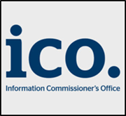
Email: Data.ProtectionOfficer@gov.wales
You can also contact the Information Commissioner’s Office:
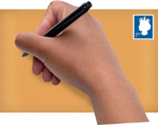
Wycliffe House
Water Lane
Wilmslow
Cheshire
SK9 5AF
Phone: 01625 545745 or 0303 123 1113
Website: ico.org.uk

Questions
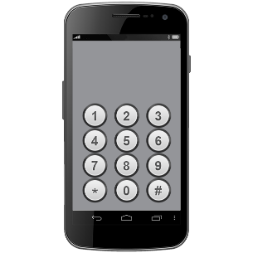

Your name:

Where do you work?

Your email address:

Your phone number:

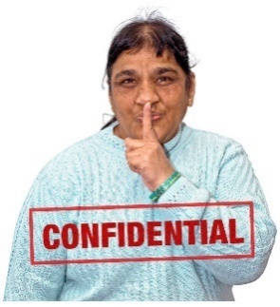

If you would like your answers to remain private, please tick here:
☐
- Do you agree with the ideas for how to achieve period dignity?

And what would you do to improve them?

- Do you think we can do all this in the next 5 years?

What needs to change to make these plans happen?

- Do you think there are any important areas we have left out of the plans?

If so, what?

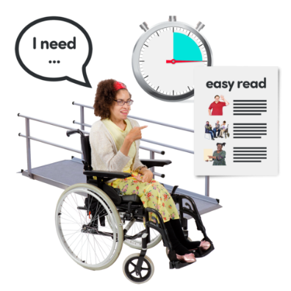
- Do you think we have covered the issues people with additional needs face? For example, being disabled and not having enough money?

How could we make this better?

- There are a lot of health issues related to periods. Should these be covered in the plan?

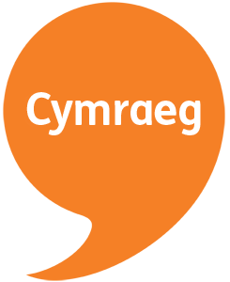
- Do you think our plan will have any effects on using the Welsh language?

What could be improved?

- If there is anything else you would like to add, please do so here:

Thank you.

