Easy Read

Changing business rates in Wales
Response Form

This document was written by the Welsh Government. It is an easy read version of ‘Reforming Non-Domestic Rates for Wales’.

September 2022

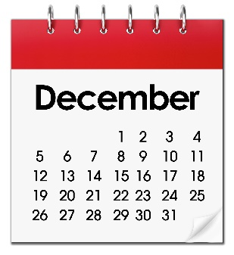
How to respond

Send us your form by the end of Wednesday 14th December 2022 by:

Email: LGFR.consultations@gov.wales

Post: Non-Domestic Rates Policy Branch
Welsh Government
Cathays Park
Cardiff

This document was made into easy read by Easy Read Wales using Photosymbols.

Questions

Updating how much you pay in business rates more often

Please read pages 7 to 11 of the main document to answer questions 1 to 6.
Question 1:
Do you think we should check business rates every 3 years instead of every 5 years?

Yes ☐
No ☐
Please add any other comments here:

Question 2:
Do you think we should check business rates more often than every 3 years?
Yes ☐
No ☐
How often do you think we should check business rates?

Question 3:
Do you think the gap between checking business rates and changing business rates payments should be smaller?
Yes ☐
No ☐

Please add your comments here:

Question 4:
What do think about giving us information that helps us:
- Check business rates more often?
- Make changes to our ratings list?
Please add your comments here:

Question 5:
Do you agree that ratepayers should be fined if they do not give us the information we need?
Yes ☐
No ☐

Do you think the amount ratepayers will be charged is fair if they get a fine? Please read page 11.
Yes ☐
No ☐

Do you think it is fair that ratepayers could spend a short time in prison if they provide false information on purpose?
Yes ☐
No ☐

Please add your comments here:

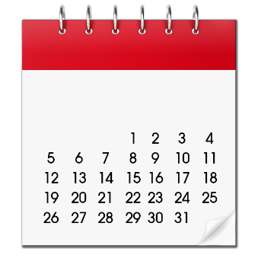

Question 6:
Do you think 60 days is enough time for ratepayers, to give us the information we need to check business rates?

Yes ☐
No ☐
Do you think 30 days is enough time for ratepayers to reply to a penalty notice?

Yes ☐
No ☐

Please add your comments here:

Reliefs and exemptions

Please read pages 13 to 14 of the main document to answer questions 7 to 10.
Question 7:

Do you think we should look at our reliefs from business rates to see if they could be changed to work better?
Yes ☐
No ☐
Do you have any comments about what we should look at to see if the reliefs we provide could be improved?
Please add any other comments here:

Question 8:

Do you think we should be able to make our own plans for giving relief from business rates if needed?

Yes ☐
No ☐
Please add any other comments here:

Question 9:

Do you think we should be able to decide who does not need to pay business rates in Wales?

Yes ☐
No ☐
Please add any other comments here:

Question 10:

Do you think Local Authorities should have more control over when they can give relief?

Yes ☐
No ☐
Please add any other comments here:

Working out business rates

Please read pages 15 to 16 of the main document to answer Questions 11 and 12.
Question 11:

Do you agree that we should be able to use different multipliers depending on:

- The rateable value of your property.

- The business taking place at your property.

- Where your property is?

Yes ☐
No ☐

Please add any other comments here:

Question 12:
Is there anything you would like to say about using different multipliers?

Please add your comments here:

Improving how we value property and make changes

Please read pages 17 to 23 of the main document to answer Questions 13 to 17

Question 13:
Do you think it is fair that big changes affecting lots of properties across Wales will be dealt with by checking rateable values for all properties more often?
Yes ☐
No ☐
Please add your comments here:

Question 14:
Do you think we should start using completion notices for buildings that have been done up?
Yes ☐
No ☐

Please add your comments here:

Question 15:

Please read page 21. Do you agree that we should have more control over our central rating list?

Yes ☐
No ☐
Please add your comments here:

Question 16:

Do you agree that we should have a rule to help us stop people avoiding business rates?

Yes ☐
No ☐
Please add your comments here:

Question 17:

Do you think Local Authorities should have more power to deal with ratepayers who avoid paying the right amount of business rates?

Yes ☐
No ☐
Please add your comments here:

Changing local taxes in the future

Please read pages 23 to 24 of the main document to answer Question 18.
Question 18:
Should we keep looking into having a local land value tax in future to replace:
- Business rates and
- Council tax?

Yes ☐
No ☐

Please add your comments here:

Wider views

Question 19:

Is there anything else you want to tell us about business rates and the changes we are suggesting?

Please add your comments here:

Welsh language

Question 20:

Do you think our suggestions for business rates will help people to use the Welsh language?

Yes ☐
No ☐

Please add your comments here:

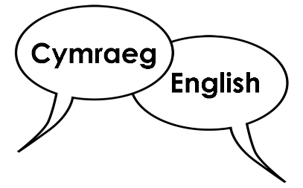
Do you think our suggestions for business rates will support the Welsh and English languages to be treated equally?
Yes ☐
No ☐

Please add your comments here:

Question 21:
Do have any ideas how about we can make sure our suggestions for changes to business will:
- support the use of Welsh language?

Please add your comments here:

- and make sure that the Welsh and English languages are treated equally?

Please add your comments here:

Next steps
You will be able to tell us what you think until the end of the day on 14th December 2022.
We will take some time to look at all the answers and comments that we receive.

They will help us decide on the next steps.

We will let you know what we plan to do next.

How we use your information
We use your information by following a law called UK General Data Protection Regulation (UK GDPR).

Our staff will be able to see your answers.
Sometimes we ask other organisations to help us understand people’s answers. So, they may see your information too.
We normally publish a report showing the kinds of things people said.
Sometimes this means people’s personal details are included. Please tell us if you do not want your personal information included.

If you are in our report the information could be available for a long time.
But information that is not published is only kept for 3 years.

The data protection laws give you the right to:
- Know what information we have about you and how you can see it.

- Make us change any mistakes in the information about you.

- Ask us not to use the information in some cases.

- Ask us to delete the information we have about you in some cases.

- Move the information about you somewhere else in some cases.

- Complain to the Information Commissioner’s Office.
If you would like to know more about how your information is kept and used please contact us at:
Data Protection Officer
Welsh Government
Cathays Park
CARDIFF
CF10 3NQ

Email: Data.ProtectionOfficer@gov.wales

You can also contact the Information Commissioner’s Office:
Wycliffe House
Water Lane
Wilmslow
Cheshire
SK9 5AF

Tel: 01625 545745 or 0303 123 1113
Website: https://ico.org.uk

