Easy Read

Citizen Voice Body
We want to know what you think

This document was written by the Welsh Government. It is an easy read version of ‘Consultation Document: Establishment of the Citizen Voice Body for Health and Social Care, Wales. Draft Code of Practice on Access to Premises, Statutory Guidance on Representations and Draft Guidance on Service Change in the National Health Service’.

December 2022

How to use this document
This is an easy read document. But you may still need support to read it. Ask someone you know to help you.

Words in bold blue writing may be hard to understand. You can check what all the words in blue mean on page 27.

Where the document says we, this means Welsh Government. For more information contact:

Website: gov.wales/citizen-voice-body-guidance-access-representations-and-nhs-service-change

E-mail: cvbinfo@gov.wales

This document was made into easy read by Easy Read Wales using Photosymbols. To tell us what you think about this easy read version, click here.

How we use your information
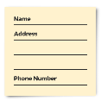

We use your information by following a law called UK General Data Protection Regulation (UK GDPR)

Our staff will be able to see your answers. Sometimes we ask other organisations to help us understand people’s answers. So, they may see your information too.

We normally publish a report showing the kinds of things people said.

Sometimes this means people’s personal details are included. Please tell us if you do not want your personal information included.

If you are in our report the information could be available for a long time.

But information that is not published is only kept for 3 years.

The data protection laws give you the right to:
- Know what information we have about you and how you can see it.
- Make us change any mistakes in the information about you.
- Ask us not to use the information in some cases.
- Ask us to delete the information we have about you in some cases.
- Move the information about you somewhere else in some cases.
- Complain to the Information Commissioner’s Office.

If you would like to know more about how your information is kept and used please contact us at:
Post: Data Protection Officer
Welsh Government
Cathays Park
Cardiff
CF10 3NQ

Email: Data.ProtectionOfficer@gov.wales

You can also contact the Information Commissioner’s Office:
Post: Wycliffe House
Water Lane
Wilmslow
Cheshire
SK9 5AF

Phone: 01625 545745 or 0303 123 1113

Website: https://ico.org.uk

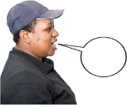
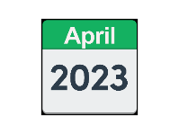
Introduction

We want Wales to be a place where people are listened to.

People should have a say in how health and social care should work.

In April 2023 the Community Health Councils will change to the Citizen Voice Body.

The Citizen Voice Body will make sure people get a chance to have their say about the NHS and local authorities.

The Welsh Government wrote some documents to help the Citizen Voice Body, the NHS and Local Authorities do a good job.

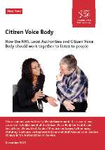
These documents are:
- Code of Practice on Access to Premises
- Statutory Guidance on representations
- Revised guidance on service change in the NHS

We want to know what you think about these documents.

It is important you read the main document before you answer these questions.

Code of Practice on Access to Premises

The Welsh Government has written a code of practice for the Citizen Voice Body, NHS and local authorities.

A Code of Practice gives rules and advice about the law. It helps the Citizen Voice Body, NHS bodies, local authorities and other partners do what the law tells them to do.

The code of practice will make sure people get a chance to have their say in decisions that affect them.

The code of practice tells you how the Citizen Voice Body can ask to meet people face to face in buildings that belong to the NHS or local authorities.

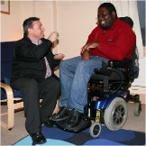
It also helps the Citizen Voice Body to talk to people in their own homes or buildings run by other organisations on behalf of Social services or NHS.

The code explains:
- how the Citizen Voice Body should ask to make a visit
things the local authorities or NHS must think about
- Things the Citizen Voice Body should think about when visiting people in their own homes
- Other things to think about when making a visit.

The Citizen Voice Body, NHS and local authorities must follow the code of practice.

Statutory Guidance on representations
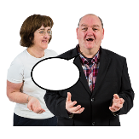
The Health and Social Care (Quality and Engagement) Wales Act 2020 says the Citizen Voice Body can make representations.

Representations mean speaking about or on behalf of other people. This means telling people what they have found out from listening to others.

The Citizen Voice Body can make representations about anything it thinks is right for the NHS or local authorities to think about.

We think that by doing this the NHS and Local Authorities will be able to know what people have to say.

And this will make healthcare and social care services better.
The NHS and local authorities must listen to representations made by the Citizen Voice Body.

The NHS and local authorities must think about how they will make sure they:
- listen to people through the Citizen Voice Body
- tell the Citizen Voice Body how they will use the views of people to make things better
- tell the Citizen Voice Body how people’s views have made a difference.

The guidance also says that the NHS and local authorities must listen to representations about organisations that do work for them. For example, charities and care companies.

Revised guidance on service change in the NHS
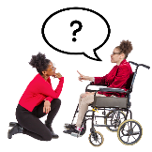
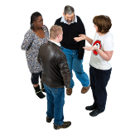
The National Health Services (Wales) Act 2006 tells Local Health Boards and NHS trusts that they must ask people about:
- Plans for services which the NHS offer.
- Changes to the way services are provided.
- Decisions that affect how service is provided.

The Guidance on Service Change tells the NHS what they should think about when making changes.

The guidance makes sure NHS asks people what they think about the changes. Before the changes happen.

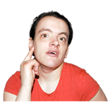
We want the NHS and the Citizen Voice Body to work together to listen to people’s views.

We think this way of working will make services better.

The guidance explains how the NHS should plan changes.

And how to make sure they listen to people.

The document also explains what might happen if things cannot be agreed.

We would like to know what people think about these documents about the NHS, local authorities, and Citizen Voice Body.

Please answer the questions in this document and send it back to:

E-mail: cvbinfo@gov.wales

Please put the reference number WG46403 in the email subject.

Post: Citizen Voice Establishment Team
Welsh Government
Cathays Park
Cardiff
CF10 3NQ
March

Please send us your responses by Monday 6 March 2023

About you

Name:

Your job (If you are answering for work)

Who do you work for (If you are answering for work)

Email:

Address:

We might publish people’s answers on the internet or in a report.
If you don’t want your name or address shown anywhere, please tick here ☐

Question 1

Code of Practice on Access to Premises

In the Code of Practice we want to encourage the use of face to face visits to help get people’s views.

We want to make sure that we think about how this might be difficult in health and social care. And how it could be made easier.

We also want to think differently about someone’s home from a public place. Is this right?

Are there other places we need to view differently?

Do you think that we have thought enough about this?

How could we make this better?

Please write your answer to question 1 in the box below:

Question 2

Statutory Guidance on Representations
In the guidance we gave advice on how representations should be thought about and listened to.
Do you think it is better to give advice than to tell organisations how they should do it?
How can we make this better?

Question 3

Guidance on service change in the NHS

Do you think it should be the law that NHS bodies follow the guidance on service change?
Do you think there is anything we have missed?
Or is there anything we need to add or delete to make it easier to understand?

Question 4
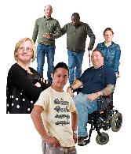
We would like to know if you think these documents could affect people with protected characteristics.

Protected characteristics is a term used to describe some groups of people who are sometimes treated unfairly. For example:
- Disabled people
- Men and women
- People from different races or cultures or religions
- People of different ages
- Straight, gay and lesbian people
- Pregnant women or women with a new baby
- People who are married or have a civil partnership
- Transgender people

Are there ways in which these documents could have positive effects? And how can we reduce negative effects?
Please tell us what you think about question 4 in the box below:

Question 5

Do you think these documents could have any other positive effects on anyone or anything?

Or have any negative effects on anyone or anything?

What could be done to change these things?

Question 6

Do you think these plans could have any good or bad effects on the Welsh language?

How could we make sure Welsh is treated fairly to English?

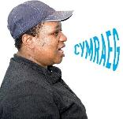
Question 7

How could the plans be changed to make sure there are more chances to use the Welsh language?

Question 8

Do you have anything else to say about these documents?

Hard words

Code of Practice
A Code of Practice gives rules and advice about the law. It helps the Citizen Voice Body, NHS bodies, local authorities and other partners do what the law tells them to do.

Protected characteristics
Protected characteristics is a term used to describe some groups of people who are sometimes treated unfairly. For example:
- Disabled people
- Men and women
- People from different races or cultures or religions
- People of different ages
- Straight, gay, and lesbian people
- Pregnant women or women with a new baby
- People who are married or have a civil partnership
- Transgender people

Representations
Representations mean speaking about or on behalf of other people. This means telling people what they have found out from listening to others.

