Section 1. What action is the Welsh Government considering and why?
(Please note that this Section will be published)
In narrative form, please describe the issue and the action proposed by the Welsh Government. How have you applied / will you apply the five ways of working in the Well-being of Future Generations (Wales) Act 2015 to the proposed action, throughout the policy and delivery cycle
- Overview
The Welsh Government’s Childcare, Play and Early Years Workforce Plan, launched in 2017, sets out the ambition “to develop a skilled childcare and play workforce, which is highly regarded as a profession and a career of choice and recognised for the vital role the sector plays in supporting our children’s development”.
A long-term ambition of the plan is to explore the introduction of professional registration for the childcare and playwork workforce.
Professional registration is widely considered to raise the status and perception of a workforce and thus encourage individuals to enter, develop and stay in a sector.
The overarching intention in seeking to establish a professional register would be to showcase and drive quality of provision; to ‘professionalise’ the sector through membership of a workforce register and provide assurance to families that practitioners adhere to a code of conduct.
Our ambition therefore is rooted in the understanding that a register will establish the workforce as a profession and boost its perception with the public.
- Progressing our ambition
In 2022, the Welsh Government commissioned an Independent Review focused on the professional registration of the Childcare Play and Early Years (CPEY) workforce.
The review report found that although there was an overall “agreement in principle with the establishment of a CPEY registry” it was unable to be conclusive on a number of key elements regarding registration and so further work would be required to more fully develop Welsh Government principles for a register and to test these with the wider sector via a consultation.
A working group was established in September 2022 with the following objectives:
- To develop a shared understanding of what the purpose of registration is
- To support Welsh Government in the development of proposals for a childcare and play register
- To support Welsh Government in the development of a childcare and play sector consultation on registration as well as to raise awareness of the consultation and encourage the sector to respond

- Consultation
To progress our ambition for a professionally registered workforce, we have worked closely with the professional registration working group to develop a set of draft principles for the workforce register. The consultation will ask fundamental questions regarding a register- it will explore whether a professional register would be of benefit to the workforce at this time, which parts of the sector the proposed register would affect and provide insight into what being on a register would mean for practitioners and employers and the benefits we feel it could bring to the sector. This will be a public consultation which will seek responses from those working across the sector in both registered and unregistered settings. Potential positive and negative impacts will be actively sought.
- Benefits

Some of the benefits of professional registration identified so far include:

For the workforce
- Professional identity and status
- Access to ongoing professional development
- Job satisfaction/motivation
- Value/recognition

For families accessing childcare provision
- Reassurance via safeguarding focus/fitness to practice process
- Affirming that it is a safe, competent, and qualified workforce that can be trusted to support their children.
- Raise the status of the workforce - not just babysitting.

For employers
- Reassurance that those on the registry fulfil requirements/adhere to a code of conduct.
- A registry would be a central point to log documents and checks such as qualifications, training certificates, DBS certificates, references etc. to allow for easier movement between settings.

For Welsh Government
- An opportunity to demonstrate value and appreciation of the sector.
- Improve visibility of the workforce
- Enhance attractiveness of working in the sector
- A mechanism for monitoring, measuring and reaching the workforce.
- Impact
The benefits set out above detail the positive impacts of professional registration for the workforce, employers, Welsh Government and parents/carers and would aim to support the sustainability of the workforce.
The proposal to move to register the childcare and playwork workforce will provide the sector with a more professional status akin to health, social care and education workforces, offering recognition and support for continuing professional development (CPD) and a place to store all work-related records (DBS checks, qualification and training info) in one accessible place.
It is anticipated that the register would also realise positive impacts for the quality of care due to its proposed clear links to a skilled and qualified workforce committed to ongoing professional development.
A workforce registry would allow for the collection of accurate and specific statistics which would allow officials to spot trends, identify emerging/changing markets to support workforce planning. This would feed into better decision making and enable better policy decisions, whilst allowing for targeted support for the sector.
Potential negative impacts include:
The consultation exercise would not incur a cost for those asked to respond however, the proposal to move to professional registration would involve significant cost in the long term both in terms of financial implications for the establishment and ongoing work programme of a registering body as well as costs for eligible individuals to register and renew.
Childcare and playwork workers therefore would likely incur a cost should the consultation find that a register should be developed, as they would need to pay registration and renewal fees . These would likely be based on fees for similar workforce registers and be tiered depending on job role. However, as a low paid workforce this could have a negative socio- economic impact and could also potentially discourage entry into and retention within the sector. On balance the cost to an individual to respond to the consultation outweighs the overall cost if the proposal were to proceed, therefore we believe these costs are negligble. The introduction of a workforce register may make the sector less attractive to those who may be put off by further administrative burden or the possibility of a fitness to practice process which could mean they are no longer able to work in the sector.
If the consultation finds that a professional register should not be established at this time, this would impact our understanding of the workforce as data pertinent to a workforce registry would not be collected.
- Five Ways of Working
The proposal has already seen significant engagement with sector representative bodies via the Independent review on professional registration of the childcare play and early years workforce and the professional registration working group. The consultation will seek to engage with all those in the childcare and playwork sector to seek their views on professional registration and act on their responses. Representative groups will be holding engagement events to raise awareness and garner views with the workforce. If appropriate further consultations will be undertaken. Professional registration seeks to include and support eligible practitioners working in the registered childcare and playwork sector and bring benefits to the workforce and children and families in the long term.
The proposal recognises that professional registration will provide greater reassurance to both employers and parents and that the ongoing development of the childcare and play workforce will mean that the sector is able to best support children and their families so they can fully meet their potential. In line with other sectors, professional registration of the childcare and playwork workforce would include adherence to clear codes of conduct and fitness to practice procedures – this would mean that the workforce and employers will be equipped to further protect children from harm and thus prevent negative experiences.
Officials have engaged and sought involvement from key stakeholders who are part of the professional registration working group including Play Wales, Clybiau Plant Cymru Kids’ Clubs, the Education Workforce Council, Social Care Wales and Unions in developing consultation questions. There has also been engagement with those with responsibility for registering the childcare workforce in Scotland. This means that learning has been taken from the experiences of others who have already developed a workforce register for the childcare and playwork workforce. Consultation questions will be informed and enriched by expert knowledge and experience. In general, there is support for professional registration of the sector from key sector stakeholder bodies at the current time.
In proposing professional registration, there is a recognition that work to support the sector would continue in a collaborative way with the body charged with hosting the registry working closely with sector umbrella bodies in its development and ongoing functioning.
As other similar sectors are already subject to professional registration processes, this supports our ambitions to address inequality in the future and bring the sector more in line with similar professions. The proposal will help in the recognition of childcare and playwork as a profession and supporting practitioners with their ongoing professional development.
Investment in the professionalisation of staff for the benefit of future generations will thus contribute towards realising the well-being goal relating to creating a sustainable foundation for future generations to build on and will also work towards the well-being goals relating to a prosperous and a more equal Wales.

Section 8. Conclusion
(Please note that this section will be published)
  - How have people most likely to be affected by the proposal been involved in developing it?
Following publication of the Independent Review on professional registration of the childcare and playwork workforce in July 2022, a professional registration working group was established in response to its recommendations. The group comprising key sector stakeholders has been instrumental in assisting the development of key principles for a workforce register and advising of potential issues.
The Welsh Government will use its digital channels and existing networks to raise awareness of the consultation and to engage a diverse range of people. This will include registered and unregistered childcare and play work providers, key stakeholder bodies, local authorities and those which represent the interests of children in Wales, as well as The Children’s Commissioner, Future Generations Commissioner and the Welsh Language Commissioner. The Care Inspectorate Wales, Social Care Wales, Cwlwm, Play Wales and other members of the professional registration working group will support the consultation process, ensuring it is publicised with childcare and play work providers across the sector and encourage them to respond. The next steps in relation to professional registration of the workforce will be informed by feedback received from the consultation. If the consultation finds that a workforce register should be established, then a further consultation will take place to help shape the detail of the register.
8.2 What are the most significant impacts, positive and negative?
A number of potential benefits of professional registration have been identified for the public, employers, the workforce and Welsh Government. For example, it makes clear that the workforce is a profession like teachers, social care workers and nurses with eligibility criteria, renewal requirements and a code of professional practice; It provides assurance and confidence that the workforce has the skills, knowledge, and character to care for children safely and effectively; promotes understanding of the workforce and the vital role it plays. A workforce register can also provide accurate and reliable data about the workforce which would help develop a better understanding of its make-up, professional development, and employment needs. In time, if we move to a workforce register for the sector then potential positive impacts would include recognition that this is a skilled and highly valued workforce; reassurance for parents who use the service and a means of ensuring policy proposals are developed appropriately. The consultation on professional registration will ensure we are responding to the recommendations of the independent review. By consulting widely with those who manage or work in childcare and playwork settings we will ensure that we gather their views on workforce registration and raise awareness of what a register may entail. This will have a positive impact as we are ensuring that those most affected by the principles will be able to affect what happens next including whether a workforce register is developed. The consultation will also seek to identify/understand any negative impacts of the proposal with registration costs and fitness for practice processes anticipated as a potential concern and a potential negative impact for providers at this time. In terms of negative impacts, this may include additional administrative burden particularly at the birth of a register and ongoing fees to join and remain on the register.
8.3 In light of the impacts identified, how will the proposal:
- maximise contribution to our well-being objectives and the seven well-being goals; and/or,
- avoid, reduce or mitigate any negative impacts?
The proposal for a professional register outlined above will play an important part in supporting the general principle of the Well-Being of Future Generations (Wales) Act 2015, which is about making positive interventions now, to benefit people living their lives in Wales in the future.
The proposal contributes towards the Act’s Well-being goals:
- A prosperous Wales
  - Supports the sustainability of the childcare and playwork sectors as a key part of the foundational economy.

- A healthier Wales
  - Access to high quality safe and secure childcare and play improves children’s physical and mental health and well-being.
  - Childcare and play settings provide children with access to qualified childcare workers who can support their play.

- A more equal Wales
  - Ensures that all children can access quality provision, helping to reduce the gap between the least and most deprived in our communities.
  - High quality childcare provision can have a positive influence on a child’s development and help them develop to their full potential. Evidence suggests children from disadvantaged backgrounds benefit more from quality childcare and that it can help redress both developmental disadvantages and the attainment gap.

8.4 How will the impact of the proposal be monitored and evaluated as it progresses and when it concludes?
Responses received in response to the consultation will be considered in determining the next steps for the professional registration of the workforce. If it is determined that a professional workforce register is to be developed, there will be an opportunity for the childcare and playwork sector to shape the specifics of that register via a further consultation which will seek feedback on the detail of a workforce register.

Children’s Rights Impact Assessment
All completed Children’s Rights Impact Assessments must be sent to the CRIA@gov.wales mailbox
The Rights of Children and Young Persons (Wales) Measure 2011 places a duty on the Welsh Ministers to pay due regard to the United Nations Convention on the Rights of the Child (UNCRC) and its Optional Protocols when exercising any of their functions.
The CRIA process is the agreed mechanism officials should use to support Ministers to meet this duty and ensure they give balanced consideration to children’s rights in their decision making. A CRIA should be used to inform ministerial advice and must be completed prior to a ministerial decision being made. Once a decision has been reached, your CRIA must also be published.
Please note we have an established Children’s Rights Advisory Group (CRAG), comprising the Children’s Commissioner for Wales’s office, UNICEF, the Wales Observatory on Human Rights of Children and Young People, and Children in Wales, who can be used to discuss or test your draft CRIA. Please contact the Children’s Branch CRIA@gov.wales for further information.
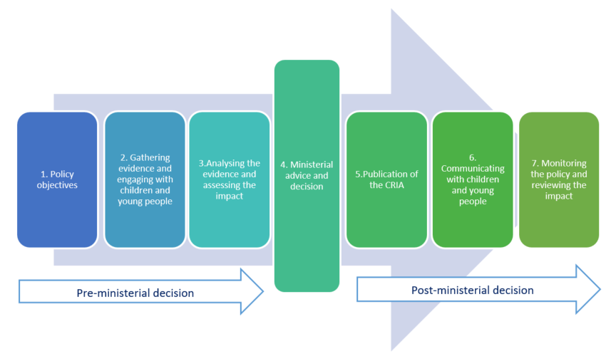
For further advice and guidance on the CRIA process, please consult the Children’s Rights Manual for Staff or contact the Children’s Branch CRIA@gov.wales

- Policy objectives

- What decision are you impact assessing?
The proposal is concerned in its initial stage with a full consultation on mandatory professional registration of the registered childcare and playwork workforce. This consultation will ask those managing or working in registered childcare and playwork settings if there should be a workforce register for the childcare and playwork workforce.
- Gathering evidence and engaging with children and young People

- What existing research and data on children and young people is available to inform your specific policy? Your policy objective may impact on other policy areas – discussions with other policy teams will be an important part of the impact assessment process ensuring you have gathered a range of information and evidence.

- Using this research, how do you anticipate your policy will affect different groups of children and young people, both positively and negatively? Please remember policies focused on adults can impact children and young people too.

- What participatory work with children and young people have you used to inform your policy? If you have not engaged with children and young people, please explain why.
For advice on participatory work with children and young people, please contact the Children’s Branch. We have an established relationship with Children in Wales, who may be able to help you work with children and young people through their Young Wales programme.
The childcare and playwork workforce provide a vital function in our society, offering key social, economic and educational benefits to children and families and meeting multiple policy agendas. These include providing the foundation to a child’s development and learning, including early intervention for language needs or special needs; supporting parental employment; contributing to family wellbeing; and addressing wider social issues such as equality, inclusion, social mobility and social cohesion.
We want children from all backgrounds across Wales to have the best start in life. Those who care for our children play a vital role in helping us achieve this vision set out in our 10-year childcare play and early year’s workforce plan - to support and develop a highly skilled workforce regarded as a profession and career of choice.
Skilled, supported and well-qualified practitioners are a key element of high-quality childcare and playwork and make a proven difference to child learning and development, particularly for children from low income and at-risk families.
All children have the right to play. The evidence shows that access to high quality childcare and play is beneficial for all children in their early years. It can play a significant role in addressing the attainment gap, in developing their social skills and supporting children in preparing for school. Any move backwards in relation to supporting the development of the workforce will, therefore, could have impacts on child development.
Typically, workforce registers set out the qualification and ongoing professional development requirements for workers acknowledging the clear links between a qualified workforce and high-quality provision. This will enable those who access this provision to better recognise and acknowledge the quality provision which is offered. The aim of introducing a workforce register would be to formalise the professionalisation of the workforce and seek to strengthen the status and visibility of the workforce.
Children and young people have not been directly involved in the proposal at this stage because their experiences of childcare and playwork will be unaffected by a consultation with the workforce on whether a workforce register should be introduced. However, if the consultation finds that a workforce register should be established then there will be a need to further consider potential impacts of the register on both the workforce and on children as direct beneficiaries in the longer term. The proposal aims, in the long term to lead to a professional registered workforce to support and nurture children and to increase the appeal of working in the sector. However, at this point, the decision on whether to proceed with a workforce register will fall to the childcare and playwork workforce. It is for the workforce to contribute to the decision-making process as to whether they feel a workforce register should be established based on an understanding of what a register is and what it will mean for them in the future. At this stage, children are not being consulted as they could not influence the decision on whether there should be a workforce register for the childcare and playwork sector.
The intended outcome of the proposal at this point is to gather the views of the workforce which is focused on – the development of a professional, highly skilled and valued workforce.

This Children’s Rights Impact Assessment will be updated following the outcome of the consultation. If it is decided that we should proceed with a workforce register, then a further consultation on the specifics of a register will take place. It is likely that at that stage, additional impacts will be identified and there would be a need to engage widely with those working in and accessing childcare and playwork settings, including children and young people.

- Analysing the evidence and assessing the impact

- Using the evidence you have gathered, what impact is your policy likely to have on children and young people? What steps will you take to mitigate and/or reduce any negative effects?

- How does your proposal enhance or challenge children’s rights, as stipulated by the UNCRC articles and its Optional Protocols? Please refer to the articles to see which ones apply to your own policy.
UNCRC Articles or Optional Protocol | Enhances (X) | Challenges (X) | Explanation
Article 3 All organisations concerned with children should work towards what is best for each child.  Article 6 All children have the right of life. Governments should ensure that children survive and develop healthily  Article 19 Governments should ensure that children are properly cared for, and protect them from violence, abuse and neglect by their parents or anyone else who looks after them.  Article 28  Children have a right to an education. Discipline in schools should respect children’s human dignity. Primary education should be free. Wealthy countries should help poorer countries achieve this. |  |  | If a workforce register is established we will set out the proposed requirements for entry onto the professional register for eligible members of the registered childcare and playwork workforce. Both required qualifications and ongoing learning will continue their clear focus on a child centred approach. These requirements are already set out in the National Minimum Standards for regulated childcare.  If establishment of a workforce register is not supported, then we will continue with our commitment to the development of a qualified high quality workforce.  If a workforce register is established, this will formalise the professionalisation of a highly skilled and qualified workforce and their ongoing learning. This would include a focus on safeguarding, for example, to help to ensure that children are cared for in a safe, secure and appropriate environment. Safeguarding requirements are already set out in the National Minimum Standards for regulated childcare  If a workforce register is established it is likely that there will be a requirement to undertake ongoing professional development which will ensure all practitioners across Wales have access to learning opportunities/training know how to care and protect children from violence, abuse and neglect and can report via the register on these areas of learning.  If a workforce register is established then it would seek to outline and enhance professional learning for the workforce.  If establishment of a workforce register is not supported, CPD opportunities will continue to be offered via bodies such as Cwlwm, Play Wales and Social Care Wales.  Both these approaches are supportive of the rights of the child.

- Consider whether any EU Citizens Rights (as referenced in the Equality Impact Assessment) relate to young people up to the age of 18.

For further information on the UNCRC and its Optional Protocols, please visit the Children’s Rights Intranet Page.
- Ministerial advice and decision

- How will your analysis of these impacts inform your ministerial advice?

- Once completed, your CRIA must be signed off by your Deputy Director.

- Your CRIA findings should be integrated into your ministerial advice to inform their decision.

The analysis of the impacts will be included in future advice to the Minister- it will set out the benefits/impacts identified to date and those gathered through the consultation process. Our ambition for a professional registered workforce is centred on the understanding that the implementation of professional registration should in the long term have a positive impact on children and young people’s childcare and playwork provision.
This Children’s Rights Impact Assessment will be updated following the outcome of the consultation with members of the workforce. If it is decided that we should proceed with a workforce register, then a further consultation on the specifics of a register will take place. It is likely that at that stage, additional impacts will be identified and there would be a need to engage widely with those working in and accessing childcare and playwork settings.

- Publication of the CRIA
- Following the ministerial decision, the CRIA should be published on the Welsh Government website.
- Send sections 1 and 8 of your IIA and the CRIA (Annex A) to your departmental web manager for publishing.
- All completed CRIAs must also be sent to the CRIA@gov.wales mailbox.
For further information and support on this process, please visit the Children’s Rights Intranet Page which contains a range of resources.

- Communicating with Children and Young People

- If you have sought children and young people’s views on your proposal, how will you inform them of the outcome?
We have not sought the view of children and young people at this stage as this consultation is predominantly focused on engaging with the workforce in relation to the formal professionalisation of the childcare and playwork sector. Whilst others with an interest may choose to comment, the primary audience is those working in the fields of childcare and playwork.
If your policy affects children and young people, remember to produce child-friendly versions of any public document relating to your proposal. Please contact the Children’s Branch for further advice.

- Monitoring and Review
It is essential to revisit your CRIAs to identify whether the impacts that you originally identified came to fruition, and whether there were any unintended consequences.
Where you are taking forward secondary legislation, it will not be sufficient to rely on the CRIA for the primary legislation; you will need to update the CRIA to consider how the details of the proposals in the regulations or guidance may affect children.
The policy lead can revisit the published version of their CRIA, rename it as a review of the original CRIA, and update the evidence of impact. The reviewed impact assessment should be presented to Ministers with any proposals to amend the policy, practice or guidance. This review CRIA should also be published.

- Please outline what monitoring and review mechanism you will put in place to review this CRIA.

- Following this review, are there any revisions required to the policy or its implementation?

We will use the findings from the consultation to review this CRIA and will present findings to Ministers outlining possible next steps which may include proposals to proceed or amend the policy direction.

WELSH LANGUAGE IMPACT ASSESSMENT
Cymraeg 2050 is our national strategy for increasing the number of Welsh speakers to a million by 2050.
The Welsh Government is fully committed to the new strategy, with the target of a million speakers included in its Programme for Government. A thriving Welsh language is also included in one of the 7 well-being goals in the Well-being of Future Generations (Wales) Act 2015.
We also have a statutory obligation to fully consider the effects of our work on the Welsh Language. This means that any Welsh Government policy should consider how our policies affect the language and those who speak it.
The Cymraeg 2050 strategy has three interrelated themes:
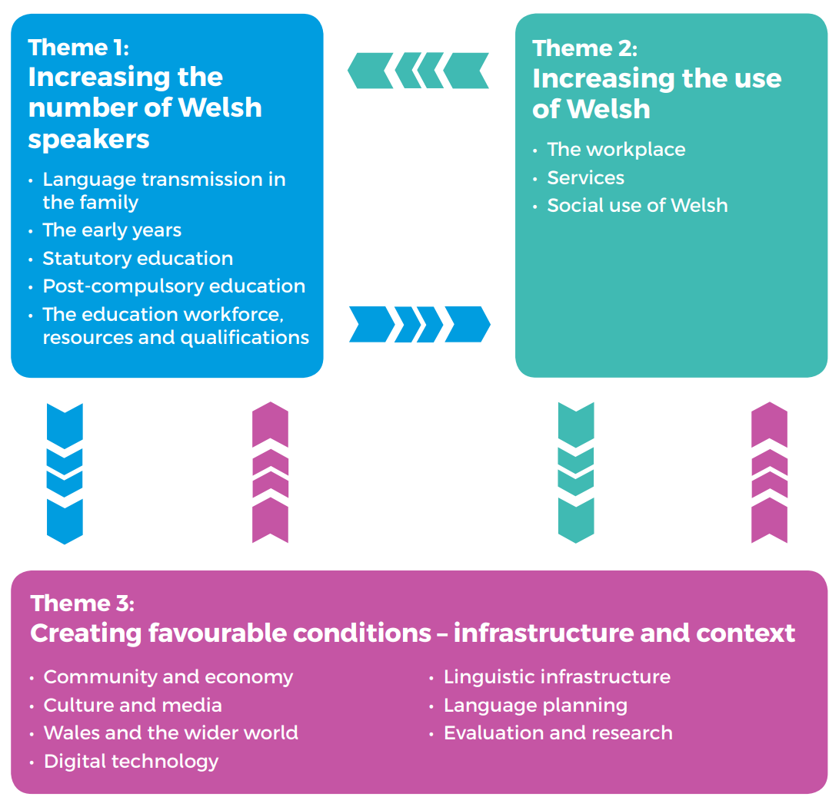
The headings under each theme outline the scope of activities that can affect the language.
As a general rule, if your policy has the potential to impact on people, it will impact in some way on Welsh speakers and therefore on the Welsh language.
- Welsh Language Impact Assessment reference number (06/10/2023)

- Does the proposal demonstrate a clear link with the Welsh Government’s strategy for the Welsh language? – Cymraeg 2050 A million Welsh speakers and the related Work Programme for 2017-2021?
The Welsh Government's vision is to see the Welsh language thrive, with an increase in the number of people who both speak and use the language in their daily lives. Both this strategy and the Well Being of Future Generations (Wales) Act state that the Welsh language is a strategic priority for the Welsh Government.
Cymraeg 2050: A million Welsh speakers, highlights the importance of the early years sector as a point of early entry to immersion education, and to increased demand for Welsh-medium education. This proposal demonstrates a link to theme 2 “increasing the use of Welsh” as it is concerned with professional registration which includes a strong focus on achieving required qualifications and ongoing professional development for those in the childcare and playwork workforce.
Our 10-year workforce plan states:
The workforce plays a key role on supporting children to take their first step towards bilingualism….”
Required qualifications have been designed to enable greater numbers of new entrants and existing practitioners to undertake their training through the medium of Welsh. In addition, other support for CPD is available in both Welsh and English.
The proposal set out in Section 1 is to move further in our ambition for a professionally registered workforce. The consultation will seek views on the professional registration of the workforce. If we proceed with establishing a professional register, this will enable us to gather data about the workforce, their language status, and aspirations. It will enable us to focus our policy ambitions more clearly for the development of a workforce that can support Welsh speakers of the future.

- Describe and explain the impact of the proposal on the Welsh language, and explain how you will address these impacts in order to improve outcomes for the Welsh language. How will the proposal affect Welsh speakers of all ages (both positive and/or adverse effects)? You should note your responses to the following in your answer to this question, along with any other relevant information:
- How will the proposal affect the sustainability of Welsh speaking communities (both positive and/or adverse effects)?
- How will the proposal affect Welsh medium education and Welsh learners of all ages, including adults (both positive and/or adverse effects)?
- How will the proposal affect services available in Welsh (both positive and/or adverse effects)? (e.g. health and social services, transport, housing, digital, youth, infrastructure, environment, local government etc.)
- How will you ensure that people know about services that are available in Welsh and are able to access and use them as easily as they can in English? What evidence / data have you used to inform your assessment, including evidence from Welsh speakers or Welsh language interest groups?
- What other evidence would help you to conduct a better assessment?
- How will you know if your policy is a success?
Our proposal for professional registration has a long-term vision of supporting and developing staff across all settings - individuals working in childcare and play settings across Wales have an increasing role to play in providing opportunities for children to learn and use Welsh.
The consultation seeks to recognise and value the views of those who engage in the consultation process.
The Welsh Government’s Programme for Government and Cooperation Agreement commitments regarding expanding childcare provision to all 2-year-olds in Wales, as well as the commitment to grow Welsh-medium provision, depend on the sector being sustainable; on there being a sufficiently sized and qualified workforce. A professional register would enable a better understanding of workforce numbers and make-up and set out requirements for entering and remaining on the register. This will include CPD support for those working across the sector, potentially including information on Welsh Language courses or courses through the medium of Welsh.
Support for those working in Welsh medium settings will also support Welsh medium education as children who attend Welsh medium childcare are more likely to progress to Welsh medium schools than those attending English medium provision.

Independent Review: Registration of the Childcare, Play and Early Years Workforce in Wales (gov.wales)
Membership includes Cwlwm, Social Care Wales, Education Workforce Council, Play Wales, Local Authorities, Scottish Social Services Council, WLGA, Unison and Voice Unions
What is registration? | Social Care Wales
Professional Registration working group
FGCW_Equalities-Report_E-UPDATED.pdf (futuregenerations.wales)
Membership includes Cwlwm, Social Care Wales, Education Workforce Council, Play Wales, Local Authorities, Scottish Social Services Council, WLGA, Unison and Voice Unions
You may, for instance, consider how your policy would affect the following groups of children and young people differently: early years, primary, secondary, young adults; children with additional learning needs; disabled children; children living in poverty; Black, Asian and minority ethnic children; Gypsies, Roma and Travellers; migrants; asylum seekers; refugees; Welsh-language speakers; care experienced children; LGBTQ+ children. Please note that this is a non-exhaustive list and within these cohorts there will not be one homogenous experience.
Article 12 of the UNCRC stipulates that children have a right to express their views, particularly when adults are making decisions that affect them, and to have their opinions taken into account.
Early-Years-Impact-Brief.pdf (suttontrust.com)
Childcare, play and early years workforce plan | GOV.WALES
Early Years Workforce Review - Sutton Trust
https://www.eif.org.uk/blog/early-years-education-what-does-high-quality-provision-look-like
These can be close-knit rural communities, dispersed social networks in urban settings, and in virtual communities reaching across geographical spaces.
The Welsh Language Strategy aims to increase the range of services offered to Welsh speakers, and to see an increase in use of Welsh-language services.

