Bathing Water Designation 2026: Consultation Response Form
Your name:

Organisation (if applicable):

email / telephone number:

Your address:

Responses to the consultation may be published. Your response will be anonymous.

However, if you would like your name to be published alongside your response, please tick the box.
I agree to my name being published alongside my response to this consultation.☐
Request to identify Fontygary Bay, Rhoose, Vale of Glamorgan as a bathing water
We have received a request from a member of the public for Fontygary Bay, Rhoose, Vale of Glamorgan (ST 05100 65800) to be considered for designation as a bathing water for the 2026 bathing season.
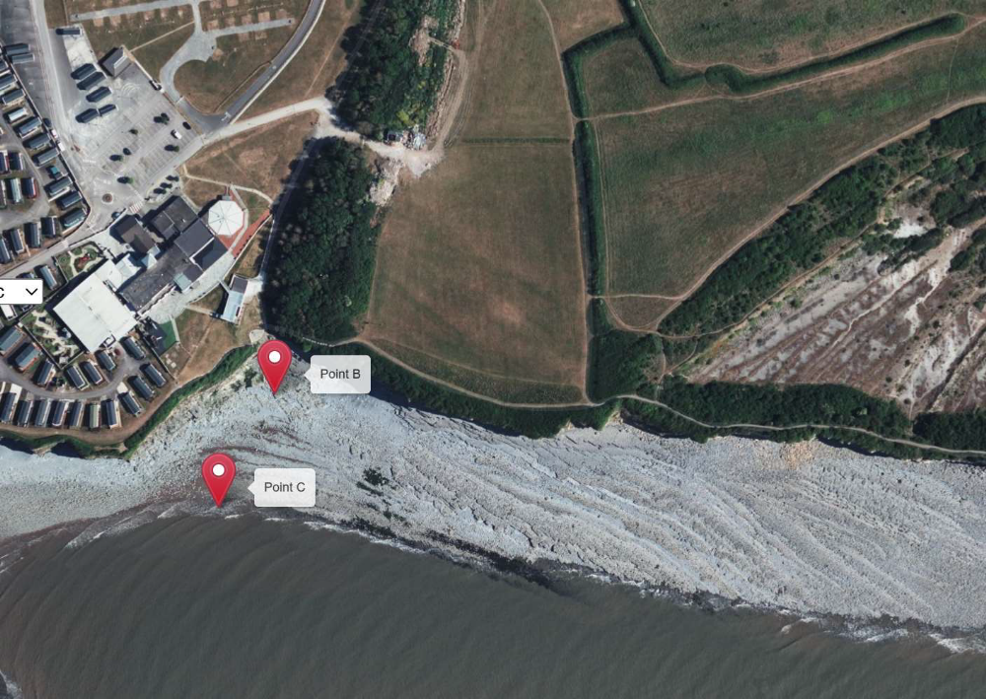
Point B: High tide
Point C: Low tide

Evidence and information provided by the applicant in support of the application for Fontygary Bay.
Bather Numbers - The application provided a bathing water survey for Fontygary Bay, which was compiled by the applicant. The application included a user survey, which provided data on bather numbers and recorded a total of 2162 bathers across 31 days. In excess of 100 daily bathers were recorded on 9 separate days with a daily average of 70 bathers.
The survey data was compiled by the applicant over the bathing season (May 15 to September 30).
Facilities – The application provided information regarding facilities at or nearby the site, including, public toilets, café and parking.
Evidence of support – Evidence was provided on local consultation and support for the proposed designation from individuals and local groups.

Question 1: Do you agree or disagree with our proposal to designate Fontygary Bay as a bathing water for the 2026 bathing season?
☐ Agree
☐ Disagree

Question 2: Do you agree the evidence presented in the consultation covering bather numbers, facilities and community support is accurate and provides a sufficient basis for designating this site as a bathing water for the 2026 season? If you disagree, please explain why and include supporting evidence in your response to Question 3.
☐ Agree
☐ Disagree

Question 3: What evidence and measures have you observed that identify and promote bathing at the site? (e.g., number of bathers, signage, website, social media, etc.). If you disagree with the evidence presented in the consultation, please explain why and include any supporting evidence.
Please provide evidence and measures you have seen taken to promote bathing at the site here. If you disagree with the evidence presented in the consultation, please explain why and include any supporting evidence.

Question 4: What is your view on the proposal, and what is the reasoning behind your opinion?

Please enter here.

Question 5: A number of specific questions have been asked. If you have any related issues which have not been specifically addressed, please use this space to identify them:
Please provide your view on the proposal.

Please enter here.

Views on Bathing water season national extension 2026

Following changes to the Bathing Water Regulations in 2025, the Welsh Government now has the power to set both national and site-specific bathing seasons.

The current bathing season runs from 15 May to 30 September each year.

We’re inviting views on our proposal to extend the national bathing season in Wales. Under this proposal the season would start two weeks earlier and run from 1 May to 30 September, beginning in 2026. This change is based on available information and past applications which suggest that May is potentially as busy for bathers as June and September. Currently limiting monitoring to mid-May onwards risks missing early-season pressures and leaves bathers without the same protections applied later in the season. By covering the entire month including the Early May Bank Holiday rather than starting mid-way through, we can provide a complete and representative picture of water quality, strengthen public health safeguards, and give communities confidence that standards apply consistently throughout this period.

This is a modest but meaningful step that aligns regulation with a full calendar month of sampling and oversight, rather than partial coverage that could overlook early-season activity. It ensures bathers during this time receive protections at the same standards applied later in the season, improving fairness and consistency across the bathing season. It also provides a longer timeframe for conducting bather number surveys to support new bathing water designation applications.

We recognise that not all bathing waters are used in the same way or for the same length of time. Alongside the proposed change to the national bathing season, we will continue to develop a robust, evidence-based approach for site-specific bathing seasons. This work may also lead to a review of the national season to ensure it reflects patterns of use and meets the needs of bathers across Wales. To support this, we plan to seek more detailed public views in 2026.

Question 6: Do you agree with the proposal to extend the national bathing season in Wales by two weeks, changing the dates from 15 May - 30 September to 1 May - 30 September?
☐ Yes
☐ No
☐ Unsure
Please explain your answer

Welsh Language

Question 7: We would like to know your views on the potential effects of the proposals on the Welsh language, particularly regarding opportunities for people to use Welsh and ensuring the language is treated no less favourably than English.

What effects do you anticipate, and how might these proposals be adjusted to enhance positive effects or mitigate any negative ones on the Welsh language?
Please enter here.

Next steps following the consultation

All the responses to this consultation will be analysed and considered and the Welsh Government will publish a summary of responses.

