<Insert local authority logo>
<Insert local authority logo>
<Insert local authority logo>
<Insert local authority logo>

What do you think about your care and support?
<Insert name of carer>
<Insert address of carer: line 1>
<Insert address line 2>
<Insert address line 3>
<Insert address line 4>


We are writing to you because you have had help from social services.



We want you to help us make the support better.


How you can help us


Please answer the questions we have sent you.



The questions are about how your support has helped you have a good life.


We want to know what you think. Not what the person you care for thinks. We will ask them separately.

We have sent an addressed envelope with the questions. It does not need a stamp.


When you have answered the questions please send them back in the envelope.

Send it back by <insert date>.



Who will know I helped?

Answering the questions will not affect the care and support you may get now or in the future.

We will make sure that you are not asked to answer the questions again if you have already answered them.

We will send everyone’s answers to the Welsh Government but we won’t tell them which answers are yours.

You may need support to answer the questions. That is fine.


Or ask someone to write for you. That is fine.


How can I answer the questions?

You may want to answer the questions:

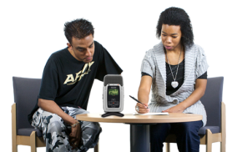
- on the internet

- with a person talking to you
- over the phone



Please phone <insert number> if you would like to do one of these.


Thank you for helping us.

<insert printed name of Director of Social Services with photo if possible>
<insert title of Director of Social Services>

