[Insert local authority logo here]
[Insert local authority logo here]
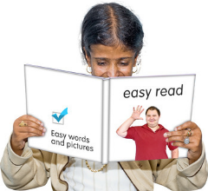  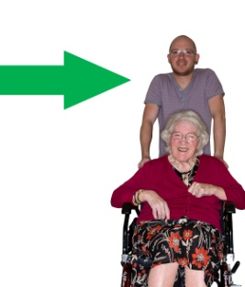  ✓  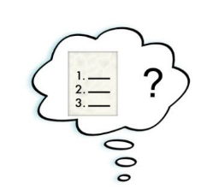  …………………..  ………………….. | This is an easy read version. The words and their meaning are easy to read and understand.  Some words may be difficult to understand. These are in bold blue writing and have been explained in a box beneath the word.  It is your own views we want to hear about and not the views of someone you care for. We will ask them separately.  The form will take about 10 minutes to fill in.  - Please tick one circle for each question.  - If a question does not apply, please leave it blank.  - If you make a mistake or change your mind, please cross it out and put in the right answer.  - If you want to, please add any comments below your answers.  - Please use more paper if you would like to say more.

Thinking about your life now, do you agree that:

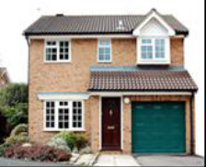 | - I live in a home that best supports my well-being  Well-being means a person is happy, healthy and is comfortable with their life and what they do.  ⃝ Yes  ⃝ Sometimes  ⃝ No  ⃝ Don’t know  Please add any comments if you would like to  ……………………………………………………………………………  ……………………………………………………………………………
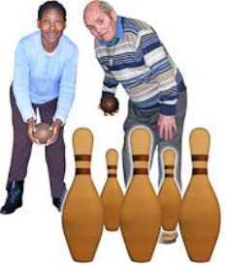 | 2. I can do the things I like to do  ⃝ Yes  ⃝ Sometimes  ⃝ No  ⃝ Don’t know  Please add any comments if you would like to  ………………………………………………………………………..  …………………………………………………………………………  Please carry on over the page…..

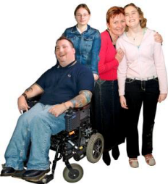 | 3. I feel I belong in the area where I live  ⃝ Yes  ⃝ Sometimes  ⃝ No  ⃝ Don’t know  Please add any comments if you would like to  …………………………………………………………………………..  …………………………………………………………………………...
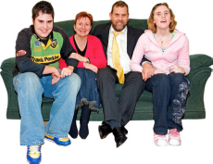 | 4. I am happy with the people around me  ⃝ Yes  ⃝ Sometimes  ⃝ No  ⃝ Don’t know  Please add any comments if you would like to  ……………………………………………………………………………  ……………………………………………………………………………  Please carry on over the page…..

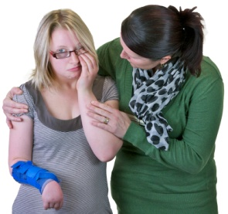 | 5. I feel safe. For example, safe from any kind of abuse, or from falling both inside and outside your home  Abuse is when someone hurts you or treats you badly.  ⃝ Yes  ⃝ Sometimes  ⃝ No  ⃝ Don’t know  Please add any comments if you would like to  ……………………………………………………………………………  ……………………………………………………………………………
Thinking about you and the support you have had, do you agree that…

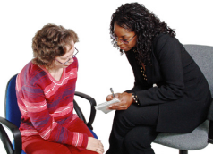 | 6. I know who to speak to about my support  ⃝ Yes  ⃝ Sometimes  ⃝ No  ⃝ Don’t know  Please add any comments if you would like to  ……………………………………………………………………………  ……………………………………………………………………………  Please carry on over the page…..
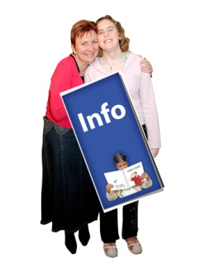 | 7. I have had the right information or advice when I needed it  ⃝ Yes  ⃝ Sometimes  ⃝ No  ⃝ Don’t know  Please add any comments if you would like to  ……………………………………………………………………………  ……………………………………………………………………………
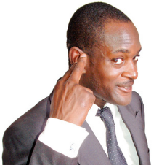 | 8. My views about my support have been listened to  ⃝ Yes  ⃝ Sometimes  ⃝ No  ⃝ Don’t know  Please add any comments if you would like to  ……………………………………………………………………………  ……………………………………………………………………………
 | Please carry on over the page…..

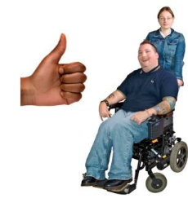 | 9. People have listened to my views about the care and support for the person I care for  ⃝ Yes  ⃝ Sometimes  ⃝ No  ⃝ Don’t know  Please add any comments if you would like to  ……………………………………………………………………………  ……………………………………………………………………………
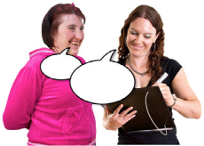 | 10. I was able to use my own language. For example, using English, Welsh, Polish, Bengali or any other language  ⃝ Yes  ⃝ Sometimes  ⃝ No  ⃝ Don’t know  Please add any comments if you would like to  ……………………………………………………………………………  ……………………………………………………………………………
 | Please carry on over the page…..

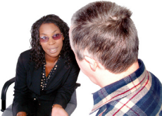 | 11. I was treated with respect  ⃝ Yes  ⃝ Sometimes  ⃝ No  ⃝ Don’t know  Please add any comments if you would like to  ……………………………………………………………………………  ……………………………………………………………………………
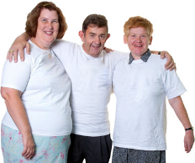 | 12. I feel supported to continue in my caring role  ⃝ Yes  ⃝ Sometimes  ⃝ No  ⃝ Don’t know  Please add any comments if you would like to  ……………………………………………………………………………  ……………………………………………………………………………
 | Please carry on over the page…..

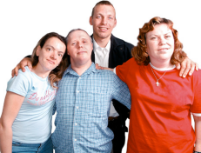 | 13. I am happy with the support I have had  ⃝ Yes  ⃝ Sometimes  ⃝ No  ⃝ Don’t know  Please add any comments if you would like to  ……………………………………………………………………………  ……………………………………………………………………………
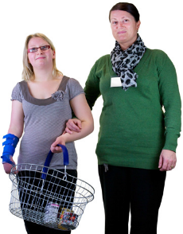 | Please only answer this question if you are aged 18-24 years’ old. All others go to Q15.  14. I have had advice, help and support to prepare me for being an adult  ⃝ Yes  ⃝ Sometimes  ⃝ No  ⃝ Don’t know  Please add any comments if you would like to  ……………………………………………………………………………  ……………………………………………………………………………  Please carry on over the page…..

A little about you…..

   | 15. Are you?  ⃝ Male  ⃝ Female  ⃝ Prefer not to say
16. How old are you?

⃝ 18-24 years old
⃝ 25-64 years old
⃝ 65-84 years old
⃝ 85+ years old

Thank you for your help.

Please post this back to us by [Insert date] using the envelope we gave you.

It will not cost you anything

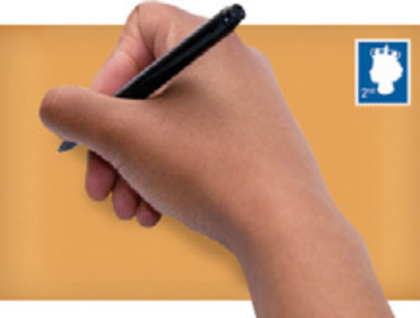

This document was made into easy read using Photosymbols 5.

