© Crown Copyright 2021 ISBN: 978-1-80391-024-6

Appeal Form –

How to Complete Guide

Contents

RPW Online – Home screen 1
Start Application 2
Continue Application / Start Again 3
Introduction 4
Privacy Notice 6
Appeal Detail 7
Errors, Information and Summary 14
Declaration and Undertakings 14
Submit 15
Submission Confirmation 15

RPW Online – Home screen

In RPW Online, click the Home tab as shown in the screenshot to access the Home screen.

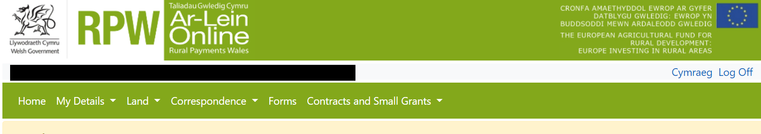

In the Start a Form section at the bottom of the Home screen, click the “Appeal” – link as shown in the screenshot to access the form.

Start Application

This page provides some information prior to starting the form. It includes a Customer Contact Centre link if required, and details of the Customer Details and Online Preferences we hold for you. You should check and amend these before starting your form if they are incorrect. Please note: For any problems with RPW Online you should contact the Customer Contact Centre. For any queries regarding completion of the form, which aren’t answered by this guide, see the Introduction section of this guide, or within the form.

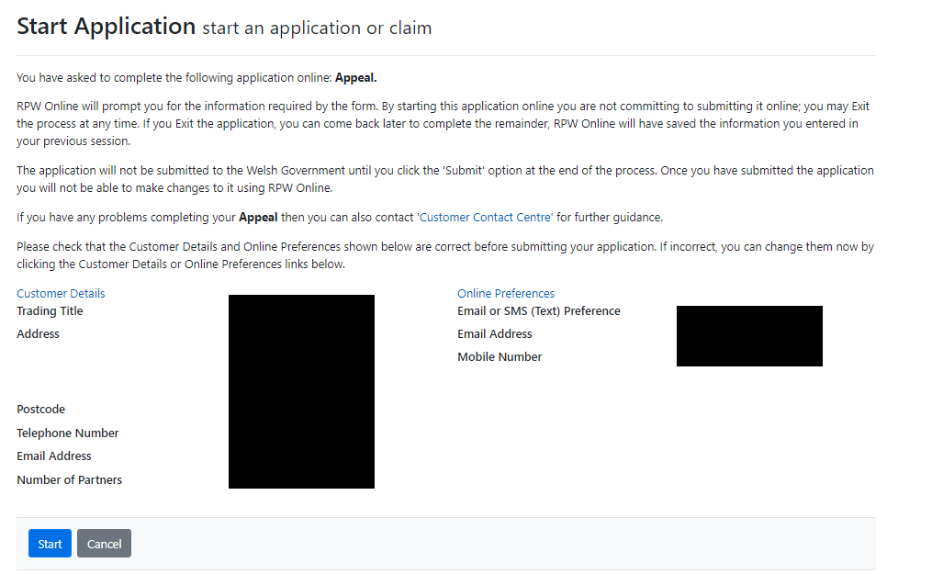

Continue Application / Start Again

Once you start your Appeal form, you have the option to leave it and return to it again. If you are accessing an Appeal form you have started previously, on this screen you will now be able to Continue (blue button at the bottom of the screen), or Start Again by clicking the link shown on this screenshot.

Back to Contents

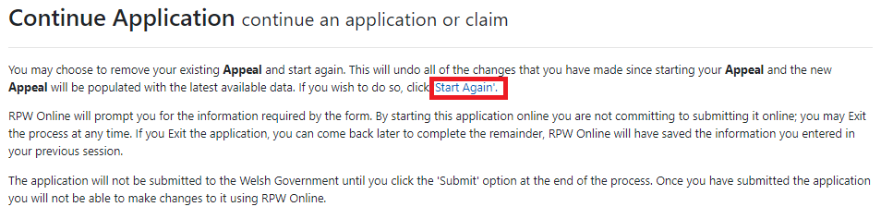

Please be aware – if you choose to Start Again, this will un-set all of the questions you have answered and remove all of the information you have added. If you are sure you wish to Start Again, click Yes or if you do not click No, as shown in this screenshot.

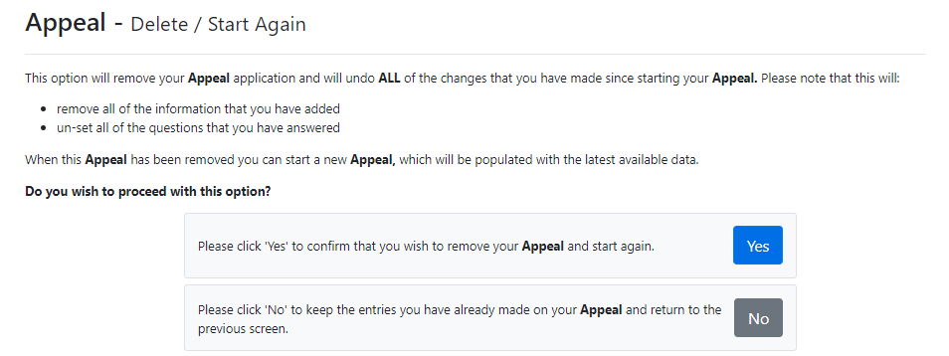

Back to Contents

Introduction
The appeal process is intended to ensure customers who consider officials did not reach the correct decision concerning their subsidy or grant application, have access to an appeal procedure which is fair, simple and affordable. Decisions will be reconsidered to ensure officials have been objective and have applied the rules correctly in reaching their decision.
The process consists of two stages:
- review by officials within the group responsible for administering the scheme and agreed by a senior official

- review by the Independent Appeals Panel (‘the Panel’) which makes recommendations to the Welsh Ministers, who in turn take the final decision which concludes the process.
At each Stage, the facts of the case, the evidence presented and the applicable European and domestic legislation will be reviewed.
There is a link to this How To Complete Guide at the top left, as shown in the screenshot below.

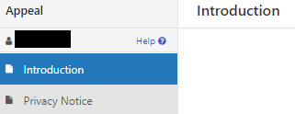

As shown in the screenshots below, on the left the different sections are displayed. A red cross indicates you either have not accessed each section yet, or you have errors on the section(s). A green tick will display once you have completed each section and there are no errors we can identify. There are various navigation buttons at the top and bottom of the form. Also if you wish to switch between English and Welsh there is a button to do so at the bottom left of the screen.

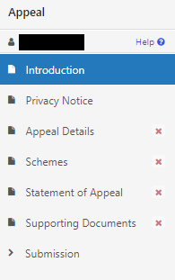

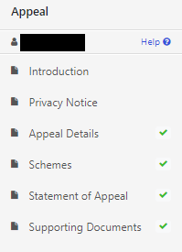

Once you have finished on this section, click Next.

Back to Contents

Privacy Notice

Next you will see the Privacy Notice. Ensure you read the information on this section, which states what the data provided is used for. The link, shown in the screenshot, accesses the Appeal: privacy notice.

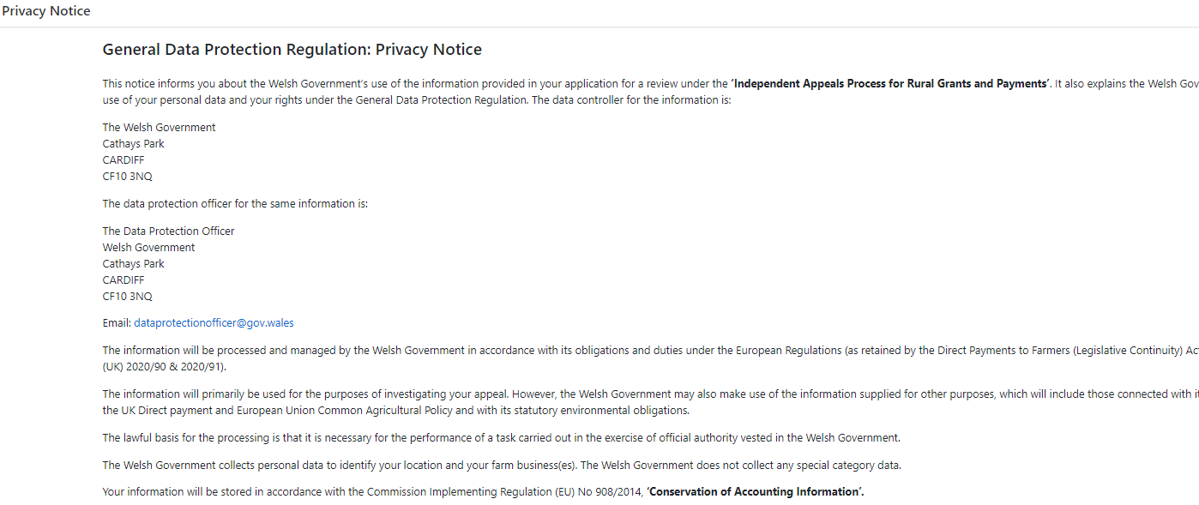

Back to Contents

Appeal Detail

The next section is the Appeal Details section. The first screenshot shows the top part of this section. As it states, “Type of Appeal”.

If your Appeal is Stage 1, you must select Stage 1. Then click next and go to the next stage of the form.

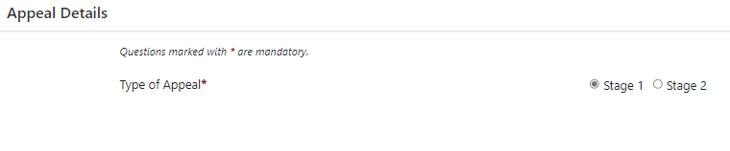

However, if you select “Stage 2”, you must tick to confirm the acceptance “For a Stage 2 appeal a payment of £50 (written hearing) or £100 (oral hearing) is required by the ‘Welsh Government’. As shown in the screenshot below.

The next question for stage 2, you will have to indicate whether you have appointed a representative to work on your behalf for the appeal

If you tick “No” then move onto next question

However, if you tick “Yes” then you must name the representative, as shown in the screenshot below.

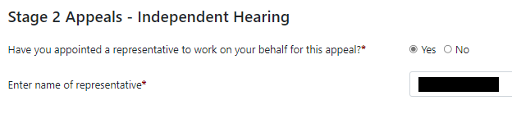

Then select your preferred format of the hearing - Written (£50) or Oral (£100) and select the preferred language for your hearing and go to the next section. However, if you select other, you must state your preferred language. As shown in the screenshot below.

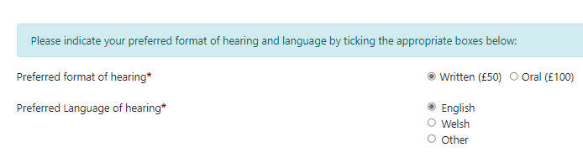

Schemes

In this section you will need to select which scheme(s) type the appeal relates to. Once you select the type of scheme, a list of the schemes will appear further down the page, as shown in the screenshot below.

If you select “any Land- based scheme(s) the schemes will appear as listed below. In this section you can select more than one scheme, however the reason for appeal must be the same. For example, if you have an over-declaration penalty that you wish to appeal and it applies to both Glastir and BPS you select both schemes. However, if you have a scheme breach on Glastir and an over-declaration on BPS, the appeal is not for the same reason and therefore you will need to submit an appeal form for each scheme.

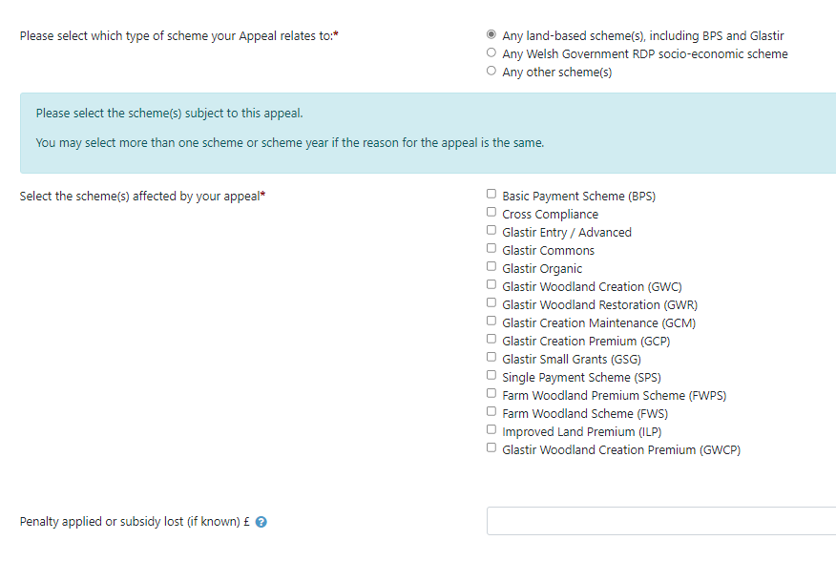
Once you select the scheme(s), for the appeal, a new selection to confirm the scheme year or the window for Glastir Capital Works to which the appeal relates will appear further down the screen for selection. Examples of the year and window selections are shown in the screenshot below.

Select the scheme year(s) and move onto next question.

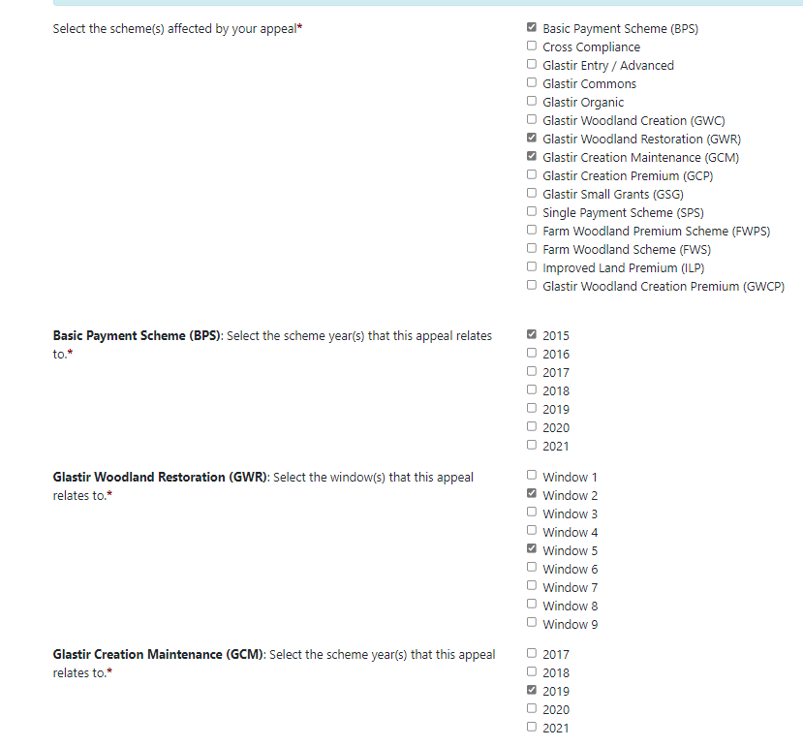

For the older schemes such as Single Payment Scheme (SPS) you must enter the scheme year(s) for which you wish to make the appeal, as shown in the screenshot below.

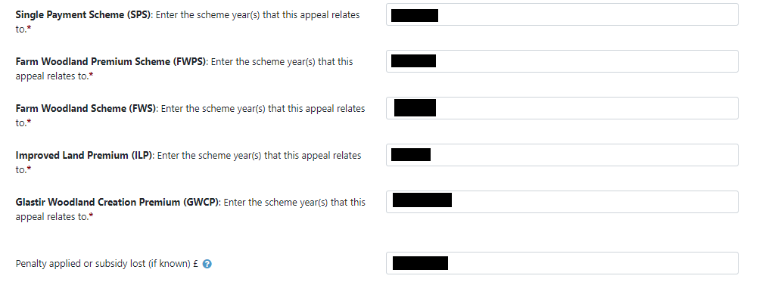

Then insert penalty or subsidy (if known) £ and Next.

If you select “Any Welsh Government RDP Socio-economic schemes”, then select the scheme you wish to appeal and then if applicable, select the EOI it relates and the penalty applied or subsidy lost (if known) and select Next. You can only select one scheme and one window under this section, as shown in the screenshot below. If you wish to appeal under multiple schemes and/or windows you must submit a separate appeals form for each.

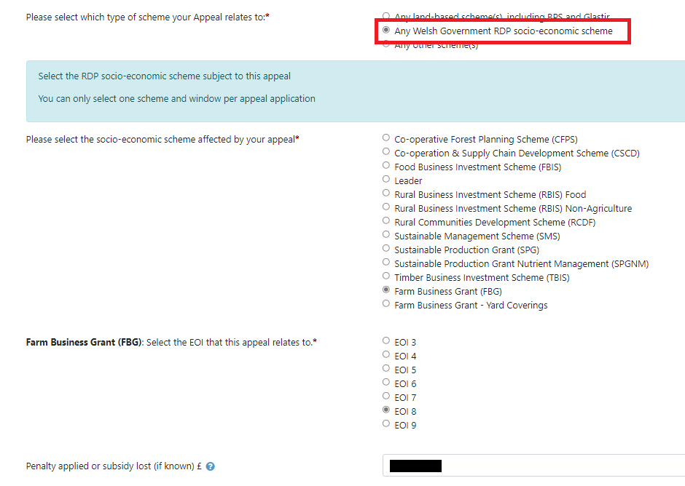

If you select “Any other scheme(s)” you must enter the name(s) of the scheme(s) being appealed. Then enter the penalty applied or subsidy lost (if known) and select Next, as shown in the screenshot below.

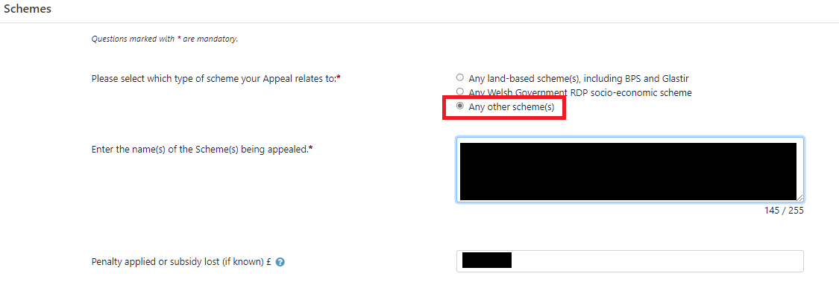

Statements of Appeal

Give details of the reason for the appeal (20,000 characters is the maximum the form allows) and secondly the change sought to the decision (4000 characters is the maximum the form allows). As shown in the screenshot below.

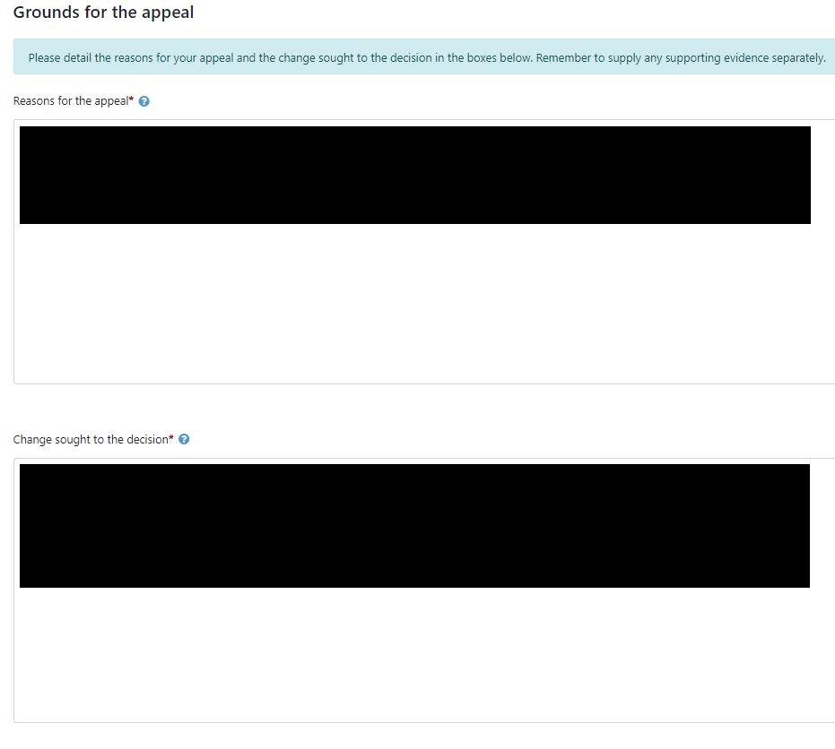

Supporting documents

List any supporting documents, you will be providing to support the appeal and then tick the appropriate box(s).

For Stage 2 appeals you must confirm the payment fees (selected in the Appeals Details section) is to be paid by ticking the box (as shown in the screenshot below) and then to go to the next stage of the form

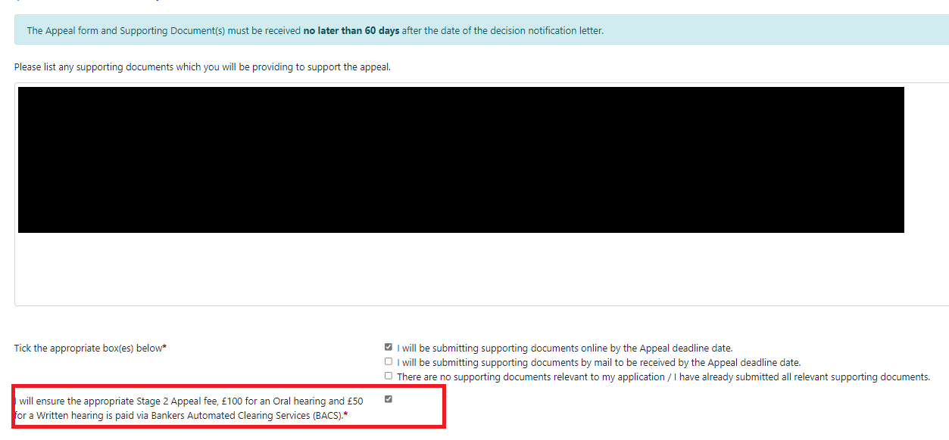

This confirmation is not applicable for Stage 1 appeals and you can move onto the next stage of the form

Submission

Errors, Information and Summary

The next section will show any Errors on your Appeal form, and a Summary of the Appeal form. (Please note: There are no Information Messages that display on the form.)

The following screenshot shows the message that will display if there are no errors.

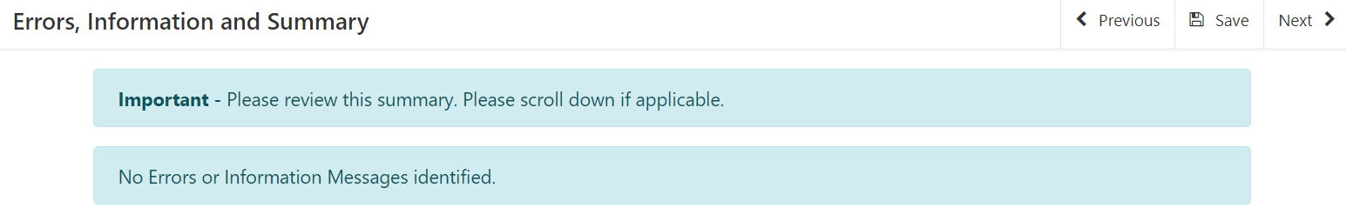

If there are any errors a message will be displayed as shown in the following screenshot.

Declaration and Undertakings

Read the Declaration and Undertakings section shown in the following screenshot and once you have done so, tick the box at the bottom to confirm you agree to these.

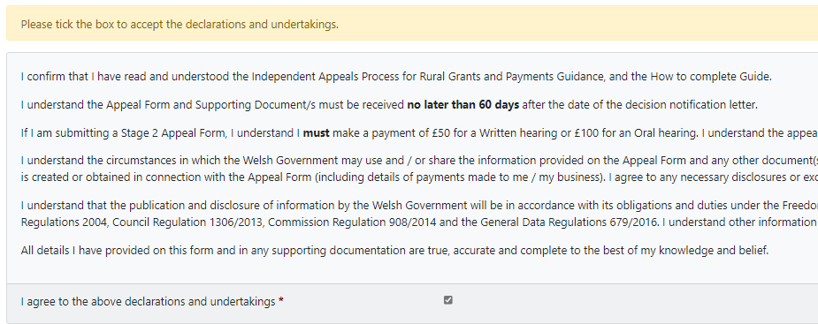

Submit

When you have finished completing the Appeals form, click the Submit button.

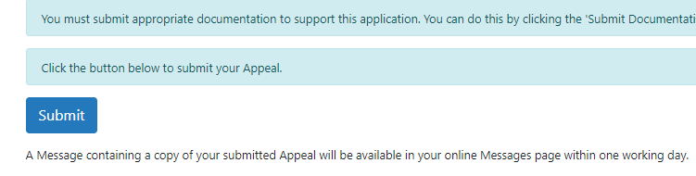

Submission Confirmation

A Submission Confirmation will now display as shown in the following screenshot. You should save or print the Submission Confirmation, by selecting the Print this Screen button shown in the screenshot. Click the Exit button shown to leave the Appeal form and return to RPW Online.

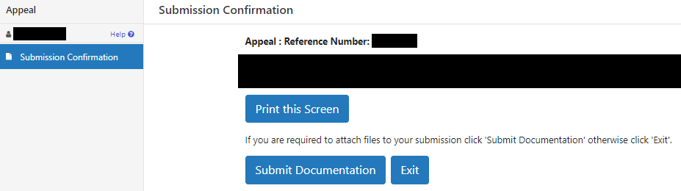

A Message containing a copy of your Appeal form will be available in your Online Message page within one working day.

Back to Contents

