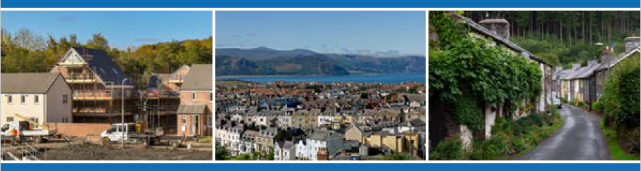
Undertaking Local Housing Market Assessments (LHMAs) – Template LHMA Reports
Contents

Preface 3
Part 1 – Rewrite Template LHMA Report 4
1. Introduction 4
1.1 National Policy Background 4
1.2 Local Policy Background 5
1.3 Governance and Consultation 5
2. Overview of Assessment and Methodology 5
2.1 Methodology, inputs and assumptions 5
2.2 Housing Market Areas 6
3. Overview of Housing Market and Socio-economic and Demographic Trends 7
3.1 Housing Market Analysis by Tenure 7
3.2 Socio-Economic and Demographic Trends 7
3.3 Specific Housing Needs Requirements 7
4. Range of additional housing need estimates 10
5. LHMA additional housing need estimates 11
6. Quality assurance statement 12
Appendix A – Key Issues Tables 13
Appendix B – Example of the output summary tables from the LHMA tool 15
Appendix C – Analysis of change in the additional housing need estimates 18
Part 2 – Refresh Template LHMA Report 20
1. Background 20
1.1 Additional housing need estimates 20
1.2 Latest additional housing need estimates 20
1.3 Housing Market and Socio-economic and Demographic Trends 21
1.4 Specific Housing Needs Requirements 21
2. Analysis of change 22
2.1 Data inputs and key assumptions 22
2.2 Additional housing need estimates over the first five years of the LHMA using the Welsh Government Principal Household Projections 23
3. Summary 25
3.1 Overall additional housing need estimates 25
3.2 Additional market housing need estimates 25
3.3 Additional affordable housing need estimates 25
4. Quality assurance statement 25

Preface

This template report document provides an expected minimum level of detail that Welsh Government would expect to see within a local authority’s LHMA report. Welsh Government has provided an Excel Tool (LHMA Tool), guidance and training videos to assist local authorities with their additional housing need assessments.

Local authorities are required to undertake an LHMA. Every five years, local authorities are required to rewrite their LHMAs and refresh their LHMA once during that five year period (between years two and three). Local authorities can refresh their LHMAs more frequently if required but these would not be reviewed nor signed off by Welsh Government.

Part 1 provides the rewrite template LHMA report and Part 2 provides the refresh template LHMA report.

Example text has been provided (in blue) throughout the template reports for suggested inclusion. Whilst local authorities can use their own text should they wish, it is expected that the text covers the areas outlined in the template report.

In relation to additional housing need estimates, local authorities will be expected to show understanding of the sensitivity of the estimates to a change in the data inputs and assumptions, and using the different household projections produce a range of additional housing need estimates. As explained in the outputs section of the guidance (3.28 to 3.32).

Part 1 – Rewrite Template LHMA Report

Introduction

National Policy Background
Example text is provided below (in blue) - you can use your own text and may wish to include:

- Section 8 of the Housing Act 1985 - Section 8 of the Housing Act 1985 places a statutory duty on local authorities to periodically assess the level of housing need in their area. It is vital that authorities have a comprehensive understanding of their local housing market(s) and provide a robust evidence base for effective strategic housing and planning services. Production of a Local Housing Market Assessment (LHMA) falls under this duty, building upon the requirement to review housing needs through a more holistic review of the whole housing market. Local authorities are expected to rewrite LHMAs every five years and refresh that LHMA once during that five year period (between years two and three) utilising section 87 of the Local Government Act 2003.
- Independent Review of Affordable Housing Supply - The importance of LHMAs, and using the best possible data on housing need and demand to inform housing policy and decisions regarding affordable housing supply, was underlined in the 2019 Independent Review of Affordable Housing Supply. The Review placed significant emphasis on understanding exactly how many homes are needed, in which geographical areas and in what tenures. A robust LHMA is the key means of identifying this evidence at the local level.
- Planning Policy Wales - Planning Policy Wales also stresses that LHMAs form a fundamental part of the evidence base for development plans.
- Housing (Wales) Act 2014 - In addition, local authorities must develop a homelessness strategy every four years under sections 50, 51 and 52 of the Housing (Wales) Act 2014. The LHMA plays a fundamental role in informing this strategy which must include a review of the resources available to the local authority and other bodies associated with supporting people who are or may become homeless.
- Equality Act 2010 - It is essential also for local authorities to consider their equality duties under the Equality Act 2010 and the Welsh Public Sector Equality Duties.

Local Policy Background

A short overview of the local policy context and vision should be included, with the connection between these policies and the LHMA set out.

Governance and Consultation

Production of an LHMA should be undertaken through a collaborative approach with stakeholders. In producing LHMAs, local authorities will need to have engaged with a range of stakeholders. Please use this section to provide information on the method of engagement, including details of the organisations and groups you have engaged. Feedback from these engagements and how they have influenced the LHMA will be an important element of this work. Local authorities should also set out their internal sign off processes.

Overview of Assessment and Methodology

Methodology, inputs and assumptions
Provide an overview of the methodology.
The additional housing needs estimates are determined using the LHMA Tool. This Tool uses a formulaic approach to allocate the additional housing need, formed from the existing unmet need and the newly arising need (change in the household projections over the LHMA period), to the different housing tenures. All existing unmet need is allocated to affordable housing and assumed to be covered during the first five years of the LHMA period. The newly arising need is allocated between market and affordable housing using a formulaic approach.

By housing market area (HMA), the LHMA Tool provides default data inputs for rent, house price paid and household projections (used to generate the newly arising need) with local authorities providing the income percentile distributions, existing unmet need and the planned supply and turnover of existing stock. The latter two data inputs are considered over the first five years only of the LHMA period and are fully allocated to affordable housing. This is because it becomes less accurate to predict supply beyond the first five years of the LHMA period. A local authority can have up to 20 HMAs which are defined using wards, middle-layer super output areas (MSOAs) or lower-layer super output areas (LSOAs). Each HMA can have up to 40 wards, MSOAs or LSOAs.

The input data together with a number of assumptions is used to generate an income level above which households would be considered able to meet their needs in the market and a lower income level below which households are considered to be in need of social rent. The intermediate households are those not allocated to market housing or social rent. The LHMA Tool also forecasts how the data inputs may change over the first five years of the LHMA period.
The output tables from the LHMA Tool are used as the starting point for development plans to provide the range of LHMA additional housing need estimates.

Use Appendix A – Key Issues Tables to set out any deviation from the methodology and default data and assumptions provided in the Tool, along with clear rationale and evidence as to why the alternative approach is more suitably robust, relevant and appropriate. You should also note any limitations on your data sources and assumptions.
There is no need to explain methodologies that have been explained robustly elsewhere, for example household projections are explained fully on the Office for National Statistics (ONS) website and a link to these is sufficient.

Housing Market Areas

Provide an introduction to Housing Market Areas (HMAs) and include details of your local authority’s HMAs in this section.

HMAs are areas that have been defined geographically based on the functional areas where people currently live and would be willing to move home without changing jobs, recognising that housing markets are not constrained by administrative boundaries. A number of key factors need to be taken into account when defining these areas, including the broad price of housing (to consider ‘transferability’ within the market) and major transport links by road or rail (to take account of commuting patterns).

3. Overview of Housing Market and Socio-economic and Demographic Trends
  - Housing Market Analysis by Tenure

Provide an overview of the local housing market, which should include:
- geographical size
- population including a breakdown of protected characteristics such as:
  - age
  - disability
  - ethnicity
- number of households
- an analysis of households by tenure
- overview of owner occupier position
  - property price trends for area and by HMA
  - sales (volume) trends by HMA
- overview of the private rented sector
  - property type
  - rents by bedroom and by HMA
- overview of the social rented sector
  - stock profile by HMA
- overview of second homes (and implications for the Welsh language), where appropriate
- overview of empty homes by HMA and sector.

  - Socio-Economic and Demographic Trends
Provide an overview of the socio-economic and demographic trends within the local authority. The following datasets are all Census datasets and can be extracted from NOMIS. You may wish to use the following datasets in your analysis. The relevant links and table codes are provided below:
- trend analysis of households by tenure and by HMA (e.g. table KS402EW)
- household incomes and housing costs as a percentage of income
- household composition (e.g. table KS105EW)
- occupancy ratings by HMA (e.g. tables QS412EW or QS408EW)
- ethnicity (e.g. table KS201EW)
- commuting patterns (e.g. table QS702EW)
- disability (e.g. table QS303EW)

  - Specific Housing Needs Requirements
Provide an introduction to specific housing needs requirements and complete the template tables in this section. Please note this section is largely a qualitative overview of policies/strategies/data sources, but where there is statistical data to assist with a numerical level of need this should also be included.

It is acknowledged that initially there may not be existing policy coverage for certain specific housing needs. This exercise represents a chance to identify those gaps and consider whether there is need to enhance strategic direction at the local level.

Data sources may be limited initially in some of the areas noted below. Where datasets are incomplete or do not exist, this section will allow identification of the data gaps which can be fed back to stakeholders and Welsh Government.

- Accessible and adapted housing provision

Local policies/ strategies | Delete this field if not applicable
Property needs (key section) | E.g. low level appliances, stair rails, barriers free, sheltered housing, housing with care, wheelchair accessibility.
Suitable for | E.g. people with limited mobility and/or dexterity, need for low level care, wheelchair users.
Evidence including data sources (key section) | - The current type and level of needs and provision  - Future type and level of needs and provision required  - Any gaps or shortfall in provision  - Data sources
External stakeholder consultation and engagement | Who was consulted and how the consultation was undertaken.  What were the findings?
Key Issues identified | Note any limitations or gaps in data

- Multi-generational and/or larger families requiring larger properties

Local policies/ strategies | Delete this field if not applicable
Property needs (key section) | E.g. larger properties, to accommodate cultural needs associated with some multi-generational living
Suitable for | E.g. larger or multi-generational families
Evidence including data sources (key section) | - The current type and level of needs and provision  - Future type and level of needs and provision required  - Any gaps or shortfall in provision  - Data sources
External stakeholder consultation and engagement | Who was consulted and how the consultation was undertaken.  What were the findings?
Key Issues identified | Note any limitations or gaps in data

- Non-permanent housing

Local policies/ strategies | Delete this field if not applicable
Property needs (key section) | E.g. good quality temporary accommodation
Suitable for | E.g. students, migrant workers, asylum seekers, refugees, homeless households (permanent housing is the preferred choice but temporary housing is considered where there is currently insufficient permanent housing to meet the needs).
Evidence including data sources (key section) | - The current type and level of needs and provision  - Future type and level of needs and provision required  - Any gaps or shortfall in provision  - Data sources
External stakeholder consultation and engagement | Who was consulted and how the consultation was undertaken.  What were the findings?
Key Issues identified | Note any limitations or gaps in data

- Housing, care and support needs

Local policies/ strategies | Delete this field if not applicable
Property needs (key section) | E.g. extra care, contemporary sheltered housing, supported living for people with a learning disability and/or ASD, temporary supported housing
Suitable for | E.g. for young people coming out of care, people with a learning disability learning to live independently, refuges
Evidence including data sources (key section) | - The current type and level of needs and provision  - Future type and level of needs and provision required  - Any gaps or shortfall in provision  - Data sources
External stakeholder consultation and engagement | Who was consulted and how the consultation was undertaken.  What were the findings?
Key Issues identified | Note any limitations or gaps in data

- Locational needs for student accommodation

Local policies/ strategies | Delete this field if not applicable
Land needs (key section) | E.g. requirement for student accommodation to be close to the University
Evidence including data sources (key section) | - The current type and level of needs and provision  - Future type and level of needs and provision required  - Any gaps or shortfall in provision  - Data sources
External stakeholder consultation and engagement | Who was consulted and how the consultation was undertaken.  What were the findings?
Key Issues identified | Note any limitations or gaps in data

- Locational needs for people with physical or cultural needs

Local policies/ strategies | Delete this field if not applicable
Property needs (key section) | E.g. close proximity to shops, places of worship and services
Suitable for | E.g. for people with physical or cultural needs
Evidence including data sources (key section) | - The current type and level of needs and provision  - Future type and level of needs and provision required  - Any gaps or shortfall in provision  - Data sources
External stakeholder consultation and engagement | Who was consulted and how the consultation was undertaken.  What were the findings?
Key Issues identified | Note any limitations or gaps in data

- Range of additional housing need estimates
From section 4 of the LHMA Tool, extract the completed summary tables from sheet ‘Summary tables for LHMA Report’ and include them here. Summary tables based on the Welsh Government household projections (principal, higher and lower variants) must be included. For a given household projection basis, there are four tables presenting the following annual additional housing need estimates:

First table: Estimated annual additional affordable housing need by HMA and tenure, net of planned supply and turnover of existing stock, over the first five years of the LHMA period.

Second table: Estimated annual additional total housing need by HMA and tenure, gross need before any allowance for planned supply and turnover of existing stock, over the first five years of the LHMA period.

Third table: Estimated annual additional total housing need by HMA and tenure over the remaining 10 years of the LHMA period. No allowance has been made for any planned supply and turnover of existing stock beyond year five as it becomes less accurate to predict.
Fourth table: Estimated annual and total additional affordable housing need by HMA and tenure over the 15-year period of the LHMA. These estimates are a combination of those estimates from the first and third tables.

See Appendix B for an example of the above tables. You will need to provide the four tables above for each of the Welsh Government household projections, so 12 tables in total. If the additional housing need estimates are also provided on the ‘user’ household projection basis then there will be 16 tables in total.

The data inputs and key assumptions generating each of the above estimates should also be included here. In particular, any deviations from the default data or assumptions should be clearly evidenced and supported as to why the alternative data or assumptions are more suitably robust, relevant and appropriate.

- LHMA additional housing need estimates
State which of the household projection variants set out in Section 4 you propose to use to provide your LHMA additional housing need estimates.

Where the preferred projection is not one of the Welsh Government variants (for example where it is based on the Development Plan’s Preferred Growth Strategy), this must be benchmarked against the Welsh Government projections and the degree of variation clearly evidenced and explained. If the LHMA is due to be reviewed in-between revisions to the Development Plan, it should be based primarily on the Welsh Government principal projection, with the alternative variants acting as upper and lower estimates.

Provide an analysis of these estimates against your previous LHMA additional housing need estimates using the tables in Appendix C.

As each LHMA is based on a snapshot at a point in time it is recognised that it would be inappropriate to directly compare one set of outputs with another due to different underlying data and assumptions. You should include any limitations or risks of simple comparisons of your first LHMA using the new process with the LHMA undertaken using the previous process.

You should note stakeholder engagements and the action taken as a result of these discussions.

- Quality assurance statement
A full statement should be included in the LHMA Report setting out each quality assurance procedure. Final draft LHMAs submitted to Welsh Government must ensure figures in the narrative match those in the tables, figures are arithmetically correct, figures are rounded consistently, data is fully sourced and figures / charts are labelled in full and consistently - including any footnotes, caveats or warnings. For example, you should caveat where statistical rounding leads to totals in tables not summing correctly: This is a common problem when calculating housing need, although it does not undermine the robustness of an LHMA when appropriately caveated.
Appendix A – Key Issues Tables
Key Issues Table 1 – Key data inputs

Key data inputs | Key issues identified with the data inputs
- Housing Market Areas (HMAs) | 1.  2.  3.
- Household data | 1.  2.  3.
- Rent data | 1.  2.  3.
- Income data | 1.  2.  3.
- House price paid data | 1.  2.  3.
- Existing unmet need | 1.  2.  3.
- Existing stock and planned supply | 1.  2.  3.

Key Issues Table 2 – Input assumptions

Key input assumptions | Key issues identified with the input assumptions
- Affordability criteria | 1.  2.  3.
- First time buyer (FTB ) assumptions | 1.  2.  3.
- Percentage of households eligible for owner occupier tenure that decide to go on and buy | 1.  2.  3.
- Five-year financial forecast for key variables – income, rent and house prices | 1.  2.  3.
- Calculation of intermediate housing (IR and LCHO) | 1.  2.  3.

Key Issues Table 3: Calculations and outputs

Calculations / outputs | Key issues identified with the calculations / outputs
- Market housing need covering owner occupier and private rented sector | 1.  2.  3.
- Affordable housing need covering social rent and immediate housing | 1.  2.  3.
- Scenario testing tables | 1.  2.  3.
- Five year outputs / 10 year outputs | 1.  2.  3.

Appendix B – Example of the output summary tables from the LHMA tool

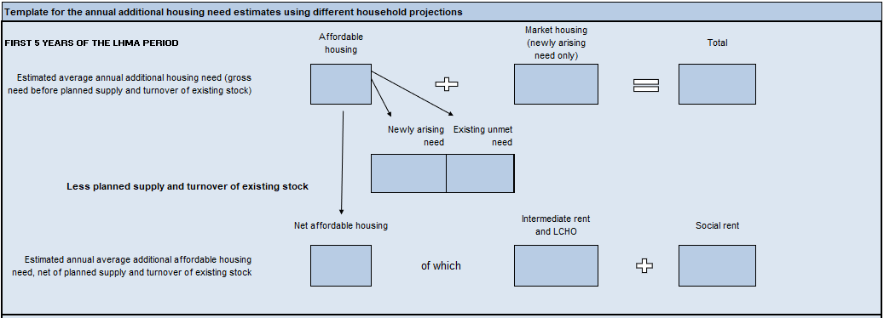

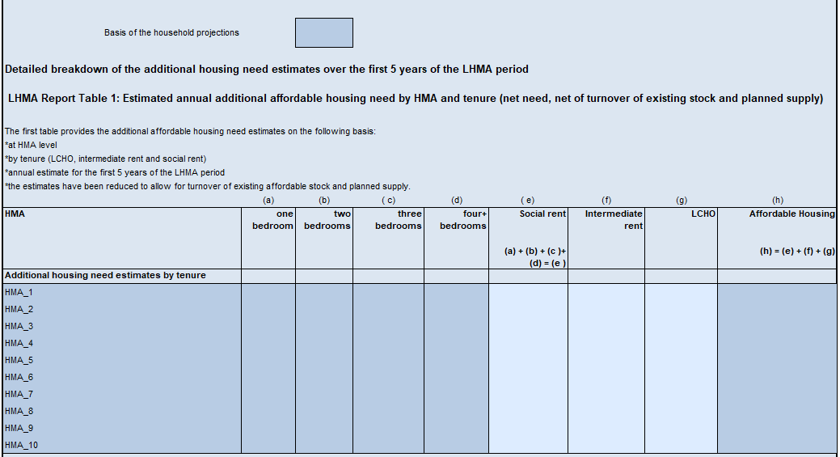

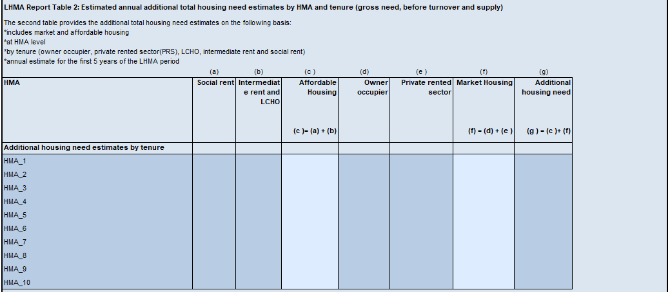

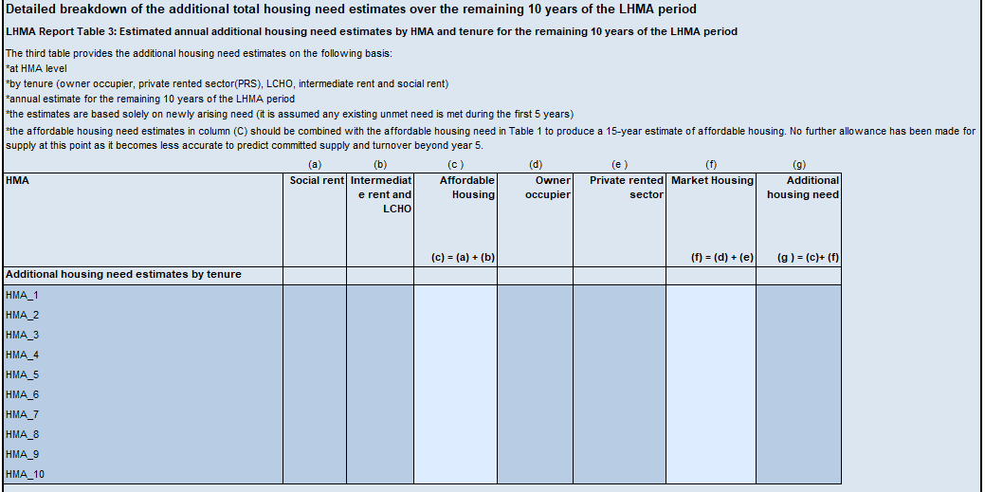

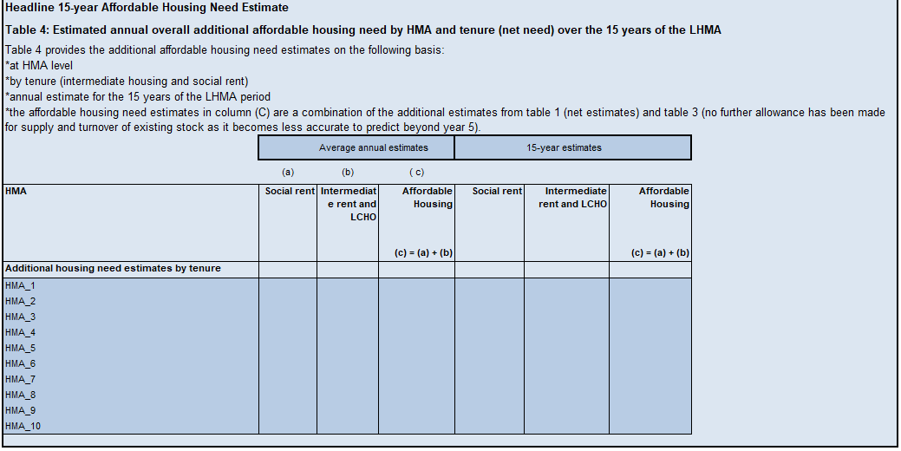

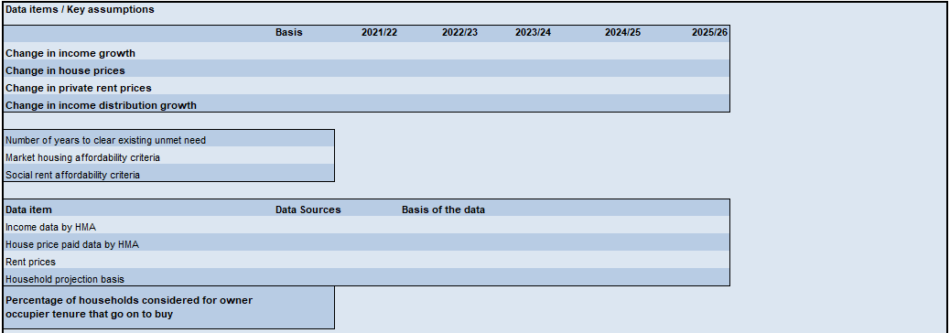

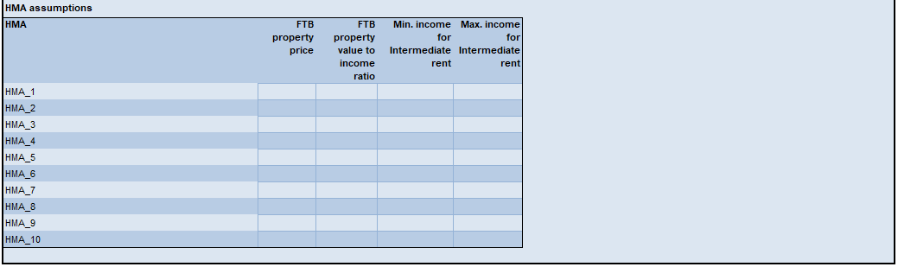

Appendix C – Analysis of change in the additional housing need estimates

Annual additional housing need estimates | Column index | Current LHMA | Previous LHMA
 |  | Over the first five years of the LHMA period
Total housing need estimate | (a)
Market housing | (b)
Affordable housing | (c)
Percentage split of additional housing need by market and affordable housing | (b)/(a): (c)/(a)
Annual planned supply and turnover of existing stock for affordable housing | (e)
Affordable housing need – net of planned supply and turnover of existing stock | (f) =(c)-(e)
Annual additional housing need estimate split by tenure:
Owner occupier | (g)
Private rented sector | (h)
LCHO – net basis | (i)
Intermediate rent – net basis | (j)
Social rent – net basis | (k)
One bedroom social rent | (l)
Two bedrooms social rent | (m)
Three bedrooms social rent | (n)
Four+ bedrooms social rent | (o)
Market housing percentage split:  Owner occupier estimate  Private rented sector estimate | (g)/(b)  (h)/(b)
Affordable housing need percentage split:  LCHO  Intermediate rent  Social rent | (i)/(f)  (j)/(f)  (k)/(f)
Social housing need percentage split by number of bedrooms
1 bed | (l)/(k)
2 beds | (m)/(k)
3 beds | (n)/(k)
4+ beds | (o)/(k)

Data Input and Key assumptions | Current LHMA | Previous LHMA
 | Over the first five years of the LHMA period
Number of HMAs and basis of defining HMAs (ward, MSOA, LSOA)
Selected household projection basis
Annual newly arising need
Rent data – state default or source used
House price paid data – state default or source used
Income data – state source used
Annual existing unmet housing need
Market housing affordability criteria
Social rent affordability criteria
Percentage of those considered appropriate for owner occupier that go onto buy
Average FTB property price for the LA
FTB property value to income ratio for the LA
Five-year financial forecast – OBR or alternative source
Split of intermediate housing need – method 1, 2 or 3

Part 2 – Refresh Template LHMA Report

This template provides you with the basis of a refresh report for a LHMA. Local authorities are required to refresh their LHMA during years two and three of the LHMA five-year cycle and submit the impact on the additional housing need estimates using this template document. Local authorities can refresh their LHMAs more frequently if required, but these would not be reviewed and signed off by Welsh Government.

Example text has been provided (in blue) throughout the template report for suggested inclusion. Whilst local authorities can use their own text should they wish, it is expected that the text covers the areas outlined in the template report.

Background

  - Additional housing need estimates
Example text is provided below - you can use your own text and you may wish to include:

The Local Housing Market Assessments estimate the additional housing need likely to be required by [INSERT NAME OF THE LOCAL AUTHORITY] split by housing market areas and tenures. The latest LHMA rewrite was prepared in [INSERT DATE] and signed off by Welsh Government in [INSERT DATE]. Utilising section 87 of the Local Government Act 2003, local authorities are expected to rewrite their LHMAs every five years and refresh that LHMA once during that five year period (between years two and three).

  - Latest additional housing need estimates

From section 4 of the LHMA Tool, extract the completed summary tables from sheet ‘Summary tables for LHMA Report’ and include them here based on the Welsh Government principal household projections. There are four tables presenting the following additional housing need estimates:

Table 1: Estimated annual additional affordable housing need by HMA and tenure, net of planned supply and turnover of existing stock, over the first five years of the LHMA period.

Table 2: Estimated annual additional total housing need by HMA and tenure, gross need before any allowance for planned supply and turnover of existing stock, over the first five years of the LHMA period.

Table 3: Estimated annual additional total housing need by HMA and tenure over the remaining 10 years of the LHMA period. No allowance has been made for any planned supply and turnover of existing stock beyond year five as it becomes less accurate to predict.
Table 4: Estimated annual and total additional affordable housing need by HMA and tenure over the 15-year period of the LHMA. These estimates are a combination of those estimates from table 1 and table 3.

See Appendix B in part 1 for an example of the above tables.

In particular, any deviations from the default data or assumptions should be clearly evidenced and supported as to why the alternative data or assumptions are more suitably robust, relevant and appropriate.

  - Housing Market and Socio-economic and Demographic Trends

Please use this section to share any changes considered worthy of noting by the local authority in the housing market or socio-economic and demographic trends since the previous LHMA was carried out. This section aligns with section 3 of the rewrite LHMA report.

  - Specific Housing Needs Requirements

Please use this section to provide any updates to specific housing needs requirements, using as the basis, the tables set out in section 3.3 of the rewrite LHMA template in part 1.

Note any actions the local authority may take in light of the refreshed specific housing need requirements. If no action is required then a statement to that effect should be included.

Analysis of change

  - Data inputs and key assumptions
If this is the first time the LHMA is being prepared using the new LHMA Tool then comparison with the previous LHMA additional housing need estimates, data sources and assumptions may be difficult. From the previous LHMA you will need the following information:
- Annual additional housing need estimates over the LHMA period
- Annual additional market housing need estimates (if provided)
- Annual additional affordable housing need estimates
- Annual additional households requiring social rent
- Any known data sources, assumptions and limitations used to estimate the additional housing need estimates.

Table 5 below should be populated where the local authority is refreshing the annual additional housing need estimates following a rewrite of the LHMA using the LHMA Tool. Table 5 requires you to note any changes to the data inputs and key assumptions between the rewrite and refresh of the LHMA which is considered relevant by the local authority.

Table 5: Comparison of the data inputs and key assumptions between the refresh and previous LHMA.

Data inputs and key assumptions
Item | Rewrite LHMA [INSERT DATE] | Refresh LHMA [INSERT DATE]
Housing Market Areas
E.g. if there has been a move of wards, MSOAs or LSOAs between HMAs, or a change in the number of HMAs.
Household Projections
E.g. if applicable, state if the user projections have changed and how; if the LHMA Tool is using updated Welsh Government household projections.

Rent Data
E.g. state whether the LHMA is based on default or other data.
House Price Paid Data
E.g. state whether the LHMA is based on default or other data.
Income Data
E.g. state the percentage of households at the 25th, 50th and 75th percentiles.
Existing Unmet Need
E.g. state the overall number of housing units for each affordable housing tenure and highlight any significant change in any HMA.
Planned Supply and Turnover of Existing Stock
E.g. state the overall number of housing units for each affordable housing tenure and highlight any significant change in any HMA.

Key Assumptions
E.g. state whether the LHMA is based on the default or other assumptions and any key change within any HMA.

  - Additional housing need estimates over the first five years of the LHMA using the Welsh Government Principal Household Projections

Using the additional housing need estimates based on the Welsh Government principal household projections from section 1.2 and the annual additional housing need estimates from the previous review, by HMA and tenure, you should complete Table 6.

The additional affordable housing need estimates reported here should be net of any planned supply and turnover of stock and based on the first five years of the LHMA period. Table 6 can be duplicated if more HMAs are required.

If the local authority does not hold the previous LHMA housing need estimates at a HMA level, then total estimates can be provided for the additional overall housing need estimates and market housing. Local authorities are expected to provide the additional affordable housing need by HMAs. It is recognised that LHMAs are a point in time exercise and Table 6 is designed to show how that snapshot has produced different outputs on subsequent occasions.
Table 6: Annual additional housing need estimates for the first five years of the LHMA period, net of planned supply and turnover of existing stock

Tenure Type |  | Local authority | HMA1 | HMA2 | HMA3 | HMA4 | HMA5 | HMA6 | HMA7
Estimated annual additional total housing need | Current LHMA
 | Previous LHMA
Estimated annual additional market housing need | Current LHMA
 | Previous LHMA
Estimated annual additional affordable housing need | Current LHMA
 | Previous LHMA
Estimated annual additional intermediate housing need | Current LHMA
 | Previous LHMA
Estimated annual additional social rent need | Current LHMA
 | Previous LHMA

Summary
  - Overall additional housing need estimates

Note any actions the local authority may take in light of the refreshed housing need estimates. If no action is required then a statement to that effect should be included.

  - Additional market housing need estimates
Note any actions the local authority may take in light of the refreshed housing need estimates. If no action is required then a statement to that effect should be included.

  - Additional affordable housing need estimates
Note any actions the local authority may take in light of the refreshed housing need estimates. If no action is required then a statement to that effect should be included.

Quality assurance statement
A full statement should be included in the LHMA report setting out each quality assurance procedure. Final draft LHMAs submitted to Welsh Government must ensure figures in the narrative match those in the tables, figures are arithmetically correct, figures are rounded consistently, data is fully sourced and figures / charts are labelled in full and consistently - including any footnotes, caveats or warnings. For example, you should caveat where statistical rounding leads to totals in tables not summing correctly. This is a common problem when calculating housing need, although it does not undermine the robustness of an LHMA when appropriately caveated.

1985 Housing Act - https://www.legislation.gov.uk/ukpga/1985/68/section/8
2003 Local Government Act - https://www.legislation.gov.uk/ukpga/2003/26/part/7
Independent Review of Affordable Housing Supply - https://gov.wales/sites/default/files/publications/2019-04/independent-review-of-affordable-housing-supply-report_0.pdf
Planning Policy Wales -https://gov.wales/sites/default/files/publications/2021-02/planning-policy-wales-edition-11_0.pdf
Housing (Wales) Act 2014 - https://www.legislation.gov.uk/anaw/2014/7/contents/enacted
Equality Act 2010 - https://www.legislation.gov.uk/ukpga/2010/15/contents

