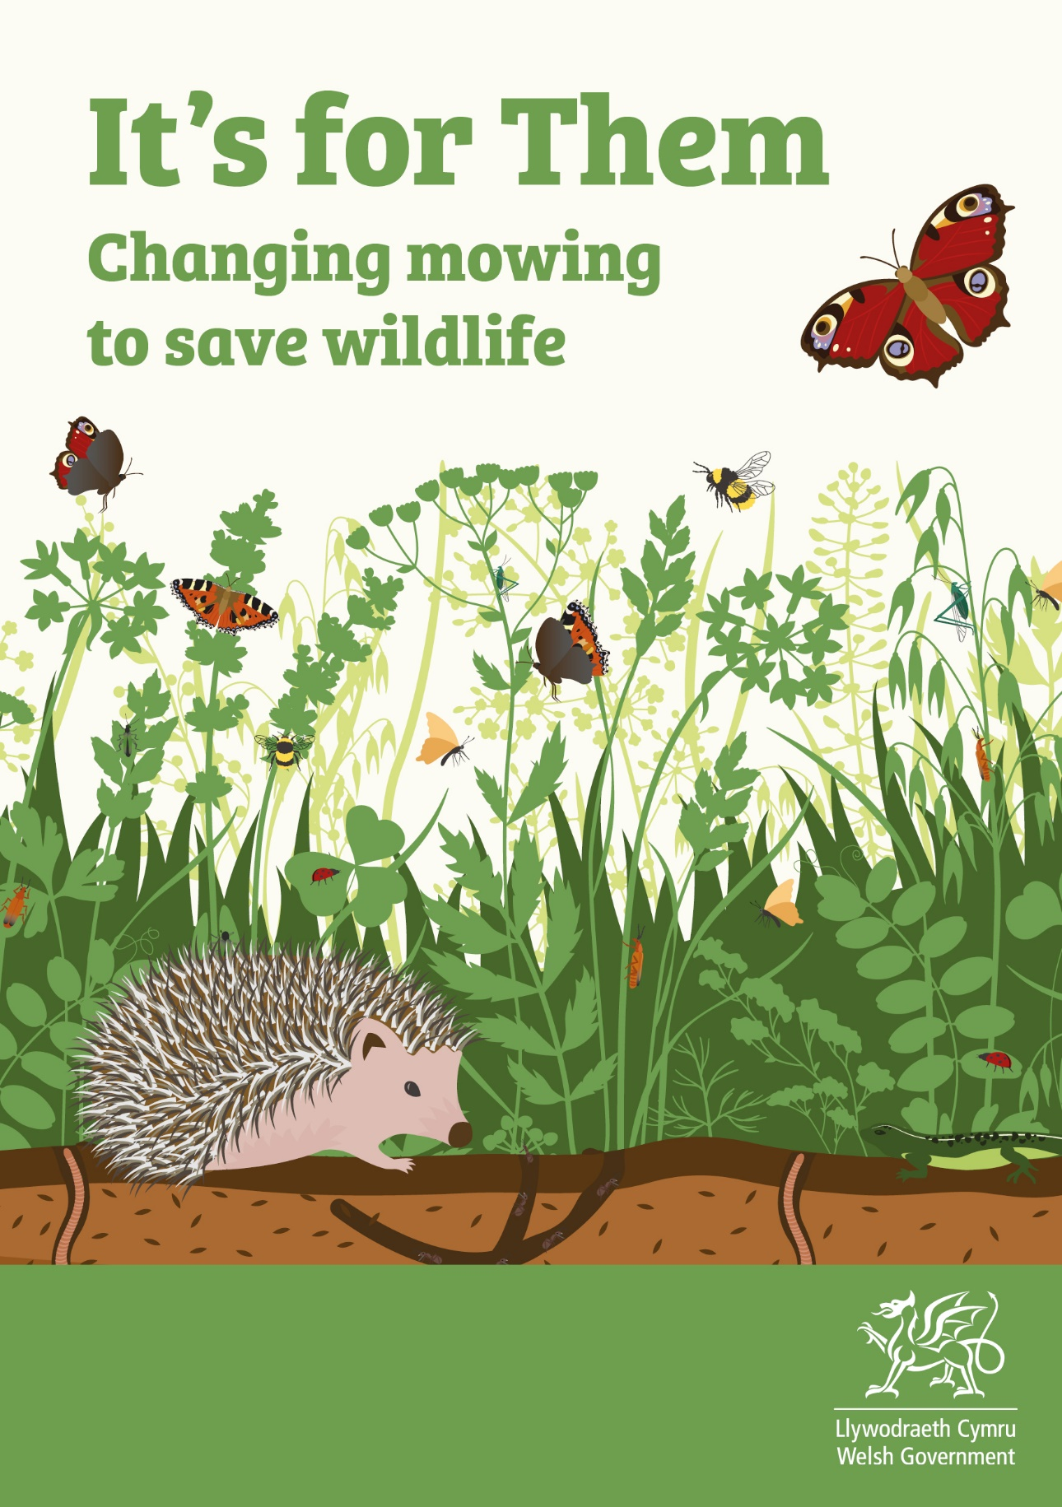
[Delete this text and add your logo(s)
or organisation’s name here]

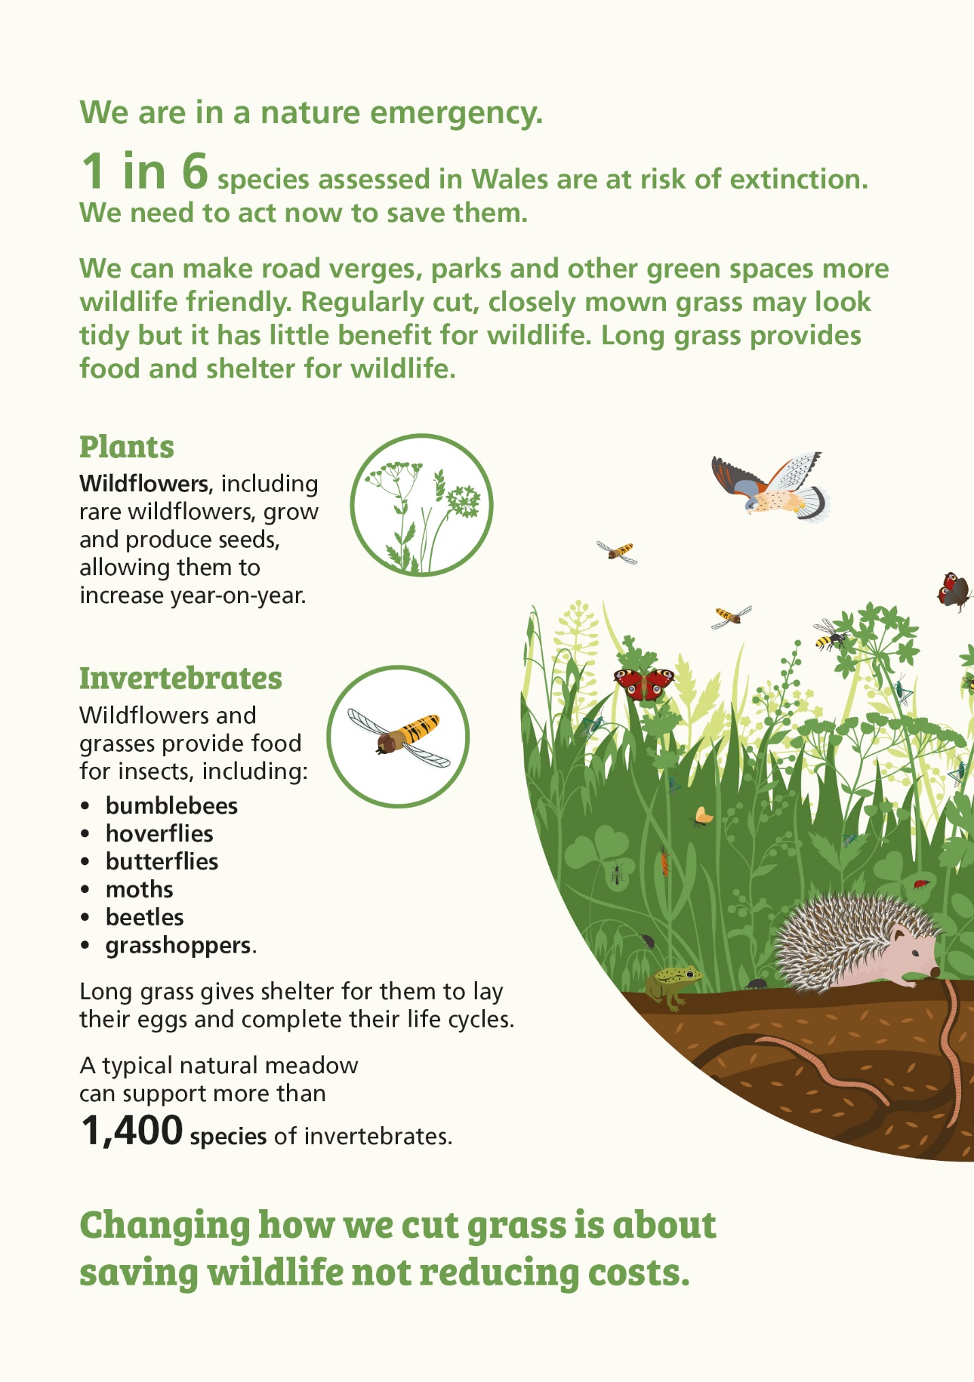

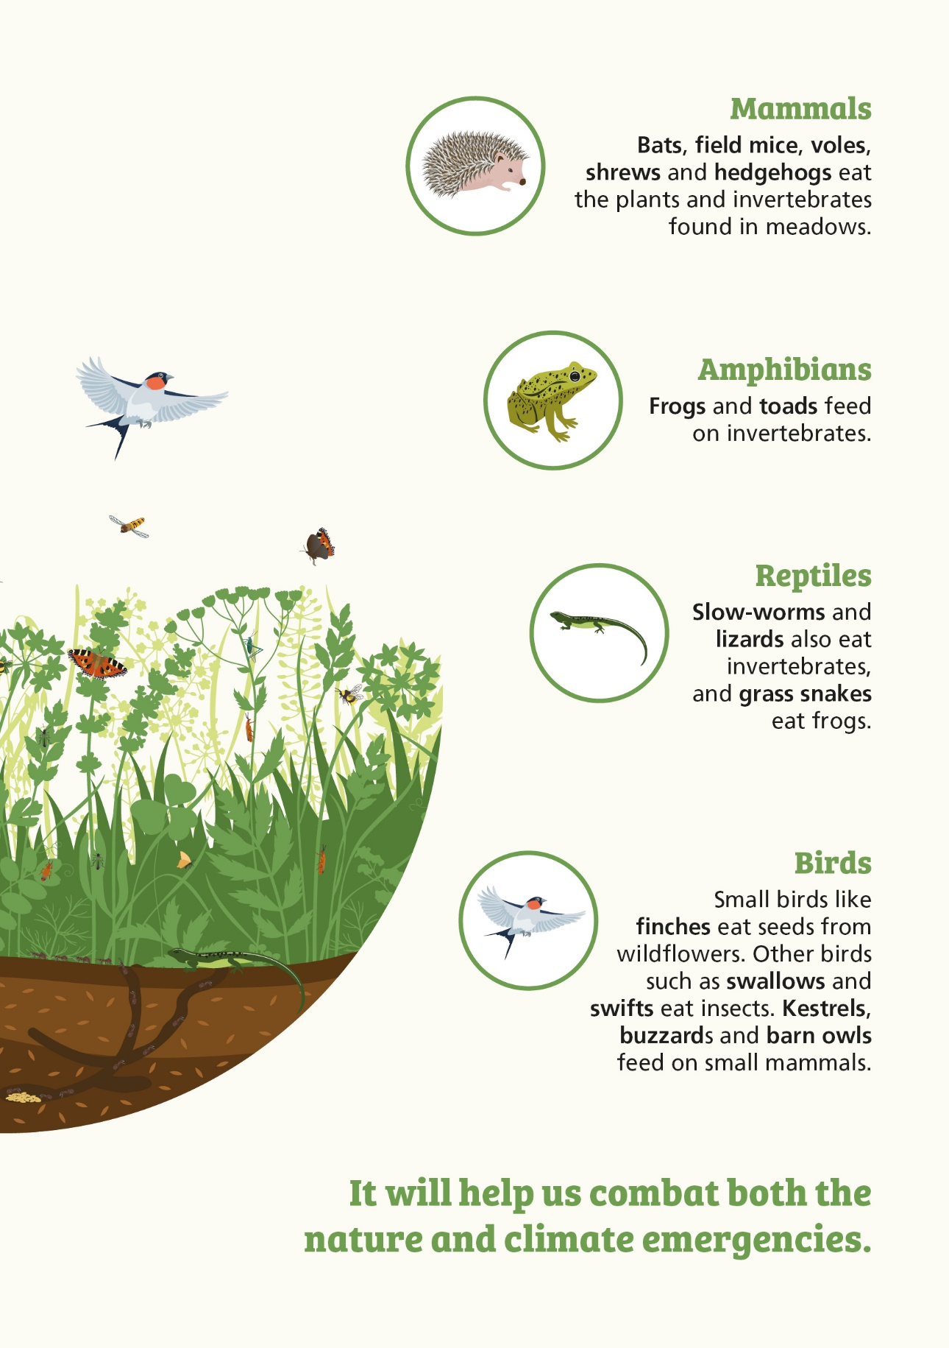

How does it help combat climate change?
Plants absorb carbon from the atmosphere. Reducing mowing allows plants to grow bigger root systems, storing more carbon in the soil. Better root systems increase soil aeration, which increases water storage and so helps reduce flooding.
Frequently Asked Questions
Why are pollinators important?
Pollinators pollinate many farmed crops that we eat. They pollinate wild plants to produce seeds, fruits and nuts which birds and mammals eat. They are essential for the maintenance of food production. Many wild pollinators are in decline, mainly due to loss of habitat. Pollinators need flowers to feed from, places to live and lay eggs, and shelter for their young to develop. Honey bees are also pollinators. In Wales, they arelargely a managed species. and are not in decline.

Are meadows good
for people?
Connecting with wildlife can benefit our health and mental wellbeing making us feel calmer, happier and more focused. Creating more meadow-like areas allows us to experience nature
day by day.
Will having long grass have an impact on
road safety?
It is important that we keep the road safe for all users. Having biodiverse verges does not mean roads will be less safe. Certain areas such as sightlines and junctions may be cut more often to ensure safety.
Doesn’t it look untidy?
Meadow-like areas with long grass have an informal natural beauty. After the flowering season, areas of long grass can start to look tired as plants put their energy into seeds for next year’s wildflowers. These areas still have vital importance for pollinators, other insects, birds and mammals like hedgehogs.
How does ‘cut and
collect’ help create a native meadow?
A meadow is a field made up of native wildflowers and finer grasses left uncut until late summer. ‘Cut and collect’ copies traditional ways of managing hay meadows. It involves removing grass cuttings after mowing. It allows seeds to grow on more exposed ground. It reduces the fertility of soil which slows the growth of nutrient-loving grasses that choke wildflowers and finer grasses. Letting wildflowers grow and set seed allows them to increase year-on-year. It will take some time and it is important to be patient.
Where can I learn more about meadows?
You can find out more about meadows on Plantlife’s
Meadows Hub:
https://meadows.plantlife.org.uk/about-meadows/
Which wildflowers
might I find?
To begin learning the names of the wildflowers you might see, ‘Nature Isn’t Neat’ has made a guide to some of the most important wildflowers for pollinators. Download their guide here: https://www.monlife.co.uk/outdoor/nature-isnt-neat/training-and-resources/
What about our places
to play?
Recreation areas will still be maintained regularly, and patches mown for play and picnics. Areas of wildflowers and grass will provide opportunities for children to engage with nature.
Will there be more litter?
It is an offence to throw or drop litter in any place the public has access to. We will continue to monitor our greenspaces for litter.
What about dog mess?
It is the dog owner’s responsibility to collect all waste regardless of the grass height or environment. If a person allows their dog to foul and does not pick it up, they are committing an offence. For dog walkers, paths will be cut through the grass meadows so there will still be plenty of routes to
exercise dogs.

Why aren’t you sowing annual ‘wildflower’
seed mixes?
Annual seed mixes may look colourful but they have drawbacks. They are sometimes called ‘wildflowers’ but are often non-native species. They can be expensive to buy, require work to maintain and may need to be sown each year. Herbicides are often used to clear areas before sowing. Sowing these mixes does little to conserve our native wildflowers. They do not support the wide range of invertebrates that feed on native meadow flowers.
What is Local Places
for Nature?
Local Places for Nature (LPfN) is a Welsh Government programme to create Nature on Your Doorstep.
It is designed to restore and enhance nature where people live, work and access public services.
It provides funding and support
to implement a wide range of
local actions, from small community growing packs to larger projects, to create new meadows or an urban ‘sensory garden’. LPfN works with local partners and communities to take forward these projects for nature.
What are Local Nature Partnerships?
Local Nature Partnership (LNP) provides biodiversity advice, maximises funding opportunities, develops collaborations and empowers community groups to take action. The LNP Network supports nature recovery in
Wales and is a crucial point of contact for advice and expertise. LNP coordinators are in all parts of Wales. Find out more at: www.biodiversitywales.org.uk/Local-to-You
What is the Bee
Friendly scheme?
The Bee Friendly scheme was launched by Wales’ Action Plan for Pollinators Taskforce. The scheme encourages action to help all pollinators, not just bees. By joining this scheme, people commit to give pollinators what they need to survive and thrive. For more information see:
www.biodiversitywales.org.uk/Bee-Friendly

Is there a legal reason why you are letting the grass grow?
Section 6 of the Environment (Wales) Act 2016, Biodiversity and Resilience of Ecosystems duty, legally requires public authorities to maintain and enhance biodiversity.

© Crown copyright 2022, Welsh Government, WG44340, Digital ISBN 978-1-80364-535-3
Mae’r ddogfen hon ar gael yn Gymraeg hefyd / This document is also available in Welsh.
Rydym yn croesawu gohebiaeth a galwadau ffôn yn Gymraeg / We welcome correspondence and telephone calls in Welsh.

Get involved or let us know what you think.
We think cutting grass less often is a key contribution we can make to tackling the nature and climate emergencies. However, we appreciate that in some areas we will need to review management to ensure our greenspaces work for you and for nature.
We would like to know what you think or, if you would like to get involved, contact:
[Insert your organisation’s contact details or web page here].

