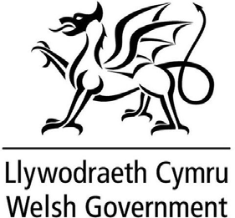

Consent Form

Smart Meter Data
Welsh Government are developing new ways to make homes more energy efficient and helping to reduce the amount of greenhouse gasses polluting our environment. Your home and your data will play an important role in deciding what energy systems will be fitted in Welsh homes in the future. More detailed information about this and the data collected is set out in the accompanying Optimised Retrofit Privacy Notice.
As part of the Optimised Retrofit project, the Welsh Government would like to use the data from your currently installed Smart Meter. The Data from your smart meter will be collected on our behalf by your Landlord and may include agents used by them (such as Sero Technologies). The data collected will be half hourly meter readings. Welsh Government will be the data controller for this information and will process it with your consent.
Your Smart Meter data will tell us about your energy use, such as how often your boiler heats your water, how often you turn on your heating etc. This data will help Welsh Government to understand how useful the modern energy systems are at reducing the energy you use.
If you consent for the data from your smart meter to be shared with the Welsh Government for the project, please tick the box below.

Please tick here to confirm your consent:
You can ask us to stop processing the data from your smart meter at any time. Please tell us if you want us to stop by writing to us by email or post to the following:
OptimisedRetroFitProgramme@gov.wales

What should you do if you want more information?
If you have any questions or concerns about anything in this document, you can contact us via OptimisedRetroFitProgramme@gov.wales and we will be happy to discuss the issue with you.
For further information about the information which the Welsh Government holds and its use, or if you wish to exercise your rights under the UK GDPR, please see contact details below:

Data Protection Officer
Welsh Government
Cathays Park
Cardiff
CF10 3NQ
Email: DataProtectionOfficer@gov.wales
If you are not happy with how your personal data is being processed, you can complain to the Information Commissioner’s Office who regulates data protection in the UK – but please contact us first as we will always try to resolve any issues or concerns. The Information Commissioner can be contacted at:
Information Commissioner's Office
Wycliffe House
Water Lane
Wilmslow
Cheshire
SK9 5AF
Tel: 0303 123 1113 (local rate)
