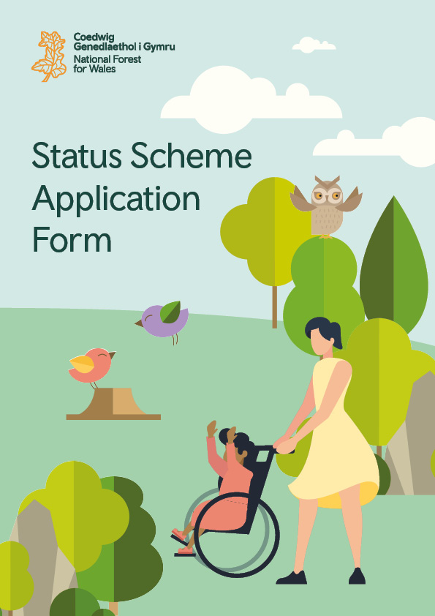
The National Forest for Wales –
Status Scheme Application Form
Applicant name:
Site name:
Site Address:

Contact Name:
Contact Number:

Introduction
Please note the following key messages before progressing with this application.
The National Forest for Wales Status process is open to applications from anyone that owns or has management control of land in Wales, including not-for-profit organisations and private owners.
You must demonstrate in the application how your project meets the National Forest for Wales Outcomes, as outlined in the ‘how to complete your application’ guidance.
What is National Forest Status?
Becoming part of the National Forest for Wales is all about being part of something unique for the people of Wales. Having National Forest for Wales Status allows exemplary woodlands to be recognised, to become part of something nationwide and provide opportunities to connect woodlands in lots of different ways.
Before completing this application:
- Please familiarise yourself with The National Forest for Wales – Status Scheme Guidance.
- You must have liaised with your National Forest for Wales Liaison Officer.
- Please read the ‘How to complete your application’ guidance.
- Please make sure you have a good understanding of the National Forest for Wales Outcomes.
If you have any problems completing or submitting your application, you should contact NationalForestWalesStatus@naturalresources.wales, or by telephone on 0300 065 3000 (Mon-Fri, 9am-5pm).
Applications must be submitted to NationalForestWalesStatus@naturalresources.wales mailbox, or via post to:
National Forest for Wales Status Team
Customer Hub
Maes y Ffynnon
Penrhosgarnedd
Bangor
Gwynedd
LL57 2DW

Project Details
Owner or Manager Details:
Please attach evidence of ownership or management agreement with your application.

Name:
Contact details:
Address:

Size of site:
Please attach a map with your application outlining the site area and relevant features.

Total size in Ha of National Forest for Wales area being applied for:

Total size in Ha of the woodland site:
If the whole site is being submitted to be part of the National Forest for Wales, please leave this section empty.

Your National Forest for Wales Liaison Officer:
Name:
Region:
Date of last visit:

National Forest for Wales Liaison Officers Signatures:
By signing here the Liaison Officer is acknowledging their involvement in the application process for this site.

Primary Liaison Officers signature: |  | Peer review Liaison Officers signature:
Print name: |  | Print name:
Date: |  | Date:

The National Forest for Wales - Evidence

Please refer to the published Status Scheme guidance and ‘How to complete your application’ guidance for more detail on the Outcomes and completing this section.

Explain how the woodland site meets the required National Forest for Wales Outcome of a:
Good quality, well designed and managed resilient woodlands (400 words max)

Explain if and how the woodland site meets the following National Forest for Wales Outcomes:
Only complete the Outcomes which your woodland site demonstrates. Other Outcomes can be marked as N/A.

- Woodlands accessible to people.
- Community involvement in woodlands.
- Connected woodlands.
- Dynamic, multi-purpose woodlands and trees.
- Woodlands that demonstrate learning, research and innovation.

Woodlands accessible to people (400 words max)

Community involvement in woodlands (400 words max)

Connected Woodlands (400 words max)

Dynamic, multi-purpose woodlands and trees (400 words max)

Woodlands that demonstrate learning, research and innovation (400 words max)

Other evidence

Please attach a copy of your woodland management plan with your application.

If any of the following information is included in your management plan then you do not need to repeat the information, but please provide a reference to the information below.

Describe the long-term plan or future ambition for the site.
Please include reference to maintaining the site or further improvements proposed to the woodland or infrastructure. (400 words max)

Please describe what you are most proud of and excited about on your site. (400 words max)

Please highlight any other information you think would be relevant to your application (including any relevant links). (400 words max)

Supporting Documents
Full applications are made up from a number of different documents and sources of information submitted in support of the application.

All supporting documentary evidence must be submitted with your application.

The following must be submitted with this application form:
Please complete the checklist.

☐ Proof of site ownership or management control (e.g. a copy of land registry) or proof of management control of the site (e.g. a copy a management agreement with the site owner).
☐ A map of the site.
☐ A woodland management plan.
☐ Governing document (where applicable – please see the ‘How to complete your application’ guidance for more information).

A non-exhaustive list of other documentary evidence which may need to be submitted with your application is given in the ‘How to complete your application’ guidance. Please check this list before submitting your application.

Privacy Notice

How we will use your information

Applications will be processed and held by the National Forest for Wales Liaison Officers who are based in Natural Resources Wales (NRW). Details of applications and successful National Forest for Wales sites will be shared by NRW with the Welsh Government as the data controller.

If successful in gaining National Forest for Wales Status, details of sites which form part of the National Forest for Wales will be shared with other National Forest for Wales sites to help build a community of practice, for knowledge building and promotion. Details of successful National Forest for Wales sites will be published on the gov.wales, Visit Wales and Wales.com websites. Details of National Forest for Wales sites will also at times be shared with third parties for the purposes of promotion and knowledge building of the National Forest for Wales.

Further information on related privacy notices can be found at the following links:

Forestry Resource Policy privacy notice: Forestry branch: privacy notice | GOV.WALES
Welsh Government privacy notice: Welsh Government privacy notice | GOV.WALES Natural Resources Wales privacy notice: Natural Resources Wales / Privacy notice

The Agreement
By signing and submitting this application you agree to become part of the National Forest for Wales should your application be successful. As part of this agreement you will maintain the standards required for and recognised by this application in line with the National Forest for Wales Outcomes and as outlined in the Status Scheme guidance. This includes acknowledging that any paths and/or access ways you have indicated as open and accessible for public use on your site will remain so for the duration of the agreement.
The agreement will initially run for a ten-year period from the date we notify you of any offer of National Forest for Wales Status. As part of this agreement ongoing contact will be maintained with your National Forest for Wales Liaison Officer referenced in this application or their successor. A five-year check-in will be carried out with your site to ensure standards are maintained and the National Forest for Wales Outcomes still met.
You also agree to your site and contact details being shared with third parties where relevant for the purposes of promotion and knowledge building of the National Forest for Wales. You may at any time choose to leave the National Forest for Wales, as can your Status be removed by Welsh Government at any point.

Signatures
Applicant
Signature:

Print name:
Role:
Date:

Lead National Forest for Wales Liaison Officer
Signature:

Print name:
Date:

Further Information

National Forest for Wales Welcome pack:
On gaining National Forest for Wales Status successful applicants will receive a Welcome pack with information about being part of the National Forest for Wales network and how to promote their contribution. The pack will include information on:
- Signage
- Branding Guidelines
- Stakeholder engagement content
- Promotion platforms.
Available funding:
Funding is currently available through the Woodland Investment Grant (TWIG) for sites which don’t yet meet the National Forest for Wales Outcomes or for further improvements to sites which have National Forest for Wales Status. The grant is delivered by the National Lottery Heritage Fund, further information can be found at the following link: The Woodland Investment Grant | The National Lottery Heritage Fund
Alternative formats:
To request a different format of the form or any of the guidance documents please contact the NationalForestWalesStatus@naturalresources.wales mailbox, or by telephone on 0300 065 3000 (Mon-Fri, 9am-5pm).

