Guidance on collating and submitting Speech, Language and Communication (SLC) outcomes for children aged 0-5 years supported by universal, population and targeted SLC services in Wales.
- Purpose of this guidance
This document accompanies the ‘Ultimate and short-term Speech, Language and Communication (SLC) outcomes for children aged 0-5 years supported by universal, population and targeted SLC services in Wales’ (annexe 1), which sets out new outcomes to be used to demonstrate the impact of Flying Start SLC provision, as well as all other universal, population and targeted level SLC provision for under 5’s.
The guidance is intended to support Local Authorities and Health Boards across Wales to collect and submit the new outcomes. It sets out timescales and suggests approaches to implementing new measures, where applicable.
- Audience
Anyone in Wales with responsibility for delivering or commissioning SLC provision outside of individualised support – this includes the universal, population and targeted levels of provision delivered in Flying Start as well as in other preventative services (e.g., EYITP pilots). Please note that while submission of the new measures will be required for Flying Start provision, this data will not be collected by Welsh Government for services outside Flying Start. For this reason, the rest of this document refers specifically to Flying Start, with the principles remaining relevant for other services.
- Background
The revised SLC outcomes are as proposed by a working group of experts in SLC from across Wales (see annex 4 for membership). Discussions have been supported by the following frameworks/ guidance:
- RCSLT guidance for measuring outcomes outside of individualised care: Measuring outcomes outside individualised care | RCSLT
- Accompanying framework: RCSLT-Measuring-Outcomes-Framework-June2021.pdf
- Key questions to ask when selecting outcome measures: a checklist for allied health professionals selecting-outcome-measures.pdf (rcslt.org)
Welsh Government (WG) do not currently ask LAs for any data on impact in relation to SLC services. The data collected for Flying Start (FS) SLC has, to date, consisted of attendance figures (outputs) only. The FS workbook, prior to April 2023, contained a single tab for SLC and parenting. The revised workbook includes separate tabs for SLC and parenting, and most of the attendance data for SLC has been removed (e.g., Hanen ‘You Make the Difference’, which is obsolete.)
The new outcomes were devised with the intention of capturing data that is, in most cases, already being collected wherever possible. For this reason, specific tools have been suggested but not stipulated, with locally used alternatives mentioned where applicable.
The new outcomes will improve the data collected during the interim period during which the ‘SLC package for Wales’ is being developed. It has been agreed with WG data colleagues that the change in the child measure will not be requested by WG until we have a fit-for-purpose tool (in development, expected Spring 2026). We will therefore be using measures of change in the adult & environment to demonstrate the impact of Flying Start SLC provision. Please note that WG does not currently request any change in the child data to be submitted, so there is no change in this respect.

- The new measures
The revised outcomes were put in place in April 2023. Please note that only outcomes 2.1, 2.3, 3.1 and 3.3 will be requested in 2023/4; with all other changes to be phased in over the coming years.
The new outcomes are as follows:
Vision statement: Children start school with functional speech, language and communication skills that are reaching their full potential.
The SLC package for Wales will incorporate a surveillance point which will provide data on whether this ‘vision’ is being achieved at population level.
  - Ultimate outcome: 90% of children receiving universal, population or targeted level SLC support will have typically developing SLC at age 3;11 AND the 10% with SLCN will be appropriately identified and supported
The ultimate outcome is not expected to be evidenced by each LA or HB – rather, the intention is that population level data will be looked at in order to establish whether the disadvantage gap is narrowing for at-risk groups. We may never achieve 90%, but year on year improvements on the baseline would demonstrate impact.
NB The ultimate outcome will not be captured until we have a ‘change in the child’ surveillance approach in place, so it will be introduced when the SLC package for Wales is rolled out.
  - Change in the Child: As the review of early language screening suitable for children in Wales from birth to 5 years concluded, we do not have a fit for purpose ‘change in the child’ tool available to us at this stage. This measure is therefore not to be requested by WG until SLC package for Wales is available across the workforce (estimated Spring ‘26)

  - Change in the Carer: ‘Carers will interact responsively with their child, implementing strategies to support their child's SLC development and/or wellbeing’.

    - Outcome number 2.1: Carers of children with identified SLCN will use responsive interaction strategies to help their child's SLC and play skills following intervention.

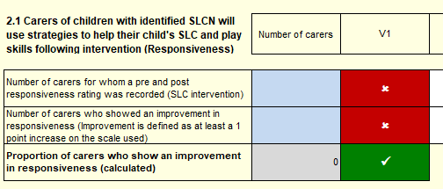
This measure is designed to capture adult behaviour change resulting from SLC intervention.
Adult responsiveness is the primary target of most, if not all, evidence based universal and targeted SLC interventions in the early years. Please see the Wales Intervention Review (WiRE) report for a summary of evidence based universal, population and targeted level SLC interventions for under 5s.
Responsiveness can be measured using the PaRRiS rating scale or an alternative measure of adult-child interaction behaviours. The PaRRiS consists of a single question and does not require training (see PaRRiS manual, annexe 2). If your service uses an existing measure of adult responsiveness, it is not essential that you adopt the PaRRiS scale, although you may choose to do so due to both its growing evidence base and its ease of use. Please note that it is not essential that a formal or published tool is used. If you have a locally developed measure in use, you may continue to use it and report on that.
Positive change is defined as an increase of at least 1 point on 1 or more items on the scale used. For example, on the PaRRiS scale, which has a maximum total score of 5, an improvement of 1 point (e.g., from 3 to 4) post intervention would be defined as a positive change. On a scale consisting of 5 items, each scored 0-10 (totalling 50 points), an improvement of 1 point (e.g., from 7 to 8) on one of the items scored would be defined as a positive change.
Consideration should be given to inter and intra-rater reliability, whichever scale is used. Good practice would be to implement supervision sessions for all practitioners using the tool to ensure that its use remains consistent and reliable.

    - Outcome number 2.2: Carers of children accessing population/ targeted SLC intervention will have increased confidence in supporting SLC development.

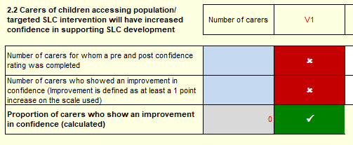
This measure is designed to capture change in adult confidence resulting from SLC intervention. This can be measured using pre and post intervention confidence rating scales (e.g., ‘on a scale of 0-10, how confident do you feel about interacting with your child in a way that supports them learning to talk?’). If existing confidence measures are used, these can be retained and reported. Positive change is defined as an increase of at least a 1-point increase on the scale used.

    - Outcome number 2.3: Carers of children accessing population/ targeted SLC support will engage with SLC interventions.

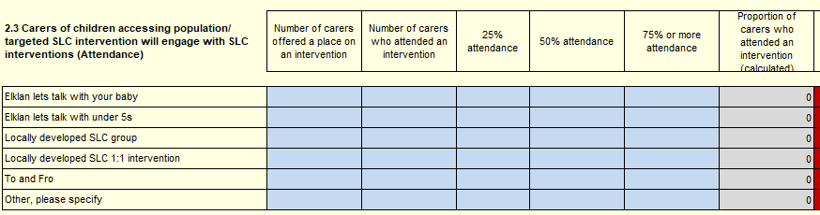
This is an output measure rather than an outcome. The decision to retain this measure is supported by the working group, because attendance is a helpful indicator of engagement.
Data to be requested:
- Intervention offered.
- Number of carers engaging with 25%/ 50%/ 75% of SLC sessions offered.
- Number of carers gaining accreditation.

  - Change in the Practitioner: ‘Practitioners will interact responsively with children and implement strategies to support children's SLC development and/or wellbeing’.

    - Outcome number 3.1: Practitioners will implement responsive interaction strategies to help children’s SLC and play skills.
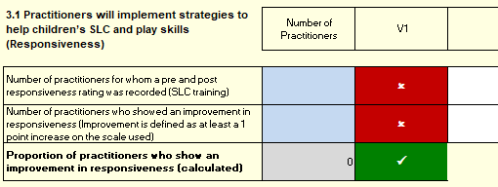
This measure is designed to capture the behaviour change resulting from SLC intervention. For the majority of practitioners, this will predominantly be in the form of SLC training (see SLC training pathway).
NB this change will need to be measured ‘per training’ and submitted on an annual basis. ‘Practitioners’ will include Flying Start childcare, parenting, members of Health Visiting teams and other Early Years Practitioners.
While the PaRRiS is designed as a measure of change in the parent/ carer; the authors have given permission for it to be used to capture change in practitioner responsiveness. This can be self-reported (e.g., using pre and post training video recordings) or peer reported. If existing measures (e.g., TILRS) are in place these can be retained and reported on. Please note that it is not essential that a formal or published tool is used. If you have a locally developed measure in use, you may continue to use it and report on that.

If you use different tools to measure the impact of different training (e.g., TILRS for LLLI; PaRRiS for Elklan 0-3s) you can combine the data for all of them and submit a total figure annually. For example, if 85 out of 100 practitioners trained showed an improvement of 1 or more points on TILRS following LLLI; and 70 out of 100 trained showed an improvement on PaRRiS following Elklan; you would submit data demonstrating that 155 of the 200 practitioners trained had shown a positive improvement in their responsive interactions with children following intervention.
Positive change is defined as an increase of at least 1 point on 1 or more items on the scale used. For example, on the PaRRiS scale, which has a maximum total score of 5, an improvement of 1 point (eg from 3 to 4) post intervention would be defined as a positive change. On a scale consisting of 5 items, each scored 0-10 (totalling 50 points), an improvement of 1 point (eg from 7 to 8) on one of the items scored would be defined as a positive change.

    - Outcome number 3.2: Practitioners will have increased confidence in supporting children’s SLC development.
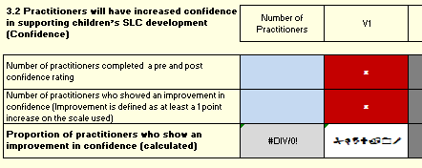
This measure is designed to capture change in adult confidence resulting from SLC intervention/ training, using pre and post intervention confidence rating scales: ‘On a scale of 0-10, how confident do you feel about interacting with the children you work with in a way that supports their SLC development?’
Positive change is defined as an increase of at least a 1-point increase on the scale used.
    - Outcome number 3.3: Practitioners will complete annual SLCF self-rating to establish SLC training needs.
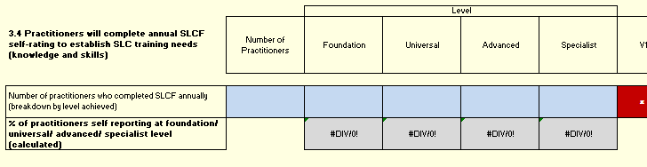

SLCF level: % of practitioners self-reporting at foundation/ universal/ advanced/ specialist level. This measure will be requested annually in the last term of the year.

  - Change in the Childcare Environment: ‘Childcare settings will provide a supportive communication environment’.

Outcome number 4.1: Childcare settings will provide a supportive communication environment’.

Following discussions with the working group and Flying Start Advisory Teaching network, it has been agreed that this data is not to be requested by Welsh Government until a consistent approach to QA is agreed. This section has therefore not been included in the new workbook.
Discussions around this measure centred on the use of ITERS/ECERS/SSTEW, with many LAs using these as their Quality assurance tools in settings. It was agreed that until a consensus has been reached around the use of these tools more widely, they would not be specified in this document. While self-rating of the communication environment has some drawbacks, it should complement the other measures requested. This also reduces pressure on e.g., advisory teachers to be responsible for submitting the measure of change in the communication environment.
We are looking at the possibility of a Wales wide certificate of ‘communication friendliness’. As we work towards that goal, this measure will not be requested by Welsh Government but may continue to be collated for local use, as follows: ‘Self-reported communication friendly environment measure as recommended in SLC training pathway (eg checklist))’
Annexes
Annexe 1:
Ultimate and short-term Speech, Language and Communication (SLC) outcomes for children aged 0-5 years supported by universal, population and targeted SLC services in Wales.
Annexe 2:
PaRRiS manual
Annexe 3:
Working group names
With thanks to all members of the working group, including:
Amy Crowther
Clare Yarnton
Delyth Dando
Hannah Dyer
Jane Hitchings
Kath Bowen
Kathryn Wright
Kathy Williams
Lindsey Hargan
Miriam Jones
Sherelle Jago
Shima Choudhury
Wendy Parker
and all other group members

NB We will never reach 100% of children having typically developing SLC on exit from Flying Start, due to 7-10% of the population having long term SLCN.
the PaRRiS is a measure of adult responsiveness, see annexe 2.
Inter-rater reliability is consistency of ratings between different observers (‘raters’) and can be checked by doing joint exercises to rate the same interaction eg using videos of parents and children)
Intra-rater reliability is internal consistency – i.e., the same rater using the same process each time to produce similar ratings for similar interactions.
‘practitioner’ is defined as any adult working within the service with a role in supporting SLC. This may be childcare practitioners. SLT Technical Instructors; Parenting/ Family Support workers etc.

