Single Unified Safeguarding Review (SUSR)

Initial Letter to Family, Friends and Others

[Please add the appropriate relationship of the letter recipient to the victim throughout the template]

Dear [INSERT NAME],
RE: Single Unified Safeguarding Review

We are writing to you in relation to a Single Unified Safeguarding Review that is being carried out by the [INSERT RSB] in relation to your [INSERT RELATIONSHIP]. A single Unified Safeguarding Review is carried out when someone has experienced significant harm or has died, and where it is thought lessons can be learned.
Firstly, we would like to say that we understand that you and your family may find this a difficult letter to receive and that we appreciate and understand that it may raise feelings linked to the [loss of your/circumstances surrounding the injury sustained by your] [INSERT RELATIONSHIP].The Single Unified Safeguarding Review will be carried out to enable the agencies involved with your [INSERT RELATIONSHIP] to come together. They will review their work and identify learning opportunities to determine if anything needs to change to improve their practices going forward.
To do this, we have been appointed as Independent Reviewers to write a report to summarise the findings of the Review. We would welcome the opportunity to meet with you personally so that we can make sure that the Review considers the family’s experience of the way things were done to support your [INSERT RELATIONSHIP] and you. Your insight is invaluable to the Reviewers and will greatly enrich the Review process should you choose to discuss your experience with us.
If you would like an opportunity to meet, please contact us on [INSERT PHONE NUMBER] or [INSERT EMAIL ADDRESS] to arrange a time and venue convenient to yourself.
A leaflet which contains further information about the Single Unified Safeguarding Review is enclosed with this letter.

Yours sincerely,

[INSERT NAME]

[PLEASE INCLUDE ANY RELEVANT SERVICES TO THE CASE/AREA]
Information sheet including Support Services you can reach out to:
If you’re struggling with your mental health, Mind offers support and bereavement services which can help you going forward. They have lots of helpful information on their website.
Call 0300 123 3393 or email info@mind.org.uk
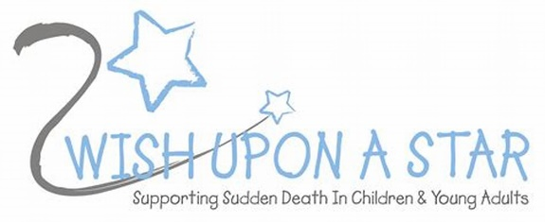
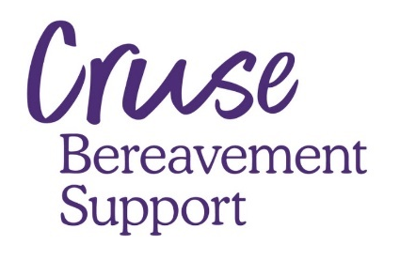

The Cruse Bereavement Care Freephone National Helpline offers emotional support to anyone affected by bereavement. You can also find helpful information on their website
National free helpline 0808 808 1677

For support when the unexpected death of a child/young person occurs.
Phone support provided/phone counselling and memory boxes supplied.
Call 01443 853125 or email info@2wishuponastar.org

