Active Travel in Wales

Annual Report

2024 – 2025

Active Travel Board

Contents
Foreword 3
Introduction 4
Key Information 2024/25 10
1. Improving our Active Travel Network 12
2. Active Travel to Schools 20
3. Building an Inclusive Active Travel Future 29
4. Everyday Active Travel 33
5. Communications and Behaviour Change 39
6. Our Active Travel Board 43
7. Recommendations 48

Foreword

Taking on the role of the Active Travel Board Chair at such a pivotal moment for Active Travel in Wales is a real honour. I’m proud to be able to bring both lived experience and professional experience to this role, having experienced first-hand the barriers that can prevent people from walking, wheeling and cycling, and my role at RNIB where I champion inclusive design and accessibility.

Wales is showing real leadership in creating transport systems that work for everyone. As Chair, I’m keen to support the Welsh Government, Transport for Wales and third sector partners and stakeholders to create infrastructure that can facilitate the needs of all. In particular, the need to ensure that wheelchair and mobility scooter users and those with a visual impairment can navigate routes.

The challenges ahead are significant. We must ensure that every pound spent moves us closer to our goal of becoming a true active travel nation. This means not just building infrastructure, but ensuring it is genuinely inclusive, properly connected, and supported by the behaviour change initiatives that will encourage more people to choose active travel for their everyday journeys.

I am grateful to my predecessor, Dr Dafydd Trystan, for his dedicated leadership and the strong foundations he has established. Building on this work, I am committed to ensuring that accessibility and inclusion are at the heart of everything we do.
Active Travel is not just about getting from A to B; it's about creating communities where everyone can participate fully in society, regardless of their age, ability, or circumstances. When we remove barriers – whether physical, cultural, or perceptual – we unlock the transformative potential of Active Travel.

I look forward to working with all our partners to ensure that Wales continues to lead the way in creating active travel networks that are not just comprehensive, but genuinely inclusive.

Together, we can build a Wales where walking, wheeling and cycling are accessible choices for all.

Kirsty James
Chair
Active Travel Board for Wales

[Note – Picture of Kirsty James is included on the page]

Introduction
As Wales' independent Active Travel Board, we assess the impact and effectiveness of active travel programmes delivered by Welsh Government and partner organisations.

Our role involves recognising key policy developments and offering evidence-based recommendations to ministers and delivery bodies on advancing active travel ambitions across Wales.

Read more about our governance in Section 6.

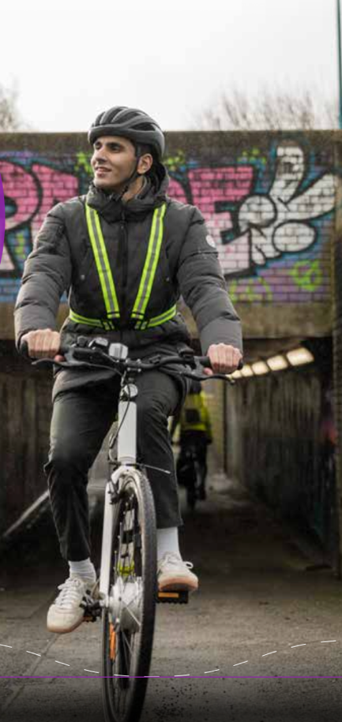

What is Active Travel? [Text Box]
‘Active Travel’ is a term used to describe walking, wheeling (using mobility aids, including wheelchairs, powered wheelchairs or wheeled walkers), scooting or cycling for purposeful journeys to a destination, alone or in combination with public transport. These are journeys that involve, for example, travel to school or work, rather than for leisure, pleasure or health reasons alone. It is often the cheapest and greenest form of transport.

Why it matters?

Health


It is estimated that obesity will cost NHS Wales £465 million by 2050, with recent Nesta analysis suggesting that Wales' obesity problem is the highest rate of all UK nations, with over a third of Welsh adults obese. Studies, including a 2024
publication in The Lancet Planetary Health, suggest active travel
interventions would make a significant difference:

- brisk 11-minute daily walks prevent one in 10 early deaths (a 23% reduction in mortality risk)
- a comprehensive cycling programme in the Netherlands delivered healthcare savings equivalent to approximately 3% of the annual Dutch GDP.

Economy

The UK’s poorest households are more than four times as likely to have no access to a car as the wealthiest – almost 20% of households in Wales based on current data. However, UK research demonstrates a £5.62 return for every £1 invested in active travel infrastructure, with Living Streets' Pedestrian Pound illustrating that people who walk and cycle contribute substantially more to local economies than businesses typically recognise. Studies in Bristol, Berlin and elsewhere consistently show that shopkeepers significantly underestimate pedestrian and cyclist customer numbers.

Sustainability


In 2023, domestic transport accounted for 17% of Wales' total carbon emissions, yet a comprehensive 2025 systematic review analysing 56 peer-reviewed studies between 2004 and 2024 across 30 countries on five continents found that walking and cycling could help reduce these emissions. A longitudinal study of seven European cities previously demonstrated that cycling instead of driving just one trip per day for 200 days could save about 500kg of carbon dioxide per year – the equivalent of five return car trips from Cardiff to Aberystwyth.

Wellbeing

Approximately two thirds of children and young people in Wales are concerned about their mental health and wellbeing. Mental wellbeing scores in 11- to 16-year-olds declining since 2019. A 2020 longitudinal study by Kroesen and De Vos found that active travel positively affects mental health over time.

A 2024 study in The Lancet Planetary Health also showed that active travel interventions consistently deliver social benefits, including improved social connection and social cohesion.



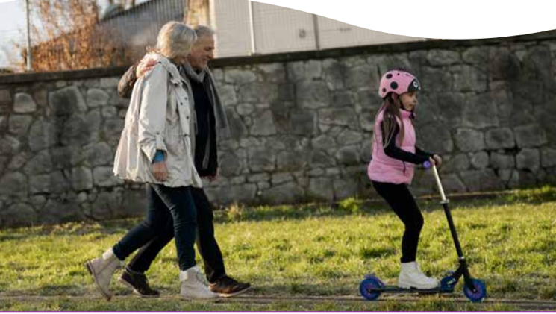

Welsh Government’s Active Travel Framework in Wales

How Active Travel is Delivered in Wales
Wales was the first country in the world to pass legislation specifically focused on active travel.

The Active Travel (Wales) Act 2013 requires the Welsh Government and local authorities to plan and deliver walking and cycling networks, continuously improving provision across Wales. It also requires the Welsh Government and local authorities to promote active travel and to enhance facilities for walkers and cyclists when maintaining and building highways.

In 2024, the Environment (Air Quality and Soundscapes) (Wales) Act further strengthened these duties by requiring Welsh Government and local authorities to promote active travel as a way of reducing air pollution, with the new duty taking effect in January 2025.

Transport Policy
Llwybr Newydd - Wales Transport Strategy (2021) sets out Wales' ambitions for transport, including 39% of all journeys by 2030 should be made sustainably, increasing to 45% by 2040.

National Transport Delivery Plan (2022-2027) maps out how the Welsh Government proposes to deliver Llwybr Newydd's targets across all transport modes.
Active Travel Delivery Plan (2024-2027) details 65 commitments on how Wales will make active travel easier to access, more attractive to use, and more inclusive. See the Welsh Government's recently published Active Travel Annual Report for full details on progress.

Welsh Government Partners
The Welsh Government works with several key partners to deliver its active travel commitments.

Local authorities plan, build and maintain local walking and cycling networks and facilities. This includes working with schools and communities to deliver training and behaviour change initiatives.

Transport for Wales (TfW) supports Welsh Government through policy and strategy advice and management of major programmes, as well as providing technical support, training and guidance to local authorities and other practitioners.

Third sector organisations like Walk Wheel Cycle Trust Cymru (formerly known as Sustrans Cymru) and Living Streets Cymru deliver behaviour change programmes, community engagement and deliver and maintain active travel route infrastructure.

Corporate Joint Committees develop regional transport plans and delivery programmes that include active travel priorities.

Public Health Wales provides strategic and technical support across intervention design, implementation and evaluation, with a current focus on active travel to schools.

The Importance of Independent Scrutiny
This report offers a critical eye and independent review of active travel delivery and impact across Wales. This is vital if we are to maintain momentum towards delivering a truly inclusive active travel nation where walking, wheeling, and cycling are accessible choices for all.
To this end, we have strengthened our focus on inclusivity this year, by dedicating a specific chapter to this crucial work.
This is the second annual report from the Active Travel Board for Wales; our inaugural report in August 2024 was welcomed by Welsh Government and received significant media coverage.

The Welsh Government’s Active Travel Annual Report provides detailed progress against all 65 Active Travel Delivery Plan (ATDP) commitments.

The value of last year’s report was reinforced by Audit Wales' own in-depth review in September 2024, which reached strikingly similar conclusions. The following pages relate not only to the specific activities of the Board, but also scrutinise the impact and effectiveness of active travel programmes delivered by Welsh Government and partner organisations between April 2024 and March 2025 in delivery of the ATDP, including recommendations for the next five years.

Funding Context
(Data Source from Welsh Government, but presented by the Board as a graph)

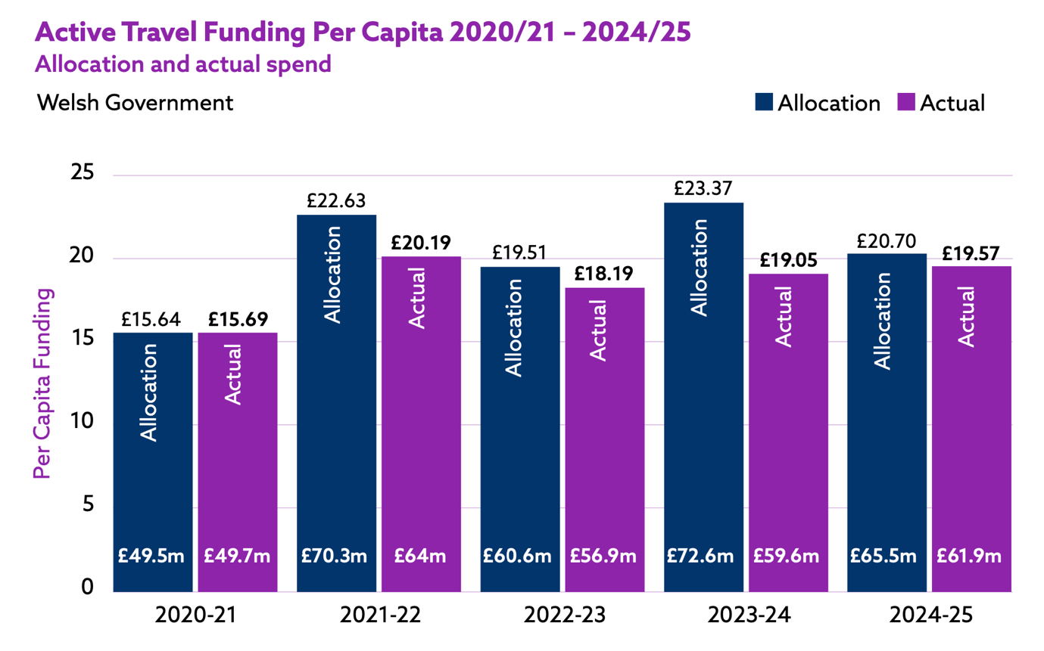

In 2024/25, allocation decreased from the previous year's allocation: from £23.37 to £20.70 per capita, but actual spend remained relatively stable, increasing to £19.57 compared to £19.05 in 2023/24.

Direct comparisons between UK nations can be complicated because active travel budgets are often developed differently. The information listed below has been provided by Government officials from each nation.

Northern Ireland’s Department for Infrastructure has recorded a provisional outturn figure for overall active travel spend in 2024/25 of around £52m (this is approximately £27 per capita). This includes all spend by the department for the benefit of pedestrians and cyclists, including activities funded by the Department that may be carried out by local councils in other areas.

In Scotland in 2024-25, £157m was allocated to active travel delivery partners and programmes across Transport Scotland from the active travel budget. Transport Scotland however has not calculated the per capita spend on active travel for 2024/25 as it recognises that there are a number of other sources of investment in this space.

In England, nearly £300m for active travel, covering 2024-25 and 2025-26, was announced by the Department for Transport in February 2025. The Department has previously estimated that over £3 billion will be spent on active travel during the period of the second Cycling and Walking Investment Strategy (covering the period 2021-22 to 2024-25).

Key Information 2024/25

Modest gains
Investment maintained at over £19 per head with adult cycling participation increasing from 6% to 7%, which is a 17% proportional increase. Strong political will saw new air quality duties to promote Active Travel, a new Active Travel to School Hub, and an emerging commitment to deliver inclusivity in active travel design.

Significant concerns remain
Transition to regional funding threatens ring-fenced active travel investment, placing Wales’ modal shift ambitions at risk. School travel rates are plateauing, with continuing gaps in infrastructure delivery and inclusive design.

Active Travel Funding
While allocation decreased from last year from £72.6m to £65.5m, the actual spend remained relatively stable at £61.9m compared to £59.6m in 2023/24.

» £19.57 per head

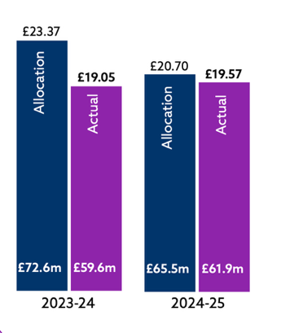

Active Travel Routes
Wales’ Active Travel network now stands at 3,126km, with 7,512km of routes yet to be completed according to Welsh Government data.

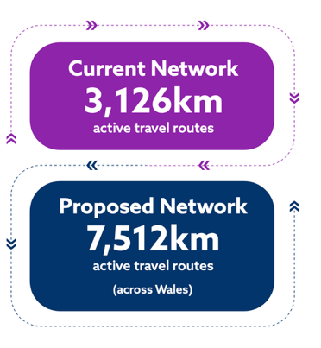

Welsh Government 2040 Targets
45% of journeys to be by public transport, walking, and cycling.
35% trip mode share of active travel.

Adult Rates of Active Travel in Wales
Walking rates remained stable with 52% of adults travelling actively for ten minutes or more at least weekly, while weekly cycling participation increased from 6% to 7%, representing a 17% proportional increase.
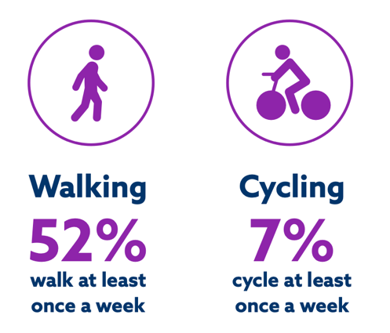



Active Travel to School Rates in Wales
Parents were asked about how their children travelled to school. 48% of primary school children were said to walk to school, and 33% of secondary school children.

For other survey data see Section 2.

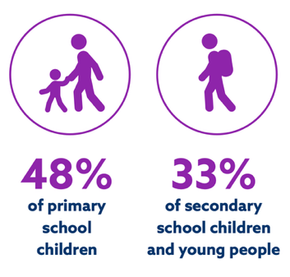
Source: National Survey for Wales Headline Results April 2024 to March 2025

1. Improving our Active Travel Network

Key commitments from the Active Travel Delivery Plan 2024-2027 in providing greater opportunities to walk, wheel and cycle in Wales include:
- creating high-quality infrastructure that improves the National Cycle Network (NCN), delivers active travel upgrades on the Strategic Road Network (SRN) (ATDP.39-40)
- maintaining current levels of investment to local authorities through the Active Travel Fund (ATDP.09)
- enhancing Transport for Wales’ (TfW) Active Travel Hub, specifically the capacity and skill base in active travel design expertise and programme management (ATDP.13).
A functioning active travel network is essential to encourage people in Wales to travel actively. Wales' world-first Active Travel Act plays a vital role, requiring all 22 local authorities to map comprehensive networks of active travel routes across Wales, keep them under review, and report on progress.
While last year's report documented steady annual growth in route building, these figures have since been revised through quality auditing. Some routes were reclassified or temporarily removed until they met required quality thresholds, reflecting Welsh Government's stated focus on delivering safe, high-quality, usable and accessible routes that genuinely encourage modal shift, rather than simply maximise kilometres built.
Current data snapshots from DataMapWales show the active travel network stands at 3,126km as of April 2024, up from 3,038km in April 2023. 7,512km of future network is yet to be built across Wales. The proposed future network would be over 10,500km, according to Welsh Government data.
These updated figures reflect ongoing data quality improvements and differ from previously reported numbers, demonstrating a commitment to accurate baseline data. Local authorities will review their network maps again in December 2026, when these figures may change once more.
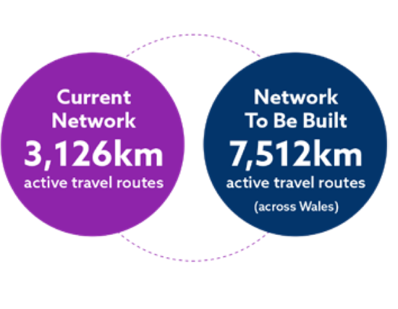

Investing in the Active Travel Network
The Active Travel Fund encourages local authorities to develop strategic projects that can transform local travel behaviours, including a core allocation distributed among all local authorities, totalling £15million, with individual allocations ranging from £500,000 to £1.48million. All remaining funds are for larger schemes like Newport's Gwastad Lock Bridge.

The Welsh Government's Active Travel Fund and Safe Routes in Communities Scheme allocations for 2024/25 accounted for more than £56m in funding, in order to provide:
- 37 funded projects across Wales, delivering 49.5km of new active travel networks through main and package schemes
- £15m core allocation distributed among all 22 local authorities for smaller improvements and scheme development
- 81 core activity and minor works projects delivered across all local authorities, including hundreds of dropped kerbs, new crossings, and accessibility improvements
- 24 Safe Routes in Communities schemes focused on creating safe walking and cycling routes to schools.
The 2024/25 allocation appears slightly smaller than 2023/24, with fewer Safe Routes schemes but similar levels of major project funding. What is evident is that Welsh Government reporting has shifted from counting routes to measuring kilometres delivered.

Transport for Wales’ (TfW) administration of the Active Travel Fund has ensured that new walking and cycling infrastructure meets Design Guidance Standards and that the delivery of new routes meets the ambitions set out in the bids for funding.

The Board is deeply concerned that the termination of TfW’s role, with the ending of the Active Travel Fund, will result in lower quality, less effective infrastructure that will provide less value for money.

The transition to a regional funding model and the end of the ringfenced Active Travel Delivery Plan suggests that active travel could well lose out to a small number of high profile and expensive projects.

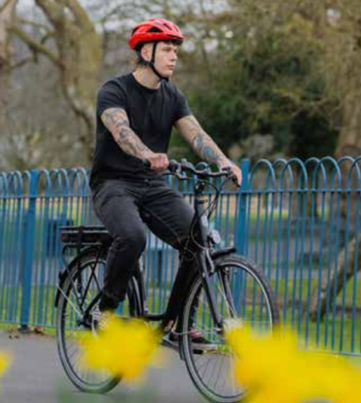

Welsh Government Allocation Breakdown: Active Travel Fund

and Safe Routes in Communities Grants 2024/25

Local Authority | Active Travel Fund | Safe Routes in Communities | Total Funding
Blaenau Gwent | £897,500 | £0 | £897,500
Bridgend | £784,861 | £0 | £784,861
Caerphilly | £2,534,000 | £0 | £2,534,000
Cardiff | £6,377,965 | £210,793 | £6,588,758
Carmarthenshire | £2,612,000 | £1,174,000 | £3,786,000
Ceredigion | £800,000 | £357,500 | £1,157,500
Conwy | £1,582,000 | £0 | £1,582,000
Denbighshire | £630,000 | £63,000 | £693,000
Flintshire | £1,432,000 | £450,000 | £1,882,000
Gwynedd | £1,400,000 | £448,000 | £1,848,000
Isle of Anglesey | £1,527,338 | £121,750 | £1,649,088
Merthyr Tydfil | £1,141,000 | £52,000 | £1,193,000
Monmouthshire | £6,681,000 | £300,000 | £6,981,000
Neath Port Talbot | £716,000 | £50,000 | £766,000
Newport | £2,046,005 | £50,000 | £2,096,005
Pembrokeshire | £1,252,019 | £466,577 | £1,718,596
Powys | £765,000 | £337,000 | £1,102,000
Rhondda Cynon Taff | £6,254,700 | £695,350 | £6,950,050
Swansea | £2,548,500 | £0 | £2,548,500
Torfaen | £2,077,931 | £0 | £2,077,931
Vale of Glamorgan | £2,102,005 | £624,868 | £2,726,873
Wrexham | £3,849,000 | £748,500 | £4,597,500
TOTAL | £50,010,824 | £6,149,338 | £56,160,162

The 2024/25 allocations represent approved funding rather than what was necessarily spent or delivered on the ground. Through their management of the Active Travel Fund, TfW co-ordinated expenditure of over 99% of the allocation. Approximately 95% of the overall funding was spent on local authority projects and the remaining funds were used to deliver walking, wheeling and cycling enhancements on the Core Valley Lines and wider Welsh Government transport projects.

In 2024/25, Monmouthshire received the highest allocation at £6.98m (including £4.54m for the continuing Abergavenny project), while Denbighshire received the smallest at £693k.

The prevalence of multi-phase projects – from Rhondda Cynon Taff's ‘phases 3 and 4’ to Cardiff's ‘phases 1 and 2’ – highlight both the necessity and challenge of multi-year funding. The gap between ambitious allocations and actual delivered infrastructure is an ever-present challenge, requiring sustained political commitment and improved delivery capacity across local authorities.

Example Routes

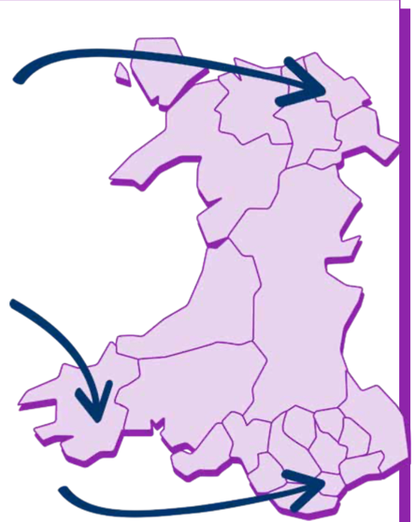

Flintshire
New controlled crossings were placed in Mold, Flint and Hawarden, improving safe walking access to local schools.

Pembrokeshire
Upgraded footpath along Jesse Road in Narberth, improving access between the local primary school and the community sports hub.

Cardiff
A new high-quality separated route was delivered in Roath Park, including parallel zebra and light-controlled crossings that link to Roath Park primary school.



1.2 Regional Transport Plans
Regional Transport Plans (RTPs) are five-year strategic documents that set out improvements to travel, developed by local authorities working together through four Corporate Joint Committees (CJCs) across Wales. This replaces the previous system where individual authorities prepared separate local transport plans.

All four CJCs conducted consultations on their RTPs up until spring 2025, and the Board agreed they would coordinate a collective response to all four, given their critical importance for active travel delivery. Each response called for a prioritisation of active travel within the sustainable transport hierarchy set out in Llwybr Newydd; the need for ‘laser-like focus’ on modal shift; clear targets; robust monitoring using National Travel Survey data; and a comprehensive approach to school access, combining infrastructure improvements with other measures, like school streets and parking restrictions.

Alwen Williams, Chief Executive of the North Wales Corporate Joint Committee (CJC), was invited to attend the Board meeting in February 2025, where she used the opportunity to highlight the significant emphasis on active travel, evidencing the collaborative efforts involving regional transport leads, Transport for Wales, Welsh Government and consultants. She pointed to 76 references to active travel in their draft RTP.

However, concerns were raised during the session, particularly in relation to how the plans would ensure that the active travel ambitions contained in the RTP would be delivered. Members also emphasised the need for more proactive outreach to stakeholders in north Wales, particularly active travel groups, including disabled persons groups.

Each Board response reflected regional contexts too: acknowledging rural transport challenges while welcoming the Newtown demonstrator town in mid Wales; emphasising inclusivity and robust equality impact assessments in south west Wales; and providing comprehensive technical critique in south east Wales.

1.3 National Cycle Network
Almost 60% of Wales' population lives within a mile of the National Cycle Network (NCN), which spans all 22 local authority (LA) areas. It is a vital component of our Active Travel Network.

Some improvements are made as part of the Active Travel Fund or through other local authority schemes, like the new light-controlled crossing installed across the busy A467 in 2024/25, which improved residents’ access to green space in Blaenau Gwent and interactive signing on the Canal towpath crossing for NCN 47 at Rogerstone, bringing this up to NCN standard.

In addition to maintenance works, like regular fencing, tree works, vegetation management, and public realm enhancements across NCN routes, capital funding is also allocated to Walk Wheel Cycle Trust Cymru for significant improvements, like major infrastructure repairs. In 2024/25 they delivered bridge replacements on the Elan Valley Trail; supported landslip remediation at Wiseman's Bridge; and repairs to the Ystwyth Trail at Llanilar.

The charity also resigned 190 miles of NCN routes following audit work and delivered a pilot project to address an innovative approach to engaging and capturing data on protected characteristics in access and barrier audits, in partnership with Pedal Power in Cardiff. Work was also completed on monitoring projects linked to barrier removals in various locations, including Wrexham.

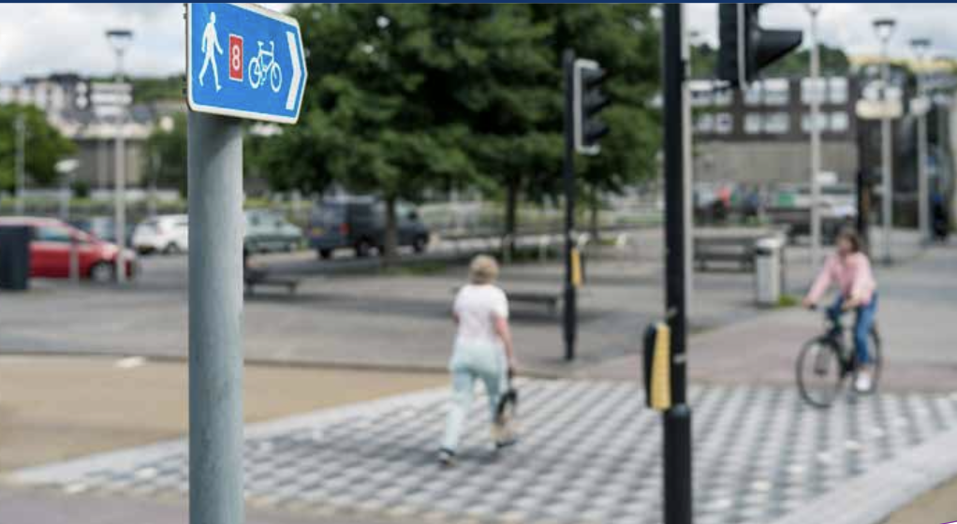

1.4 Seamless Journeys: Public Transport Hubs
Active travel needs to be integrated into overall transport planning for a fully functioning active travel network. Progress was made in 2024/25 to do just that.
In its own annual report for 2024/25, Transport for Wales (TfW) supported Corporate Joint Committees in developing active travel and public transport connectivity in their Regional Transport Plans, including projects to improve Cardiff Central and Wrexham Gateway.

According to TfW, approximately 60% of rail stations now have cycle parking. They are continuing to develop Station Network Plans, with local authority partners, to improve active travel routes to stations, such as those in Pontypridd Station and Cadoxton Station.

TfW’s Active Travel Design Office is providing technical design support to 34 local authority (LA) projects, and they also developed a draft quality assessment tool for station interchanges to better integrate active travel with public transport infrastructure.

New rolling stock is gradually increasing cycle capacity across the network, and during 2024/25, the first of six refurbished trains on the Heart of Wales line were introduced, offering more seats and 12 bike spaces.

The Board recognises progress in public transport integration but believes Wales' active travel ambitions, as outlined in Llwybr Newydd, require more strategic focus and investment. This includes enhanced cycle storage on TrawsCymru bus services, and the establishment of integrated ticketing as part of TfW's ‘One Network, One Timetable, One Ticket, One Team’ mission.

1.5 Bridging the Skills and Capacity Gap
If Wales is to become an active travel nation, it is vitally important that we have the resources and capacity to deliver the infrastructure and behaviour change needed. Building expertise across local authorities (LAs) – among officers, senior management and elected members – is essential for Wales' active travel ambitions.

Launched in 2023/24, the Academi Teithio Llesol training programme, which aims to build awareness, grow capacity and achieve at least 50% representation from LAs on each training course, demonstrated significant progress throughout 2024/25. Transport for Wales (TfW) delivered a range of personal development opportunities for all 22 LA officers, under the Academi Teithio Llesol umbrella.

Key training activities in 2024/25 included:
- An Academi Teithio Llesol Open Prospectus Day, as part of its annual conference at Llys Cadwyn on 27 November 2024, showcased its upcoming training programme, including workshops from RNIB, Sustrans and the TfW design office (more information in Section 3).
- An Introduction to the Monitoring and Evaluation Guidance Toolkit as part of the Active Travel Officers Group meeting.
- In-person Route Audit Training sessions to 40 local authority officers (from all 22 LAs), with events held in Pontypridd, Port Talbot, and Newport.
- Promotional Toolkit Training in three online drop-in sessions, which were attended by 37 participants from across 14 different LAs.
The Board particularly welcomes the programme's successful academic engagement strategy, including guest lectures at the University of South Wales and Wrexham University, alongside its extensive partnerships with universities across Wales including Aberystwyth, Bangor, Cardiff, and Coleg Grwp Llandrillo Menai.

We are also encouraged that the commissioning of AtkinsRealis in February 2025 to co-develop an Active Travel Design Training Course in 2025/26 will further strengthen technical capacity-building across Wales.

The Active Travel Design Office, established by Transport for Wales in 2023/24, expanded its team during 2024/25 while conducting comprehensive reviews of internal placemaking and design quality processes. The Board recognises the value of the Office’s practical approach: innovating by developing a draft quality assessment tool for station interchanges and delivering design projects, such as optioneering, for an Active Travel corridor in the Vale of Glamorgan and access infrastructure in Wrexham.

Supported by bi-monthly Active Travel Officers Group meetings that facilitate knowledge sharing and best practice across all 22 LAs, these capacity-building initiatives, instigated by TfW, provide a vital foundation for Wales’ active travel ambitions, and demonstrate a strategic commitment to building the professional expertise and institutional capacity necessary to deliver high-quality active travel infrastructure across Wales.

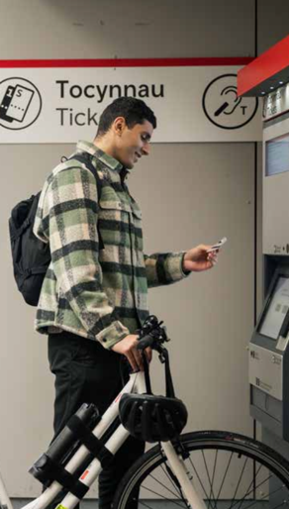

See recommendation
7.2.1 Vital Role of Ring-fenced Funding

2. Active Travel to Schools
A key commitment from the Active Travel Delivery Plan 2024-2027 is to support programmes to encourage more children and families to walk, scoot or cycle to school, supporting the development of active travel school plans for most schools (ATDP.62).

Getting children walking, wheeling or cycling to school is one of the most practical ways to embed lifelong active travel habits, supporting Welsh Government’s ambition to make these modes ‘the most natural and normal way of getting about’. School journeys are short, frequent, and often popular with children themselves, making them an ideal starting point for modal shift.

Too few children actively travel to school because systems designed to support active travel are often fragmented or poorly coordinated. But there has been some real progress this year, particularly through the work of our Active Travel to Schools (ATS) Subgroup, better investment in targeted programmes, and early signs of improvement in local planning and delivery.

2.1 Active Travel to Schools Subgroup
The Active Travel to Schools (ATS) Subgroup has become a key force in improving how we plan and support school travel in Wales. Meeting three times in 2024/25, the ATS Subgroup developed a set of six strategic recommendations (the need for a Hub, to break down silos, improve knowledge management, overhaul funding, secure effective delivery and evaluation) that have already been able to shape Welsh Government policy.

Members of the ATS Subgroup, including experts from academia and Public Health Wales (PHW), have also worked together to improve local-level insight and to support evidence-based decisions. For example, highlighting the role of school leadership in promoting active travel and the need to better understand disparities in school performance.

Altogether, the ATS Subgroup has been instrumental in the creation of the new Active Travel to School Hub, which brings together different strands of support in Welsh Government. It also plays a central role in revising the national delivery plan for ATS (which is due for completion in 2025/26) and is also keen to shape how school travel might feature in future Estyn inspections.



2.2 Active Travel to School Rates

A significant barrier to improving Active Travel to Schools (ATS) is the lack of reliable, up-to-date data, as outlined in last year’s annual report.

2.2.1 Scrutinising Official Data
New headline data from the National Survey for Wales in August 2025 suggests that 48% of primary school children and 33% of secondary school children and young people walk to school.

But the accuracy of ATS data in the National Survey for Wales is limited because it relies on parent reports and the response rate could be improved.

The School Health Research Network (SHRN) is a long-established survey that takes place every two years, and consistently enjoys a high school response rate (95.5% in 2023). This means that it is possible to gather the data required in Wales.

However, the most recent survey (from 2023), does demonstrate that the number of Year 7 to Year 11 pupils walking or cycling to school is failing to move in the right direction – 33% in 2023, compared with 35% in 2021.

New questions are being developed to strengthen national data sets, and Welsh Government’s transport team has confirmed it is working with its Knowledge and Analytical Services to carry out even deeper analysis of secondary school data through SHRN.

2.2.2 Challenges relating to the Hands Up Survey
Despite having the most robust and largest sample size set of data for active travel behaviour in Wales for 11- to 16-year-olds, we are still struggling to get a clear national picture of how many primary school children are walking, wheeling or cycling to school. Ultimately, this makes it much harder to identify where support is most needed.

Public Health Wales (PHW) coordinates the 2024 Travel to School Hands Up Survey which captures mode of travel data across participating primary school pupils in Wales. The survey results offer an improved understanding of the levels of Active Travel to Schools in Wales, which can help individual schools, local authorities and voluntary partners to take action to increase the numbers of pupils actively travelling to school.

Over 34,000 primary school pupils took part in 2024 from 202 schools (compared with 40,000 pupils in 270 primary schools in 2023) resulting in a five percentage point reduction in the number of schools that took part, down to 17%. Overall, the data suggests that 58% of children travel actively to school. However, because of the large variance in survey response rates across local authorities persisted in 2024, it means this data, while useful at school level, might not constitute a representative sample at local authority level.

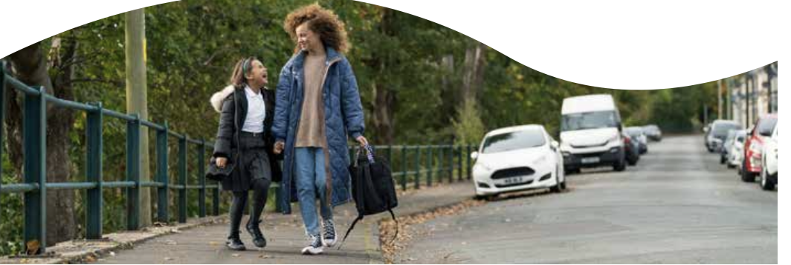

2.2.3 Research and Mapping
Swansea University (funded by Administrative Data Research (ADR Wales)) and Public Health Wales continued to work together throughout 2024/25 to develop a resource that would allow schools and local authorities to estimate what percentage of their school children live within feasible ATS distances. The project using the SAIL databank will calculate the shortest network distance from properties to all schools in Wales, within several distance bands up to 10km.

This project aims to develop an online interactive and intuitive isochrone map, where stakeholders will be able to easily filter, stratify and understand pupil population in the context of active travel distances overlaid on geographical maps.

This feasibility tool combined with existing behaviour survey data from sources such as the School Health Research Network’s (SHRN) Student Health and Wellbeing Survey, the National Survey for Wales and the national Travel to School Hands Up Survey will provide more robust intelligence led planning and intervention targeting.

The Active Travel to School Hub is also collaborating with the GIS team at Transport for Wales and DataMapWales to map active travel to school interventions. Currently an internal map, the aim is to eventually provide relevant stakeholders with access, enabling them to track progress and identify schools or areas in need of further attention.

2.3 Investing in Active Travel to Schools

The Safe Routes in Communities Grant received £6.15m in 2024/25, funding 24 schemes across Wales that focused on creating safe walking and cycling routes to schools, supporting infrastructure improvements including improved crossings,
traffic calming, lighting, and dedicated paths around schools.

Altogether, in 2024/25, Welsh Government significantly increased its investment in ATS to £8.3m. For a full breakdown, please go to the Welsh Government’s own active travel annual report. This funding supported both infrastructure improvements and behaviour change programmes.

2.3.1 Active Travel to School Hub
A major step forward this year was the formal creation of the Active Travel to School Hub (the Hub), which now coordinates delivery of:
- Safe Routes in Communities (SRiC) Grant
- School Streets Projects
- behaviour change programmes such as WOW and Active Journeys
- wider stakeholder engagement.
Detailed terms of reference for the Hub are currently being developed by the Subgroup.

In total, the Hub reviewed 40 school infrastructure business cases under the Sustainable Communities for Learning programme and helped improve routes and environments around schools, including St Richard Gwyn in the Vale of Glamorgan and Ysgol Treferthyr in Criccieth.

2.3.2 School Streets Guidance
The Board welcomes the comprehensive School Streets guidance for local authorities published in March 2025. The guidance was developed in collaboration with local authorities, UK Government, Active Travel England, Play Wales and other stakeholders.

The guidance provides an overview of what School Streets are, the key steps and factors to consider when developing and implementing schemes and the role of School Streets in the wider context of enabling walking, wheeling and cycling to school.

2.3.3 WOW Walk to School Programme (Living Streets Cymru)
The WOW programme continues to show good outcomes, according to Living Streets data provided to us. With funding of £385,000 over two years, it reached 189 primary and 42 secondary schools, involving over 63,000 pupils:
- at primary level, there was a 20% increase in walking and wheeling, and a 57% overall increase in active journeys
- more than 1 million active school journeys were logged in just seven months
- in secondary schools, nearly half of pupils taking part in the Next Steps Challenge said they were walking more as a result.


2.3.4 Active Journeys Programme (Walk Wheel Cycle Trust Cymru)
According to data provided to us by Walk Wheel Cycle Trust Cymru’s, the programme worked with 105 schools and reached over 13,000 people with £420,000 in Welsh Government support. Preliminary outcomes are similarly encouraging, ahead of the full external evaluation, which will be published in late 2025:
- 12% increase in active travel
- 14.7% decrease in car use
- over 800 activities delivered, including bike repairs, route planning, and skills training.
Additionally, as part of Welsh Government's goal that all schools should have active travel school plans, Walk Wheel Cycle Trust Cymru delivered 145 Active Travel School Plans (ATSPs) across mainstream, rural, urban, and Additional Learning Needs (ALN) settings.

This included running three Wales-wide awareness campaigns, launching a new bilingual website, and refreshing the Active Travel to Schools Toolkit with curriculum-aligned resources. The programme conducted over 30 interviews and developed eight case studies to inform delivery and showcase good practice, using mapping technology to track uptake across Wales.

ATSPs are now a mandatory requirement for schools applying for Safe Routes in Communities Grant funding, a policy that came into effect for 2024-25 funding applications.

2.3.5 Cycle and Pedestrian Training
National Standards Cycle Training (NSCT) and Child Pedestrian Training (known as Kerbcraft) are delivered through the Road Safety Revenue Grant, managed by the Welsh Government's Road Safety Team. Welsh Government data shows that, for 2024/25, funding included £687,924 for cycle training (a 3.2% increase from the previous year) and £698,487 for Kerbcraft (a 4.6% decrease from the previous year). It also shows that, overall, participation rose 11% with 31,265 pupils trained.

We can see from the Welsh Government's own annual report that standards have also been improved through strict trainer qualification requirements. It is disappointing, however, that plans to adopt Bikeability as a framework for Wales have been paused due to capacity and funding constraints.

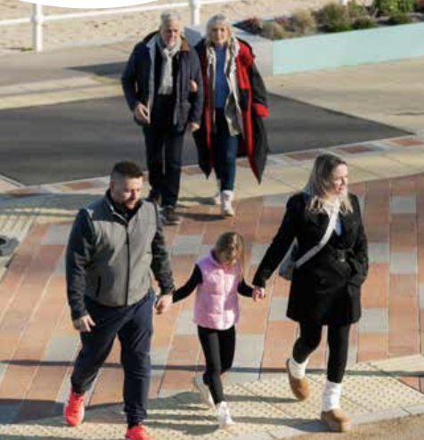

2.3.6 Cross Government Collaboration

The Board welcomes growing efforts by Welsh Government to link ATS with wider policy areas. This includes contributions to the Play Sufficiency Assessments, stronger alignment with the Healthy Weight Healthy Wales Delivery Plan, and collaboration with education and inspection bodies to better reflect school travel in both planning and practice.

In 2024/25, Welsh Government held discussions with Estyn about incorporating active travel into school inspection frameworks, with a thematic review identified as a potential way forward to support increased active travel. The Active Travel Team also worked closely with the Learner Travel Team throughout the year to strengthen active travel language in the updated Learner Travel Operational Guidance.

2.4 Healthy and Active School Journeys Conference
In March 2025, 120 delegates gathered in Cardiff for the Healthy and Active School Journeys Conference – a vital milestone in building Wales’ active travel community of practice. The Active Travel to Schools Subgroup was also represented, showcasing the strategic work they undertake to delegates.
Showcasing adapted bikes, and running inclusive workshops, including community engagement and supporting pupils with diverse needs, the day also reinforced the importance of sharing learning between schools, local authorities, and delivery partners so as to secure lasting change.
Conference learning also demonstrated the need for more engagement with schools, parents and local authorities so as to ensure any new strategy is grounded in lived experience.

2.5 Active School Travel Place Based Approach
Public Health Wales (PHW) continues to develop its Active School Travel Place Based Approach pilot project. The project aims to determine how a place-based approach could be used to generate and galvanise Active Travel to School improvement activities and actions at a hyper-local level. PHW are now in phase 2 of the pilot project, building on the methodology, intervention design, evaluation framework and the number of participating schools from phase 1.




Photo Caption – Cabinet Minister Ken Skates MS joins Living Streets staff and Ysgol Bryn Collen on their walk to school in November 2024.

Case Study

Safer Streets, Happier Students: Ysgol Bryn Collen's WOW Success
Ysgol Bryn Collen in Llangollen, Denbighshire, has recorded an impressive increase in active journeys by more than 30% since taking part in WOW – the Walk to School Challenge by Living Streets Cymru – from September 2024. Teachers were motivated to take part in WOW as the school is situated in a busy town with narrow roads and there were increasing concerns about road safety.
Headteacher and WOW Champion, Lisa Howden reported a decrease in the number of cars outside Ysgol Bryn Collen – resulting in a safer walking environment; benefits to pupil wellbeing; improved attendance; happier children coming to school, more willing to learn and enjoyment of the social aspect of walking to school.
Commenting on the results, Ms Howden said: "WOW has definitely made our school more active and it has reduced the number of cars on the roundabout on a daily basis. Walking to school has become second nature to many of the pupils, and it’s great to see happier children coming into school every day.”
Funded by Welsh Government, Ysgol Bryn Collen is one of 170 primary schools (as well as 42 secondary schools) taking part in this two-year Living Streets Cymru project, demonstrating the positive impact of active travel investment on local communities.
Graph – Title: Modal shift in Ysgol Bryn Collen
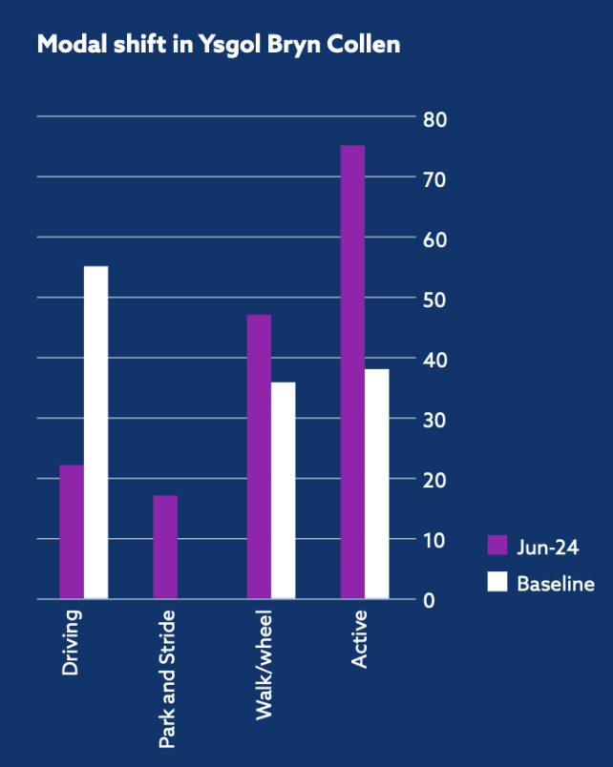
Across project primary schools, Living Streets Cymru resulted in a 20% increase (6.63 percentage points) in walking/wheeling (using mobility aids, including wheelchairs or wheeled walkers) all the way to school compared to its baseline. In the same period, there was a 57% increase (25.10 percentage points) in active journeys to school (including walking/wheeling, cycling, scooting/skating and ‘Park and Stride’).
Source: Living Streets Cymru and The Leader (November 2024)

See Recommendation
7.2.2 Build an Effective Active Travel to School Hub

3. Building an Inclusive Active Travel Future
Key commitments from the Active Travel Delivery Plan 2024-2027 in building an inclusive active travel network include:
- removing physical barriers, where possible, on active travel routes (ATDP.41)
- conducting specialist equality, diversity and inclusion design reviews (ATDP.42)
- widening opportunities for inclusive cycle training and encouraging the expansion of training outside of school settings, including provision of adult cycle training (ATDP.56)
- improving the experience of carrying cycles, mobility scooters and prams onto public transport (ATDP.51-52).

3.1 Reconvening the Inclusive Active Travel Subgroup
Welsh Government's transport strategy emphasises the importance of designing infrastructure that meets diverse needs and fosters equitable participation in active travel and the Board has done much to push this agenda further in 2024/25.

The Board successfully reconvened the Inclusive Active Travel Subgroup in November 2024, establishing a comprehensive work programme. A strong theme of inclusive design and inclusive language has developed within the Subgroup, reflecting the Board's commitment to ensuring active travel works for everyone.

3.2 A Wales-Wide Approach to Barrier Removal
Significant progress was made by the Inclusive Active Travel Subgroup in the last year in understanding the impact of existing law and Welsh Government Guidance in providing for unimpeded access for all to the active travel network, including people with protected characteristics under the Equality Act 2010. It is relevant that the Board has found Welsh law to be stronger in a couple of important ways than that applying in England – but hitherto widely ignored.

One of the Board’s Independent Members has been leading this research; we intend to publish the results during 2025/26 with the hope of securing the consequent removal of all unlawful access barriers on the active travel network throughout Wales.

Good progress has been made across the country but much remains to be done before the entire active travel network is truly ‘open to all’ in accordance with settled Welsh Government policy and the law.

3.3 Embedding Inclusive Design
Training events form part of Transport for Wales’ (TfW) newly established Academi Teithio Llesol, Active Travel academy, which has been designed collaboratively with local authorities and Welsh Government to pull together opportunities for learning, knowledge sharing and best practice. We were delighted that former Board Chair, Dr Dafydd Trystan, was asked to chair the annual conference held at Llys Cadwyn in Pontypridd on 27 November 2024.

With 12 local authorities represented, the event featured interactive workshops delivered in collaboration with RNIB, Sustrans and the TfW Design Office, providing officers with practical training on inclusive design approaches to active travel.

The value of this inclusive design training was captured in participant feedback, with one local authority officer commenting: "The RNIB session brought home the importance of inclusive design and to consider active travel through the experiences of all users. It really helped me to get an understanding of how difficult inconsiderate design of AT routes can be for visually impaired people."

A further training event is also scheduled to take place in Wrexham in 2025.


[Caption – Former Board Chair, Dr Dafydd Trystan, stressed the importance of inclusive design during the Academi Teithio Llesol annual conference in November 2024.]

Case Study

Personal Experience Guides Inclusive Active Travel
For Amanda Say, a dedicated transport accessibility campaigner living in Cwmbran, navigating Wales’ active travel network can often be challenging.

What appears as a simple journey for many can become an insurmountable obstacle for others. A-frame barriers, like the one pictured in Ebbw Vale, illustrates the challenge perfectly, as explained by Amanda: “This one makes a complete journey impossible and forces you to retrace your journey, creating anxiety about the range of my powerchair.”

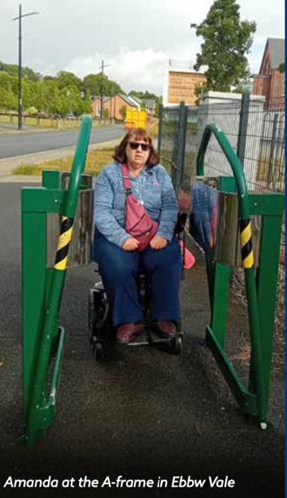

[Amanda at the A-frame in Ebbw Vale]

Her regular travels have revealed patterns that might otherwise remain invisible to transport planners: the kissing gate that forces a detour, the chicane that’s too narrow for mobility equipment and ‘minor’ design choices that can make or break someone’s independence.

“The irony” Amanda explains, “is that these barriers are meant to improve safety, but they often create the very accessibility problems we’re trying to solve.”
Amanda’s approach to campaigning is grounded in lived experience. She uses public transport several times a week to attend meetings across Wales, and personally encounters the barriers to what should be seamless journeys: “If we can link all active travel routes together, that journey – for everybody – is going to get much easier.”

This personal insight has proven invaluable in her role as a member of the Inclusive Active Travel Subgroup, which she joined in 2024, and where she has worked alongside Independent Board Member Richard Brunstrom to help develop solutions that work for everyone, including disabled people, older people using walking aids, and parents with prams.

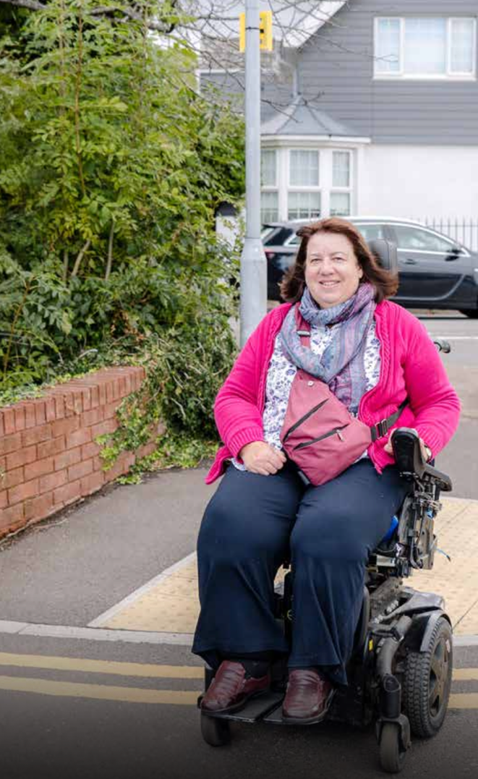

Caption: Amanda says: “The addition of the dropped curb now means I can stay on the pavement in safety rather than travel a section of my journey on the road, negotiating a blind bend into oncoming traffic.”

See Recommendations
7.2.3 Accelerate Wales-Wide Barrier Removal
7.2.4 Embed Inclusive Design Throughout Active Travel Delivery

4. Everyday Active Travel
Key commitments from the Active Travel Delivery Plan 2024-2027 in promoting everyday active travel include:
- supporting workplace travel initiatives to encourage sustainable commuting and work-related journeys (ATDP.63)
- improving access to cycles for a range of needs, including cycle loans, cycle hire schemes, and supporting access to lower cost second hand cycles working with TfW and local authorities to secure cycle parking storage units (ATDP.43-49).
We will become an active travel nation when everyone who wants to walk, wheel or cycle can do so confidently and safely. This means breaking down the barriers that deter people from travelling actively.

4.1 Safer Roads
The introduction of the 20mph default speed limit in September 2023 is showing a strong connection to safer streets and improved conditions for active travel.
Transport for Wales' comprehensive monitoring report, published in July 2025, providing data up to March 2025 confirms 630 fewer casualties (a 26.2% reduction) on 20mph and 30mph roads in total.

The period between July and September 2024 recorded the lowest quarterly casualty figures since records began. Given that safety concerns is one of the main reasons why people do not walk, wheel or cycle more, or let their children do so, these safety improvements directly support active travel.

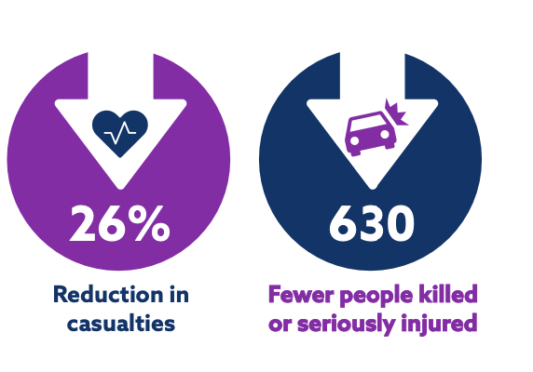



4.1.1 20mph Speed Limit Implementation
The Board received detailed updates on the 20mph speed limit implementation during 2024/25. Draft guidance was issued to local authorities, with the Board providing input on community participation, representation, and implementation challenges. During his session, the Cabinet Secretary emphasised the importance of gaining public support for the policy to achieve widespread adherence.

Key areas of Board discussion included the need for enforcement and engineering measures on 20mph roads that have poor compliance, like reducing carriageway width or introducing chicanes or speed tables / cushions; the importance of risk assessment in relation to proposals to return to 30mph speed limits; and the promotion of active travel as a key benefit of implementation.

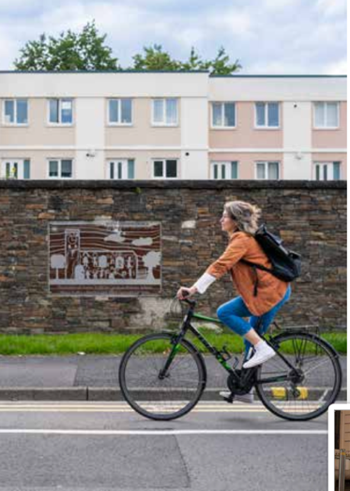

4.2 Active Travel to Work
Walking, wheeling and cycling produce zero emissions and are the least expensive way to get to work.

4.2.1 Cycle Parking and Storage
One of the most important considerations for people thinking about cycling to work is the availability of secure, weatherproof parking for their bike, such as cycle hangars, many of which can store up to six bikes in the space ordinarily taken by one car.

According to the Welsh Government’s Active Travel Annual Report for 2024/25, some progress was made in expanding cycle parking provision, with 16 Active Travel Fund projects focused specifically on cycle parking and a further 12 incorporating public cycle repair stands. Notable examples included the Vale of Glamorgan installing parking for 155 bikes and scooters with targeted school investment, Newport adding 21 new cycle stands across six city locations, and Swansea purchasing 10 new cycle hangars for residential areas.

Transport for Wales (TfW) also worked with housing associations to improve cycle security, procuring 40 cycle hangars to be installed at 36 locations across Wales. With approximately 60% of rail stations now providing cycle parking, these developments are solid steps toward addressing the barriers preventing people from cycling to work.

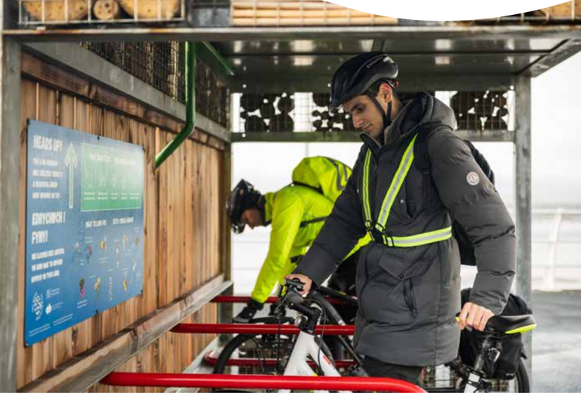

4.2.2 E-bikes
E-bikes can encourage more people to travel actively by making cycling accessible to those who may find traditional cycling challenging due to age, health conditions, or hilly terrain.

The E-Move scheme in Aberystwyth, Barry, Newtown, Rhyl and Swansea, operated by Sustrans Cymru since 2021, completed its Welsh Government pilot phase in March 2024. On the back of this pilot, a new e-bike borrowing project was launched in Abergavenny and Merthyr Tydfil, which the Board welcomes.

Board member – and now Chair – Kirsty James, drawing on her expertise as a severely sight-impaired person and in her role with RNIB, highlighted concerns blind and partially sighted people experience with e-bikes in mixed-use spaces.

As a result, Board member Alan Tapp agreed to develop a Board-authored scientific evidence review on e-cycling’s benefits and risks. The review identifies the need for clear differentiation between legal and illegal e-bikes and the enormous health, environmental and societal benefits of e-cycling. A key finding is how safety concerns in relation to e-bikes are not reflected in collision statistics, and that traffic casualties are overwhelmingly due to motor traffic. For example, in the UK, including Wales, pedestrians are 400 times more likely to be killed or seriously injured by car drivers than by bike riders.

In 2025/26, the Board will issue an advice note highlighting the importance of distinguishing between legal e-bikes that provide valuable transport benefits and non-compliant e-bikes and unregistered e-motorbikes that pose safety risks, particularly in shared spaces and pedestrian areas.

Definitions

Legal e-bikes: pedal assisted and cut-off motors at 15.5mph, with maximum continuous power output of 250W.

Modified e-bikes: illegal on public roads, paths or land; typically pedal assisted but 15.5mph cut-off is disabled, with maximum continuous power output well over 250W.

E-motorbikes: often resemble legal e-bikes, but do not have pedal assistance and offer no physical health benefits. They are typically twist and go throttled machines, often advertised and described incorrectly as 'e-bikes' in the media. They are illegal on public roads unless registered and insured as motor vehicles.

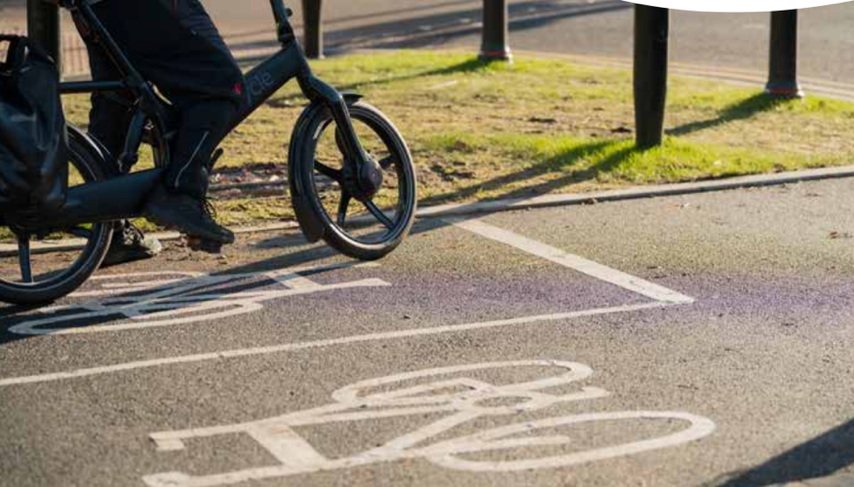

4.2.3 Workplace Active Travel Initiatives
The Welsh Government supports workplace active travel through the Healthy Travel Charter programme, which encourages public and private sector organisations to commit to healthier and more sustainable forms of transport for their employees.
Welsh Government funds two Healthy Travel Officers, hosted by Sustrans, who work with organisations that have signed up to the Charter across Cardiff and the Vale of Glamorgan, Gwent, and Swansea Bay.
A key component is the establishment of bike libraries that stock e-bikes, standard bikes, and scooters available for free loan by employees of Charter signatory organisations. Welsh Government itself is a Charter signatory and during 2024/25 funded Dr Bike sessions for its own employees and hosted active travel events through its Living Sustainably Network, including women's cycling rides and workplace programme sessions with Living Streets and Transport for Wales (TfW).
The Board welcomed these internal Welsh Government initiatives as demonstrating leadership by example in promoting active travel to employees.


Case study

How E-bikes Improve Working Conditions for Vale Care Workers

The Travel with Care pilot project, launched by Vale of Glamorgan Council in partnership with Walk Wheel Cycle Trust Cymru provides free e-bike loans, including helmets, locks, pannier bags and waterproof clothing, to domiciliary care workers with limited access to private vehicles or public transport.

In November 2024, Walk Wheel Cycle Trust Cymru wrote about the impact of the pilot project scheme, which showcases the role of e-bikes in removing travel barriers to work, by opening up care workers’ ability to serve clients across wider geographical areas and maximise their income.

One such beneficiary is Frank*, who travels over 700 miles on his e-bike, as he can now support clients in Dinas Powys and Penarth: journeys that take just 30 minutes by e-bike. This means he can take on additional shifts and earn more income, as he explains: “It really is making a big difference to my life.”

*Name changed to protect his identity.



Photo caption – People working in domiciliary care in the Vale of Glamorgan could borrow an e-bike for free as part of the Travel with Care pilot project.

Credit: Tom Lee

Source: Walk Wheel Cycle Trust Cymru

See Recommendation
7.2.5 Support Safe E-Cycling While Addressing Public Safety Issues

5. Communications and Behaviour Change
Key commitments from the Active Travel Delivery Plan 2024-2027 to motivate and encourage greater uptake of active travel, include:
- further developing its Climate Action Wales communications campaign (ATDP.29)
- supporting local authorities via a TfW promotional toolkit and DataMapWales (ATDP.33-34)
- providing active travel training for all ages, including through TfW’s Academi Teithio Llesol (ATDP.12 and 54-56)
- developing a national monitoring and evaluation framework by TfW establishing pathfinder schemes through collaboration (ATDP.16 and 26).
Welsh Government is looking to increase how many of us travel sustainably, which is why modal shift is at the very heart of the Llwybr Newydd transport strategy.

5.1 Promoting Everyday Active Travel
In January 2025, new statutory duties under the Environment (Air Quality and Soundscapes) (Wales) Act 2024 came into force, requiring Welsh Government and local authorities to promote active travel specifically as a way of reducing air pollution, which was discussed during the Cabinet Secretary's session with the Board in November 2024.
The Board welcomed this strengthening of promotional requirements for everyday journeys. Draft guidance was shared with local authorities in January 2025, with the Cabinet Secretary emphasising the importance of providing guidance on available active travel routes, cycle training, and integration with public transport.
Final statutory guidance is expected by end of 2025.
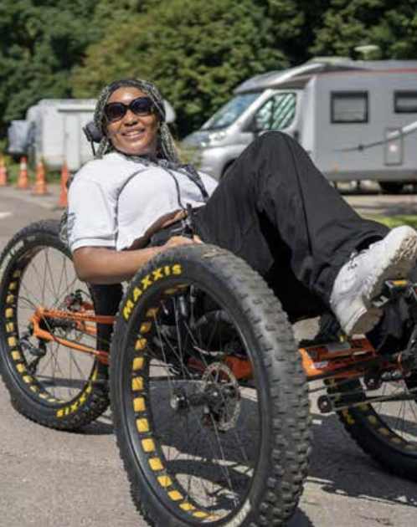

5.2 Climate Action Wales Campaign
The Board received detailed presentations from Welsh Government communications officers on the Climate Action Wales campaign during 2024/25. The campaign aims to engage people in developing climate policies and use communications to build knowledge and encourage action, focusing on four main themes: travel choices, home energy consumption, food, and consumption.

The transport communications team developed a bank of case studies promoting active travel benefits, with Board members invited to share further examples. The campaign uses two strands: actions for people to take and increasing belief that others are taking action.

The campaign's effectiveness is measured using quarterly surveys on belief that action is being taken, and annual surveys to determine increases in knowledge and willingness to do more. The approach follows the COM-B model for behaviour change, though strict standards around publishing statistics mean most campaign data will not be published.

The Board discussed Welsh Government's lessons learned exercise on the 20mph campaign, and emphasised the importance of personal stories and experiences in driving behaviour change, particularly in relation to climate change and social justice. The Just Transition Framework and challenges faced by disadvantaged groups in taking action were also highlighted.

5.3 Monitoring and Evaluation
The Board welcomed the launch of the National Travel Survey in 2024/25, which will provide comprehensive data on the impact of active travel investment by 2026. This addresses a long-standing gap in our data collection capabilities that has hindered our ability to measure progress effectively since the last dedicated survey in 2012.
Transport for Wales (TfW) made significant progress with the Active Travel Monitoring Framework, which was launched during 2024/25, a draft of which was presented to the Board in November before being launched in February 2025.

The Active Travel Monitoring Framework (the Framework), which includes 17 monitoring measures (15 of which were published at launch due to data availability), provides a baseline for consistently tracking and monitoring active travel across Wales and help identify national trends.

The Framework aims to provide consistent active travel data collection through dashboards and proxy data until the National Travel Survey becomes fully operational.

Case Study

Challenging car-dependent travel patterns

The National Eisteddfod of Wales in partnership with Transport for Wales (TfW), successfully challenged car-dependent travel patterns during the 2024 Pontypridd festival, when just under 100,000 passengers used the local rail service over the eight-day period in August, mostly from Cardiff Central, but also from Llandaff, Cathays and Queen Street stations.

Pontypridd Station normally services between 26,000 and 27,000 journeys per month, and while daily journeys remain unchanged post-festival, at 900 customers per day, phenomenal customer feedback suggests a new-found interest in combining active travel with public transport when travelling to major events.

This behaviour change initiative, which successfully encouraged people to rethink their transport choices and embrace sustainable and active travel alternatives, were also replicated in 2025 during the Wrexham festival, with TfW actively engaging with Cycling UK and Wrexham Council to identify safe routes and methods for visitors choosing to bike, wheel or walk.

The Eisteddfod itself has for many years, as part of its transport strategy, incorporated active travel considerations, such as ensuring each festival has 400 bike spaces on offer, as well as park and ride options. Strategic Director Gwenllian Carr says: “The decision to hold the Eisteddfod in Pontypridd was dependent on the commitment to promote active travel, requiring the support of many stakeholders, including the BBC as well as TfW. We dedicated a lot of resource in promoting active travel before and after the festival and it paid off, with more visitors travelling car-free than previous years.”

Twenty-one-year-old singer-songwriter Elli Glyn's first train journey to the Pontypridd Eisteddfod in 2024 left such a positive impression that she chose rail travel again for her outward journey to the 2025 Wrexham Eisteddfod.

The National Eisteddfod in Pontypridd has offered a template for other major festivals to follow suit, with the Urdd Eisteddfod also adopting a similar approach in May 2025.



[Pontypridd Station during the 2024 National Eisteddfod.
Image Credit: Transport for Wales
Elli on the way to the Wrexham festival in 2025.]

See Recommendation
7.2.6 Effective Promotion of Active Travel

6. Our Active Travel Board
The Active Travel Board for Wales provides an independent voice that scrutinises the effectiveness of active travel related measures delivered by the Welsh Government, including their funded delivery partners and agencies.

First established as a Ministerial Board in early 2014 to support the effective implementation of the Active Travel (Wales) Act 2013, an independent chair, Dr Dafydd Trystan, was subsequently appointed in 2020, ahead of a significant reshaping of the Board in 2023, including the appointment of independent members.

The Board’s role involves:
- scrutinising the Welsh Government, and other bodies charged with delivery, on progress
- reporting annually on progress including national data on active travel outcome measures, and
- bringing together delivery partners to share best practice and identify challenges.

Secretariat support for the Board was undertaken by Welsh Government for the 2024-25 period, and a small budget was made available for research and communications activities, including the publication of an annual report on 30 August 2024.

6.1 Who we are
[Editorial note - list of members with photos here.]

Dr Dafydd Trystan, who served as Chair since the Board’s reform, announced that he would step down following the April 2025 meeting. Independent member Kirsty James was subsequently appointed as the new Chair, bringing both lived experience and professional expertise in accessibility and inclusive design from her role at RNIB.

The Board maintained its core structure with independent members including
- Gwenda Owen
- Shayoni Lynn
- Richard Brunstrom
- Roisin Willmott
- Rhiannon Letman-Wade (Deputy Chair)
- Kirsty James (Chair from April 2025)
- Dr Dafydd Trystan (Chair until April 2025)
- Alan Tapp
- Chris Roberts (Cross-Party Group on Active Travel)
Local authority representation continued on a regional basis, with ongoing representation from councils including Merthyr Tydfil CBC, Isle of Anglesey County Council, Flintshire County Council, Neath Port Talbot Council, City and County Council of Swansea, and Ceredigion County Council, alongside the Welsh Local Government Association (WLGA).

“The Board has undertaken very important work this year in identifying the barriers that prevent people from walking, wheeling and cycling and in ensuring that government takes action to address them. As an independent voice working constructively with government, local councils and the third sector, the positive response to the Board's recommendations has been encouraging.”

Dr Dafydd Trystan
(up until April 2025)

Key delivery partners maintained their representation through Transport for Wales (Matthew Gilbert, Geoff Ogden, Tom Wharf), Public Health Wales (Paul Pilkington), and Transform Cymru partnership with Wheel Cycle Trust Cymru and Living Streets Cymru.

6.2 Meetings
The Active Travel Board met four times during the 2024-25 financial year:
- 7 June 2024
- 27 September 2024
- 28 November 2024
- 6 February 2025
The Board also continued its programme of local authority visits, building on the initial visit to Pembrokeshire and Saundersfoot the previous year. Board members Richard Brunstrom and Gwenda Owen joined TfW’s Matthew Gilbert on a visit to Isle of Anglesey County Council where they learned about the challenges facing local authorities – including the local challenges and level of ambition held by them – to deliver good practice in active travel. Board Members Roisin Willmott, Kirsty James and Matthew Gilbert from TfW also visited Ferndale in Rhondda Cynon Taff on 11 October 2024.

The Board scrutinised various aspects of active travel delivery, including funding allocation, Regional Transport Plans, monitoring frameworks, and school travel initiatives. These sessions provided opportunities for detailed examination of policies and programmes, with the Board offering advice and recommendations to organisations.

6.2.1 Cabinet Secretary for Transport
The Cabinet Secretary for Transport and North Wales, Ken Skates MS, attended the November 2024 Board meeting. He outlined Welsh Government's priorities and how active travel fits within these, emphasising public transport integration and promoting walking, wheeling, and cycling – especially for young people.

The Cabinet Secretary discussed the upcoming Bus Bill, safe routes to schools, and the importance of inclusive active travel. He welcomed the Board's annual report and acknowledged the need to ensure maximum impact from active travel investment.

6.3 Subgroup Activity
Both the Active Travel to Schools Subgroup and the Inclusive Active Travel Subgroup were active throughout 2024/25. The former focused on developing strategic approaches to school travel, while the latter was reconvened with a comprehensive work programme focusing on inclusive design and language.

6.3.1 Active Travel to Schools Subgroup
The Active Travel to Schools Subgroup met on:
- 9 September 2024
- 12 November 2024
- 11 February 2025.
Co-chaired by Rhiannon Letman-Wade and Chris Roberts, this subgroup developed a ‘Re-focussing Delivery’ strategy paper that was accepted by Welsh Government and the Active Travel Board. In response, Welsh Government established the Active Travel to School Hub and held a major conference on 27 March 2025 at Sophia Gardens, Cardiff, focusing specifically on school journeys.

The ATS Subgroup established a comprehensive forward work programme covering data and targets, delivery plan review, and evidence of effective interventions. Key areas of focus included addressing declining response rates in school travel surveys and developing recommendations for better data collection to support evidence-based decision-making at local authority level.

Membership of the ATS Subgroup includes Welsh Government, Public Health Wales, Sustrans Cymru, Living Streets Cymru, Cardiff Council, Transport for Wales, Cardiff University, and school representation. However, the Subgroup is keen to expand its membership to include rural local authority representatives, more academics and the voice of young people.

6.3.2 Inclusive Active Travel Subgroup
The Inclusive Active Travel Subgroup met on:
- 12 November 2024
- 21 January 2025.
Chaired by Kirsty James, this subgroup was successfully reconvened during 2024-25, after being unable to meet in 2023-24 due to secretariat support limitations. Tasked with scrutinising active travel policies and infrastructure from an inclusive and accessible perspective, particularly for underrepresented and disadvantaged groups, it has established a strong work programme, including taking the lead in reviewing the barrier removal proposals led by independent Board member Richard Brunstrom.

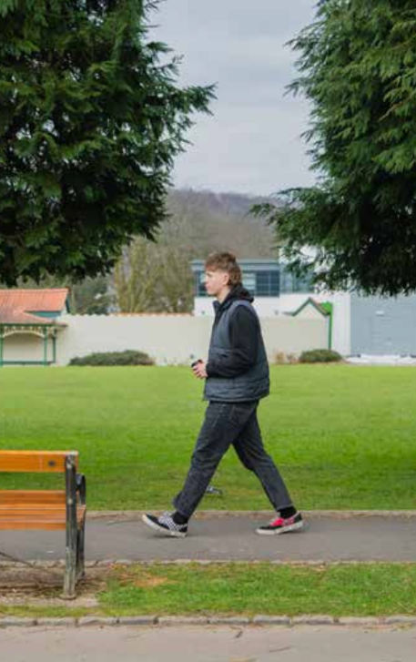

6.4 Work programme
In 2024/25 the Board engaged with external partners including Audit Wales, Planning and Environment Decisions Wales (PEDW), and regional transport bodies.

Deputy Chair Rhiannon Letman-Wade attended the Senedd's Public Accounts and Public Administration Committee to discuss active travel, specifically the Board’s annual report, while Board members contributed to various consultations and strategic planning processes.

6.4.1 Key Scrutiny Activities
The Board conducted scrutiny sessions with Welsh Government on active travel delivery plans and funding allocation; Transport for Wales on the Active Travel Monitoring Framework development; and provided coordinated responses to all four Regional Transport Plan consultations.



6.4.2 Policy Development and Advice
The Board contributed to several key policy areas during 2024-25, including barrier removal guidance and advice on e-mobility safety issues through a dedicated working group.

The Board also provided input to the Road Safety Strategy consultation and 20mph speed limit guidance development, while engaging with PEDW on planning policy matters. They also discussed their potential representation on the recently reestablished Road Safety Board to explore collaboration opportunities between active travel and broader road safety initiatives.

The Board identified enhanced data collection, improved coordination between regional and local delivery, and strengthened integration between active travel and broader transport policy as priorities for continued focus.

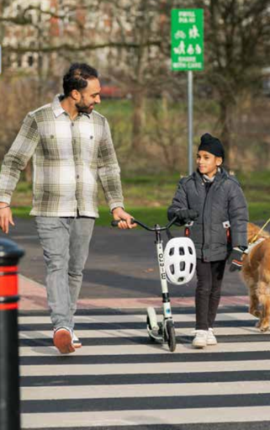

7. Recommendations

7.1 Last Year’s Recommendations (2023-24)
The previous year’s report made nine recommendations for improving active travel in Wales.

Key

NOT MET
Recommendation not achieved or minimal progress.
PARTIALLY MET
Progress made, some gaps remain.
MET
Recommendation fully achieved.

1. C-SMART objective setting
There continues to be more of a focus on inputs rather than outcomes and impact.
Status: Not Met

2. Radically improving data collation and research
Some progress made with the launch of the National Travel Survey and Active Travel Monitoring Framework.
Status: Partially Met

3. Overcoming capacity issues
The Academi Teithio Llesol programme and Active Travel Design Office expansion have
addressed some capacity and skills gaps.
Status: Partially Met

4. Reimagining active travel funding
The transition to regional funding and the ending of a ringfenced Active Travel Fund are deeply concerning.
Status: Not Met

5. Prioritising active travel and reducing car use
Limited evidence that active travel has been prioritised in transport planning.
Status: Not Met

6. Overhauling data collation in schools
New data initiatives have been launched, but inconsistent school survey participation limits reliable granular data collection.
Status: Partially Met

7. Creating a supportive environment for schools
The establishment of the Active Travel to School Hub and publication of the School
Streets guidance represents some progress.
Status: Partially Met

8. Mainstreaming a cross-government and cross-sector approach
Some cross-departmental collaboration is evidenced.
Status: Partially Met

9. Secured by design guidance
The Board prioritised dealing with access barriers on the active travel network in
2024/25 and good progress was made. Secured by Design has not yet been
addressed by the Board.

Status: Partially Met

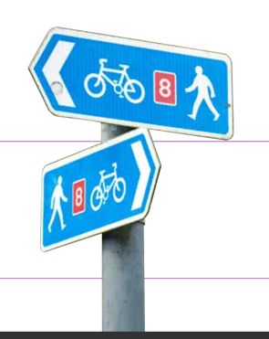

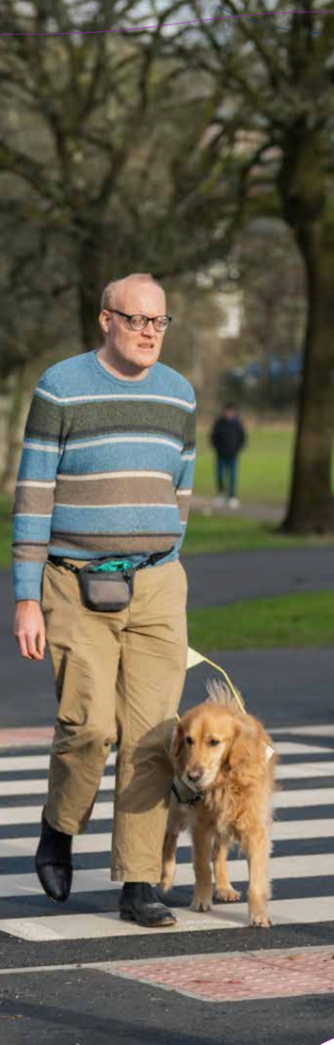

7.2 Recommendations for 2025-2030

7.2.1 Vital Role of Ring-fenced Funding
If the Welsh Government is to meet its active travel ambitions and its statutory target for modal shift to active travel, as set out in Net Zero Wales, then the new funding model must re-introduce ring-fenced funding, of at least £50 million annually (2024/25 baseline), with a minimum 4% annual increase. Transport for Wales’ (TfW) role in administering active travel funding has also been greatly beneficial for the delivery of inclusive design and active travel infrastructure, and this should continue.

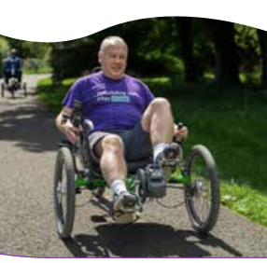

7.2.2 Build an Effective Active Travel to School Hub
The new Active Travel to School Hub (the Hub) must establish itself, by 2027, as a dynamic vehicle that can effectively coordinate publicly funded infrastructure and behaviour change programmes, targeting them at schools and school clusters where they will have the greatest potential for achieving a significant increase in the rates of walking, wheeling and cycling to school.

The Hub should also help develop, by 2026, a clear dataset that can then be used to coproduce performance targets at local authority level. The Hub must act as an effective mechanism to promote the adoption of proven good practice across schools in Wales.



7.2.3 Accelerate Wales-Wide Barrier Removal
In order to comply with law and policy Highway Authorities should take steps to modify or remove all discriminatory access barriers from their active travel routes, unless ‘objectively justified’ by 2027.



7.2.4 Embed Inclusive Design Throughout Active Travel Delivery
All future active travel investments must incorporate mandatory equality, diversity and inclusion design reviews with specialist input from groups representing protected characteristics.

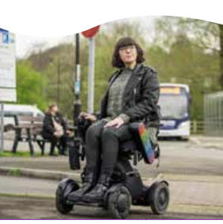

7.2.5 Support Safe E-Cycling While Addressing Public Safety Issues
Welsh Government should promote legally compliant e-cycling while taking action against the use of non-compliant e-bikes and unregistered e-motorbikes.

Priority actions between 2025 and 2030 should include social marketing campaigns that promote safe e-cycling and counters misinformation, and enhanced enforcement by police and other agencies to address antisocial behaviour, which creates an unsafe environment for everyone.

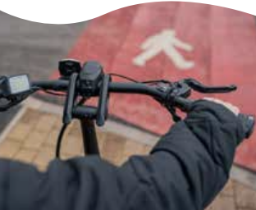

7.2.6 Effective Promotion of Active Travel
With the statutory duty on local authorities in force since January 2025 to promote active travel to reduce air pollution, a significant guidance gap has emerged in delivering the behaviour change required.

Welsh Government must publish, no later than the end of November 2025, its final statutory guidance for active travel promotion under the Environment (Air Quality and Soundscapes) (Wales) Act 2024, with clear implementation standards, performance metrics, and compliance requirements.

From April 2026, all active travel promotion interventions by Welsh Government and its partners should embed behavioural science approaches so as to achieve measurable annual increases in active travel.



To contact the Board and for all enquiries, please contact:
Active Travel Board
Transport
Cathays Park
Cardiff
CF10 3NQ
activetravel@gov.wales

