Traffic Signs Manual
Appendix C to CHAPTER 3 Regulatory Signs
Wales Variations

Traffic Signs Manual Chapter 3

APPENDIX C: WALES VARIATIONS

Background
The Traffic Signs Regulations and General Directions 2016 apply to England, Wales and Scotland. In Wales, they were amended on 17 September 2023 by the Traffic Signs (Amendment) (Wales) Regulations and General Directions 2023 (2023 no. 783). These changes were made in consequence of the decision of Senedd Cymru to amend the usual speed limit on roads with street lighting to 20 mph. This was achieved by changing in Wales the meaning of a Restricted Road, as defined in section 81(1) of the Road Traffic Regulation Act 1984, by means of the Restricted Roads (20 mph Speed Limit) (Wales) Order 2022 (2022 no. 800).
These changes affect the advice in Traffic Signs Manual Chapter 3 regarding the signing of speed limits. They have the consequential effect of introducing additional options for the signing of schools and traffic calming measures, affecting Traffic Signs Manual Chapter 4. Both are covered by this appendix.
The rules governing the placing of speed limit repeater signs in street-lit areas have changed. Whereas previously in a lit area it was not possible to place vertical signs or road markings as 30 mph repeaters, these are now permitted, as they are needed in circumstances where a traffic order has been made to impose a 30 mph limit. Conversely, repeaters showing ‘20’ are no longer permitted in a lit area, as the street lighting alone is now the indication of this limit.

Changes to Chapter 3 Section 8 for Wales
As a result of the change to the definition of a Restricted Road, in 8.1.2, replace sub paragraph b) with:
Maximum speed limit, being an upper limit (see definition of “speed limit”). This includes restricted roads (sections 81 and 82 of the Road Traffic Regulation Act 1984), which are those roads with a speed limit of 20 mph by virtue of the presence of a system of street lighting where lamps are placed not more than 200 yards (183 metres) apart.
In 8.2.3, and 8.3.1 to 8.3.3 replace all references to “30 mph” with “20 mph”:
8.2.3 On a road with a 20 mph speed limit by virtue of street lighting (i.e. a restricted road), where the adjacent length of road is unlit and is subject to the national speed limit, the 20 mph speed limit will begin at the first lighting column. The terminal sign or signs should be placed on, or in line with, that column as appropriate. To ensure that drivers are aware of the commencement of the 20 mph limit, it is essential that the terminal signs are correctly placed and clearly visible. If the 20 mph limit is to start at some other point (before or after the street lighting begins), it will be necessary to make a speed limit order and locate the terminal signs accordingly. Where a 20 mph limit commences on an unlit section of road and continues as a restricted road on the lit section, additional terminal signs must not be placed, in either direction, at the point where the street lighting begins, i.e. where the 20 mph speed limit order ends and the restricted road begins (but see 8.3.2).
8.3.1 Whilst there is no specific requirement to provide repeater signs, it is for the traffic authority to determine how many are required and where they are placed. However, to ensure that drivers are fully aware of the speed limit in force it is recommended that repeater signs are provided at the intervals shown in Table 8-4 (see 8.3.4). Schedule 10 General Direction 2 prohibits the use of 20 mph repeater signs where a road has a system of carriageway lighting. Section 82 of the Road Traffic Regulation Act 1984 defines a lit road as being a “restricted road” (see 8.1.2). Section 81 specifies that the speed limit along such a road is 20 mph unless an order has been made to impose another limit and remove the restricted road status. The presence of carriageway lighting therefore means that a road automatically has a speed limit of 20 mph with the lamps taking the place of repeater signs. It is therefore important that, when lit roads have a speed limit other than 20 mph, repeater signs are provided at adequate intervals along the road as recommended in Table 8-4. Failure to do so could undermine confidence in the signing of all speed limits, as drivers have only the repeaters to tell them that the limit is not 20 mph. Where a speed limit, other than 20 mph, applies before and after the point where the carriageway lighting begins, a repeater sign should be placed in line with the first lamp; in most cases the sign would be mounted on the lighting column.
8.3.2. Where a 20 mph speed limit is imposed on an unlit road, it is necessary to make an order. In this case it is recommended that 20 mph repeater signs are provided (see 8.3.4). Where a road subject to a 20 mph limit is lit for only part of its length, it is recommended that a repeater sign for the unlit section when leaving the lit section should be placed at a distance of not more than 100 m from the last street lamp. Where two consecutive street lamps on a lit road are more than 183 m apart a speed limit order is required as it is not a “restricted road” with repeater signs provided where considered to be appropriate. Where the two lamps are less than 200 m apart it is unlikely that a repeater sign will be necessary.
8.3.3. Schedule 10 General Direction 3 prohibits the use of repeater signs on an unlit road subject to the national speed limit. Where a lit road is subject to the national limit, repeater signs should normally be provided to remind drivers that the road is not a restricted road with a speed limit of 20 mph.
In Table 8-4 the first four rows of information are replaced by:
Speed limit and type of road^{1, 2} | Size of sign (mm) | Maximum distance (m) between |  | CVD (m)
Speed limit and type of road^{1, 2} | Size of sign (mm) | Each repeater sign | Terminal sign and first repeater³ | CVD (m)
20 mph lit road | - | No repeaters | No repeaters | -
20 mph (unlit road) | 300 | 200 | 200 | 20
30 mph (lit or unlit road) | 300 | 250 | 200 | 30

20 mph Zones
The 2023 TSRGD Amendment abolishes the signing of 20 mph zones, as these areas are almost always street-lit and will therefore have a 20 mph speed limit by virtue of their Restricted road status. Any remaining 20 mph zone signs are no longer legal and must be removed.
Section 8.7 of Chapter 3 is therefore not applicable to Wales.

Temporary warning of new 20 mph limits
The temporary sign for a new 30 mph limit (diagram 7032, S13-6-35) may not be used in Wales. An equivalent sign, but with more concise wording and greater flexibility as to its use is provided in its place. Now that the national change to the speed limit on street-lit roads in Wales has occurred, the need for this sign will be very limited. Its use is confined to situations where a road that previously had a higher speed limit is newly reduced to 20 mph either due to a traffic order or because street lighting has been erected for the first time.
Section 8.8 of Chapter 3 is retitled, and changed to the following:
8.8 Warning of a new 20 mph speed limit or extending its length
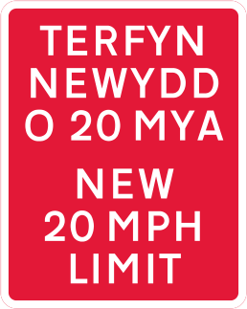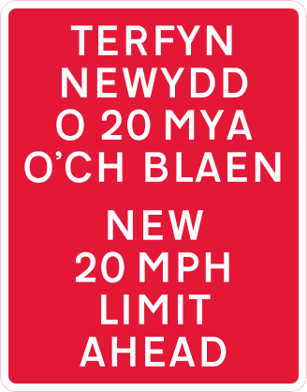
Figure C-1 Diagram 7032.1 (S13‑6‑38A) (alternative versions)
8.8.1. The sign above may only be placed at the start of or in advance of any new 20 mph speed limit for a period of up to 12 months. The variant shown to the right is used in advance of the point where the restriction commences. The sign applies to a 20 mph limit when it first comes into force as a result of either of the following:
- roads that have become Restricted roads as a result of street lighting being installed on them and there being no other limit or order in force,
- roads that become subject to a 20 mph limit as a result of the making or revoking of a traffic order.
The normal regulatory signs must always be placed at the point where a 20 mph limit commences. Signs to diagram 7032.1 may be used in addition to remind the public of the country-wide change to the limit on street-lit roads, or of changes to locally set limits.
The version shown to the left is particularly useful at the point where an existing 20 mph limit has been extended into an area that previously had a higher limit. At such locations there will be no terminal sign, and Schedule 10 General Direction 2 (as amended) does not permit 20 mph repeater signs on lit roads. Regular drivers might not at first realise that the speed limit has changed and might not notice that the speed limit signs have been removed. A sign to diagram 7032.1 (S13‑6‑38A, shown above) should therefore be erected in these circumstances to advise drivers that a new 20 mph speed limit is in force. Figure 8-13 of Chapter 3 should be interpreted by reading speed limits signs showing “30” as “20”.
8.8.2. Schedule 13 General Direction 13A sets out the conditions, all of which must be met, for the use of the sign to diagram 7032.1; they are:
a) The sign must indicate only a new 20 mph speed limit (it must not be used to indicate any other speed limit);
b) The sign must be removed not later than 12 months after the day on which the new speed limit comes into force. It follows that any such signs installed in connection with the national change throughout Wales to the restricted road speed limit must have been removed before October 2024.
8.8.3. The x‑height of the sign will depend on the location. In most cases the smallest size of 50 mm should be sufficient. A larger size might be required where the conspicuity of the sign needs to be increased, such as on a dual carriageway road. Only one sign, mounted on the nearside, will normally be needed although a second sign on the off side should be provided where a nearside sign is liable to be obscured (e.g. on a dual carriageway road). In accordance with S13‑7‑8, the sign must have, on its reverse, a date by which the person placing the sign reasonably believes the sign will have been removed.

Camera and speed limit reminder signs
Chapter 3 paragraph 8.10.3.and Figure 8-17 are replaced by the following:
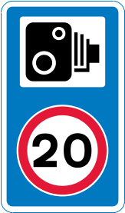
Figure C-2 Diagram 880.2 (S11‑2‑64A)
Speed camera ahead on a lit road and reminder of 20 mph speed limit
8.10.3. On a lit road with a 20 mph speed limit, 20 mph repeater signs are not permitted. However, the sign to diagram 880.2 (above) may be used to advise drivers that a 20 mph speed limit is being enforced by cameras on roads that do not have repeater signs. This sign must not be used as a substitute for repeater or terminal signs, nor to indicate any other limit. The sign should normally be placed on the approach to an enforcement camera. For other speed limits or a 20 mph limit on an unlit road, a repeater sign to diagram 670 may be co‑located with the camera sign to diagram 878 without any legend as shown in Figure 8-19, especially on the approach to an enforcement camera.

Speed limit road markings
Chapter 3 paragraph 8.18.1 is replaced by the following:
8.18.1. The road marking roundels shown in diagram 1065 (S10‑2‑9, see Figure 8-22) may be used to supplement upright signs, or on their own as repeater signs. The road marking roundel must not be used on its own where a speed limit commences; if provided it must be used in conjunction with an upright terminal sign to diagram 670 or 676 (Schedule 10 General Direction 5). As with the upright sign, the marking must not be used as a repeater on a lit road subject to a 20 mph speed limit (Schedule 10 General Direction 2, as amended). The larger marking should be used at the start of a speed limit if approaching traffic is subject to a limit higher than 40 mph, otherwise the smaller size should be used. The size of repeater markings should be appropriate to the speed indicated, with the smaller roundel being used where the limit is 40 mph or less.

Savings provisions
Signs already legally placed when the 2023 Amendment came into force could remain until 17 September 2024 if the information shown on them was still correct, but by now must have been removed. There is one exception to this:
the speed limit road marking (diagram 1065, S10-2-9) showing the digits “20” in a street-lit area may remain until September 2028,
The diagram 1065 road marking showing a limit other than 20 may be used on any road in Wales. In the unusual situation of an unlit road that has a speed limit of 20 mph by virtue of a traffic order, it would also continue to be appropriate to use the marking with the digits “20”.
This saving does not permit a sign or road marking to remain that shows the wrong speed limit for the road in question.

Additional options for warning and informatory signs

Variations relating to Traffic Signs Manual Chapter 4
The withdrawal of 20 mph zone signs in Wales has had two consequential effects:
- Physical traffic calming measures that are present in these zones may need additional signs to warn of their presence. This is to comply with the Highways (Road Humps) Regulations 1999 (1999 no. 1025) (HRHR), which have not been amended.
- The option to include a lower panel on the zone entry signs with children’s or other artwork has been lost.
To mitigate against these effects, new signs have been introduced that may have added at the bottom a plate containing a dragon graphic. This is based upon the winning design in a competition for children organised by Welsh Government and RoSPA. These signs are additional to those already prescribed and are available as an option for authorities to use at their discretion.

Warning of road humps
Regulation 6 of HRHR requires traffic signs to be placed and maintained in such positions as the authority considers requisite to provide adequate warning of the presence of a road hump(s). This requirement does not apply within 20 mph zones. HRHR makes no mention of 20 mph speed limits that are not zones, as these were very rare when it was made. Traffic authorities may therefore consider that a road subject to a 20 mph speed limit is equivalent to a 20 mph zone, and that no signs at all are required to warn of humps on such a road.
However, if the traffic authority concludes that warning signs are needed, they have the choice of the options that were available in the 2016 TSRGD, or of using signs prescribed in the 2023 amendment TSRGD.
The use of warning signs as prescribed in 2016 is described in Section 12 of Traffic Signs Manual Chapter 4, with the proviso that references to “Diagram 557.1 (S2-2-43)” should be read as “Diagram 557.2 (S2-2-43A)”.
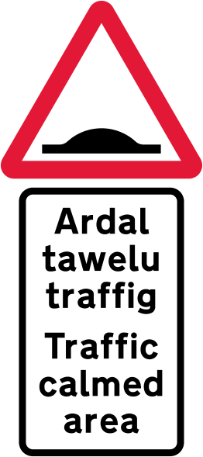 | 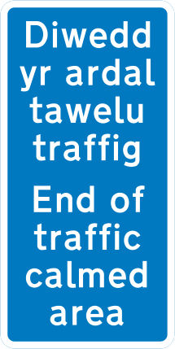
Figure C-3  Diagram 557.2 (S2‑2‑43A)  showing plate variant (e) | Figure C-4  Diagram 883.1 (S11‑2‑32A)
Figures C-3 and C-4 show signs and options first prescribed by the 2023 amendment TSRGD. These are intended to provide an area-wide warning that could cover a network of connected roads, similar to that of the former 20 mph zone entry and exit signs. This will avoid the need to mount warning signs in each road or in advance of each group of humps. These signs will usually be mounted on the supports vacated by the removal of the zone signs, saving cost and disruption. They must be reflective, but are not required to be lit.
The sign shown in Figure C-4 (Diagram 883.1, S11‑2‑32A) will only rarely be needed. It will usually be apparent to road users when the traffic calming measures have ended. Even if not apparent, it would not be a safety issue if they continued to drive cautiously. Where this sign is used, the smaller size (40 mm x-height) will normally be sufficient.

School warning signs and safety messages
The 2023 amendment regulations provide the option of a plate showing a graphic image to be placed under either the children warning sign or the humps warning sign. These two warning signs are accordingly now referenced as Diagram 545.2 (S2-2-25A) and Diagram 557.2 (S2-2-43A), respectively. They provide for the additional plate as an option by means of the reference “5” in column 5 of the table. This plate may only be used in addition to the other required plate; it must not replace it.
This optional plate, containing an image of a dragon shaped to resemble the digits “20” based upon a child’s artwork, is Diagram 545.3 (S2-3-5). It is prescribed in a single size: 545 mm wide by 410 high. This matches the width of the worded plate above at its most common x-height: 62.5 mm. The purpose of the plate is to improve road safety. The plates are separated vertically by approximately 30 mm for the usual 600 mm high triangle.
Typical arrangements for using this option are shown in Figure C-5. The whole assembly may be placed on a yellow backing board where additional conspicuity is deemed necessary.
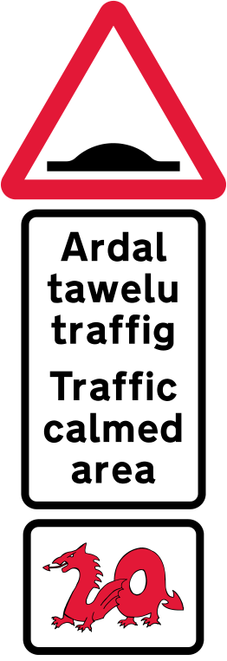
Figure C-5 School and humps warning signs
with additional plate to Diagram 545.3 (S2‑3‑5)

