Relationship circle
Who are the important people in the child’s life?

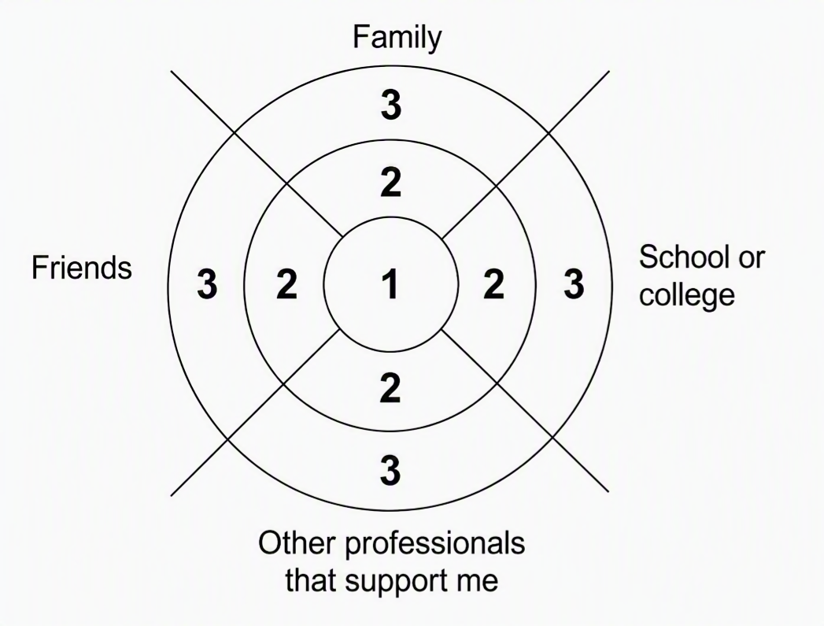

Family
1.
2.
3.

Friends

1.
2.
3.

1.
2.
3.
School or college

Other professionals that support me
1.
2.
3.

